February 9, 2011

Bicycle Board Report to Traffic Commission

HIGHLIGHTS

Accomplishments
- The Bicycle Board elected Assistant City Engineer, Damien Davis ex-officio member after City Manager Moore made Davis the liaison with the Bicycle Board.
- Created business card size handout with Confident City Cycling contact info on front and safe bicycling tips on back. Awaiting printing.
- Seven 15-second bicycle education TV spots continue to run on channel 15. Spots can also be viewed on the City website as well as at News on BikeMorgantown.com.
- Scheduled Confident City Cycling classes March – September on BikeMorgantown.com and secured venues.
- Provided to MPO Director Bill Austin an assessment of WVDOH plans to improve West Run Road. Proposed improvements will provide no special benefit to cyclists.

Plans for Next Month
- Continue to support City efforts to implement the Traffic Commision’s approved Bicycle Board June 2009 recommendations to install a bicycle climbing lane on Mon Blvd. and to install Share the Road signs along the Mon Blvd., Beechurst, Don Knotts, South University corridor.
- Continue to develop comprehensive bicycle plan.
- Continue to develop education effectiveness metrics.
- Plan 2nd application for Bicycle Friendly Community award.
- Continue to improve bike route map.
- Develop signage recommendation follow-on to Shared Lane Marking recommendation.
- Develop bike locker proposal for parking garages.
- Plan May National Bike Month and May 16-20 National Bike-to-Work activities.
- Continue to coordinate with WVDOH to replace in-line drainage grates. (Figure 1: In-line drain grate in front of Coliseum, below)
- Cruise West Run Road with MPO Director Austin and WVDOH representatives to discuss improvement impact on bicyclists.

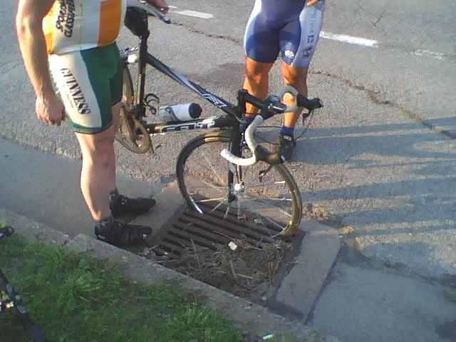
Figure 1: In-line drain grate in front of Coliseum

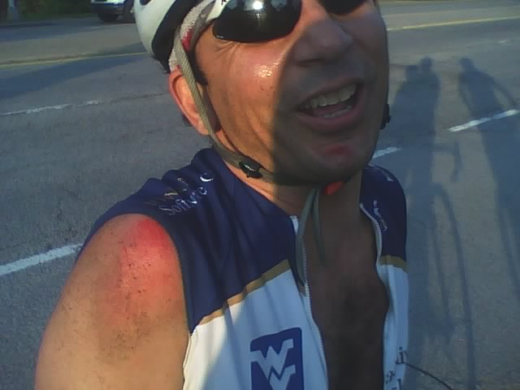
Figure 2: Lucky result of in-line grate crash

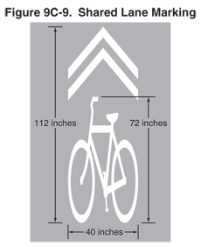
Figure 3: Shared Lane Marking

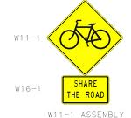
Figure 4: Share the Road sign

Figure 5: Bicycles May Use Full Lane sign

Video spots on City website: http://www.youtube.com/user/CityofMorgantown
TV spots on BikeMorgantown.com: http://bikemorgantown.com/articles.php?str=2010/08/psas-complete.html

