Morgantown Municipal Bicycle Board

Regular Meeting Minutes
October 7, 2010
Public Safety Building

Open Action Items:
Due date | Responsibility | Action Item
TBD | Springston | 71. Collect information from cities that have already implemented the SLM.
10/7/2010 | Gmeindl | 90. Contact absent members of the BB and ask them what it would take to get them to participate.
11/4/2010 | Spencer | 122. Give copy of the American Bicyclists article on Bicycle Friendly universities to Zerbe and Hugh.
11/4/2010 | Spencer | 123. Contact the local AAA regarding possible collaboration with the BB.
11/4/2010 | Zerbe | 124. Discuss the possibility of WVU becoming a Bicycle Friendly university with the SGA president.
11/4/2010 | Gmeindl | 125. Investigate business cards with Confident City Cycling info.
11/4/2010 | Hein | 126. Gather feedback on the Positive Spin proposal.
11/4/2010 | Wamsley | 127. Reorganize parking committee; define lockers and operations; inform Tom Arnold.
11/4/2010 | Gmeindl | 128. Inform statewide MPO of BB and its accomplishments.

Meeting Minutes:

Agenda Item 1 (Schmooze time)
The October 2010 monthly meeting of the Morgantown Municipal Bicycle Board (BB) was called to order at 6:30 p.m. at the Public Safety Building by Chairman Frank Gmeindl with the following members attending:

- Frank Gmeindl (late), Jim Rye (late), Betsy Shogren, gunnar Shogren, Don Spencer, Hugh Kierig, Jonathan Rosenbaum, Jonathan Zerbe, Marilyn Newcome, Aira Burkhart, Alice Vernon, Paul Becker, and Chip Wamsley.
- Absent members: Chet Parsons and Derek Springston.
- Visitors: Nick Hein

Agenda Item 2 (Agenda)
The agenda was approved, with the addition of Nick Hein’s Youth Education Proposal and Aira’s bicycle page for the Morgantown Yellow Pages, if time permits after Agenda Item 11.

Agenda Item 3 (Minutes of Last Meeting)
The minutes from the September meeting were approved without change.

Agenda Item 4 (Action Items)
- #71 – Open. Springston was absent.
- #90 – Open.
- #107 – Closed. Hein prepared a detailed proposal of the Youth Bicycle Education plan. He will present it at the end of the meeting, time permitting.
- #109 – Closed. Rosenbaum forwarded his previously prepared document on MUTCD/ASHTO bicycle-related signage for the BikeMorgantown.com website.
- #110 – Closed. Transferred to the Education Committee.
- #112 – Closed. Transferred to the Education Committee.
- #114 – Closed.
- #115 – Closed. Burkhart circulated a draft of the proposed Bicycle Page for the Morgantown Yellow Pages. Comments and clarifications are welcome. Due 10/15.
- #119 – Closed. Gmeindl obtained the closed-captioning videos from Aaron and forwarded them to Hugh. They should be displayed by the end of next week.
- #120 – Closed. Gmeindl sent Hugh the billboards with the correct aspect ratio for display on the Information Station boards.
- #121 – Closed. Gmeindl met with Bill Austin and the Pedestrian Safety Board, and determined a route for the MPO Conference’s mobile laboratory. See Agenda Item #11 for more info.

Agenda Item 5 (Ripe Banana Issues)
Don S. reported that the latest issue of the American Bicyclist had an article on Bicycle Friendly Universities. He will give a copy of the article to Jonathon Zerbe to pass along to the SGA, in hopes that WVU can achieve this status. He will also give a copy to Hugh.
Don S. inquired about a possible collaboration of the BB with the local AAA chapter. He will contact the local office to see if they have any interest in working with the BB.

Agenda Item 6 (Membership)
Vice-chairman Don Dickerson has resigned from the BB. Thank you, Don, for your many years of loyal service to the BB. After some discussion, the following list of potential BB members to replace Don D. was generated, along with the BB member who will contact the individual to see if he is willing to serve:
- Ryan Post – Yes
- Gary Rodosta – Gunnar Shogren
- Greg Ellis – Chip Wamsley
- Colin Dearman – Chip Wamsley
- Pathfinder Employee (Andrew W., Andy B., Gabe F.) – Aira
- Don Spencer will contact Jenny Selin to see if she can suggest possible candidates.

The Youth Commission is currently inactive, thus the BB still does not have a representative from this organization.

Agenda Item 7 (Bumper Stickers)
The bumper stickers are complete and ready for distribution. They were distributed to BB members, with the intent that they go on local car bumpers, NOT refrigerators, desks, out-of-town cars, etc. The bumper stickers are free and can be found at Wamsley Cycles, Pathfinder, and Positive Spin. Tell your friends!

Agenda Item 8 (Education Status)
The September Education Status Report is attached.

Agenda Item 9 (Finances)
Frank displayed the Effective Bicycling Education Program Financial summary for September 2010. All present members of the BB approved the finances. Please note: BB members with pending invoices did not vote to approve their own invoice.
Don Spencer suggested that the BB use some grant money to create business cards with the Confident City Cycling class information/website details. These cards can be passed out to anybody that expresses an interest in the class, and can also be available at local cycling shops, etc. Frank will look into this.

Agenda Item 10 (Parking)
Some of the planned bicycle parking rings have not been installed downtown, because of an unforeseen budget shortage. Frank will inquire about the origin of this shortage. Chip, Hugh, Don S., Nick, and gunnar will work together to determine a vendor and specifics for bike lockers in at least 1 parking garage downtown. They will forward this info to Tom Arnold.

Agenda Item 11 (MPO Conference)
The MPO conference is planned for the week of Oct. 25. The route has been determined for the Mobile Lab. During the tour, Frank will point out typical hazards and challenges that bicyclists face around Morgantown. He will also mention potential areas for improvement. Don S. suggested that Frank ensure that the MPO members receive information about the BB in some form.

Agenda Item 11.33 (Youth Education Proposal)
Nick Hein presented his Morgantown-Area Youth Bicycle Education proposal in hopes of establishing a collaboration between the BB and Positive Spin. There was not much time for discussion, so this will be continued at the next meeting. The BB specifically had questions regarding the content of the classes, and if they are in compliance with the LAB.

Agenda Item 11.66 (Bicycle Page for the Yellow Pages)
There was very little time for Aira to get comments and suggestions from the BB regarding the bicycle page for the Morgantown yellow Pages. Please have a look at the document and email her with comments ASAP.

Agenda Item 12 (New Action Items)
#122 – Spencer: Give copy of the American Bicyclists article on Bicycle Friendly universities to Zerbe and Hugh.
#123 – Spencer: Contact the local AAA regarding possible collaboration with the BB.
#124 – Zerbe: Discuss the possibility of WVU becoming a Bicycle Friendly university with the SGA president.
#125 – Gmeindl: Investigate business cards for the BB.
#126 – Hein: Gather feedback on the Positive Spin proposal.
#127 – Wamsley: Reorganize parking committee; define lockers and operations; inform Tom Arnold.
#128 – Gmeindl: Inform statewide MPO of BB and its accomplishments.

Agenda Item 13 (Meeting Evaluation)
Not done due to inadequate time.

Chairman Gmeindl adjourned the meeting at ~8:30 pm. The next meeting is planned for November 4, 2010 at 6:30 PM.

Minutes respectfully submitted this date by Betsy Shogren, 10/08/10.

Attendance:
 | Jan-10 | Feb-10 | Mar-10 | Apr-10 | May-10 | Jun-10 | Jul-10 | Aug - 5 | Sep-10 | Oct-10 | Nov-10 |  | Dec-10 |  | Jan-11 |  | Feb-11 |  | Mar-11
Becker, Paul | X |  |  |  |  |  |  |  |  | X
Burkhart, Aira |  |  | X | X |  | X | X | X |  | X
Dickerson, Don |  | X | X |  |  |  |  |  |  | ☹
Gmeindl, Frank | X | X | X | X | X | X | X | X | X | X
Kierig, Hugh |  | X | X |  |  | X |  | X | X | X
Newcome, Marilyn |  | X | X | X | X | X |  | X |  | X
Parsons, Chet |  |  | X | X
Rosenbaum, Jonathan |  |  |  |  | X | X | X | X | X | X
Rye, Jim | X | X | X |  | X | X | X |  | X | X
Shogren, Betsy | X | X | X | X | X | X | X |  | X | X
Shogren, gunnar | X |  |  | X | X | X | X |  | X | X
Spencer, Don | X | X | X | X | X | X | X | X | X | X
Springston, Derek |  | X |  | X |  | X
Vernon, Alice | X |  | X |  |  | X |  |  |  | X
Wamsley, Chip |  |  | X | X | X | X |  | X | X | X
Zerbe, Jonathan |  |  |  |  | X |  |  |  |  | X
X=Present
Blank = Absent

Education Report for September 2010
Summary 1
Confident City Cycling Classes 1
Driver Education 2
Video Spots 2
Radio PSAs 2
Newspaper Articles 2
BikeMorgantown.com web site 3
Billboards 3
WVU Info Kiosks 4
Bumper Stickers 5
Bicycle Route Map / Signage Plan 5

Summary
The Education Program is winding down for the year. Below, you can see that the Education Committee has produced some very respectable products.

The WV Transportation Enhancement Program grant made much of this possible. We’ve spent approximately half the funds. We’ve produced just about everything we said we’d produce. Unfortunately, participation in the Confident City Cycling classes is low. We need to improve that.

Oct. 1, the Education Committee met to define metrics that we can employ to demonstrate the education program’s impact on cyclists and motorists as well as to guide future work.

Next Spring, we should be able to roll out a full-blown education program including all the items listed in the table of contents above.

Next month, November, we’ll submit an Intent to Propose to the WVDOT for a follow-on grant. In January, we’ll submit a complete proposal.

Confident City Cycling Classes
Low participation is a major problem. Overall, we’ve only had 18 participants since March and only half of them completed the course. In the grant application, we estimated we would deliver the course to 304 people.

On Sep. 27, we completed 3rd series of Monday night classes. The next series of Monday night classes began Mon. Oct. 4. Nobody showed up. We will continue to hold the Monday night classes in the event that somebody that missed some sessions from the previous sequence wants to make them up or if someone new wants to start mid-series.

Offered a special class for experienced cyclists Sat. Oct 2. While 3-4 people expressed interest, nobody committed to attend.

Driver Education
Marilyn is trying to get delivery of the course to High School Driver Ed instructors scheduled for Oct. 15. We developed this course last year and were scheduled to deliver it in February but got snowed out.

Video Spots
After running the video spots for two months, Comcast will stop showing them Oct. 19.

The seven 15-second educational video spots are being broadcast regularly throughout each day by Comcast on networks Discovery, tbs, CNN, Comedy Central, CMT and Travel Channel as well as irregularly on random other channels.

Spots can be viewed at http://bikemorgantown.com/articles.php?str=2010/08/psas-complete.html

We also obtained closed-captioned versions of the TV spots from Aaron Shelton and gave them to WVU to display on the information monitors at the PRT stations.

Radio PSAs
We still need to develop radio PSAs. Hopefully we can get this done over the winter.

Newspaper Articles
On Sep. 2, the Dominion Post published Janel’s article Out and About on the Rail Trail. This is the 6th article that the Dominion Post published since April 2010. The following table lists the articles and their publication dates. Thanks to Paul Becker for getting these published and for getting the Dominion Post to publish the rest of them. The articles are also published in the Articles section of BikeMorgantown.com.

Newspaper Articles
Topic | Author(s) | Due Date | Submitted | Published
- ABC Quick Check | Chip | ASAP | Yes | Yes
- National Bike Month (include info about the Bicycle Board and the MEBEP grant) | Frank | early April | Yes | Apr 29
- Same Road, Same Rights, Same Rules | Frank | before May | Yes | May 20
- Riding a Bike in Traffic (including TS101) | Frank & Marilyn | after 4/15, before May, | Yes | Aug 5
- Driving Near Bicyclists | Frank | June 1 | Yes | Jul 8
- Out and About on the Rail Trail | Janel | June 1 | Yes | Sep 2
- Bikes and Pedestrians | Don S. | June 1 | Yes
- Biking for Children | Alice | June 1 | Yes
- Alternative Approaches: Bike Lanes, Road Share | Chet | Sept 1
- Civility on the Road | Aira | Sept 1 | Yes
- Green Biking | Jim Rye | Sept 1
- Healthy Biking | Marilyn | Sept 1
- Morgantown Bike Route | Derek | Nov 1
- Biking Around the World (including US) | Chip and Frank | Nov 1
- Biking Trips Around Morgantown | Betsy | Nov 1
- Positive Spin | Nick Hein | Dec 1
- Bike Groups in Morgantown | Chip | Dec 1
- Biking for Parents | Alice | Dec 1
- Commuting | Jim Rye | Jan 15

BikeMorgantown.com web site
Thanks to gunnar and Ryan for giving us a nearly perfect web site, BikeMorgantown.com. The website provides educational information, Confident City Cycling course information, schedule and on-line registration capability, news, info about bicycling law and more. Go to BikeMorgantown.com and see.

Billboards
Thanks to Chip, Jim, gunnar, Betsy, Ryan, JR Petsko and Gary Rodosta one electronic billboard was developed and is now on WV Rt. 119 heading north from Mileground Rd. going down Easton Hill. We only purchased a one month contract to display it so Lamar will stop displaying it Oct. 10. We will put up the billboards again in the Spring at better locations.

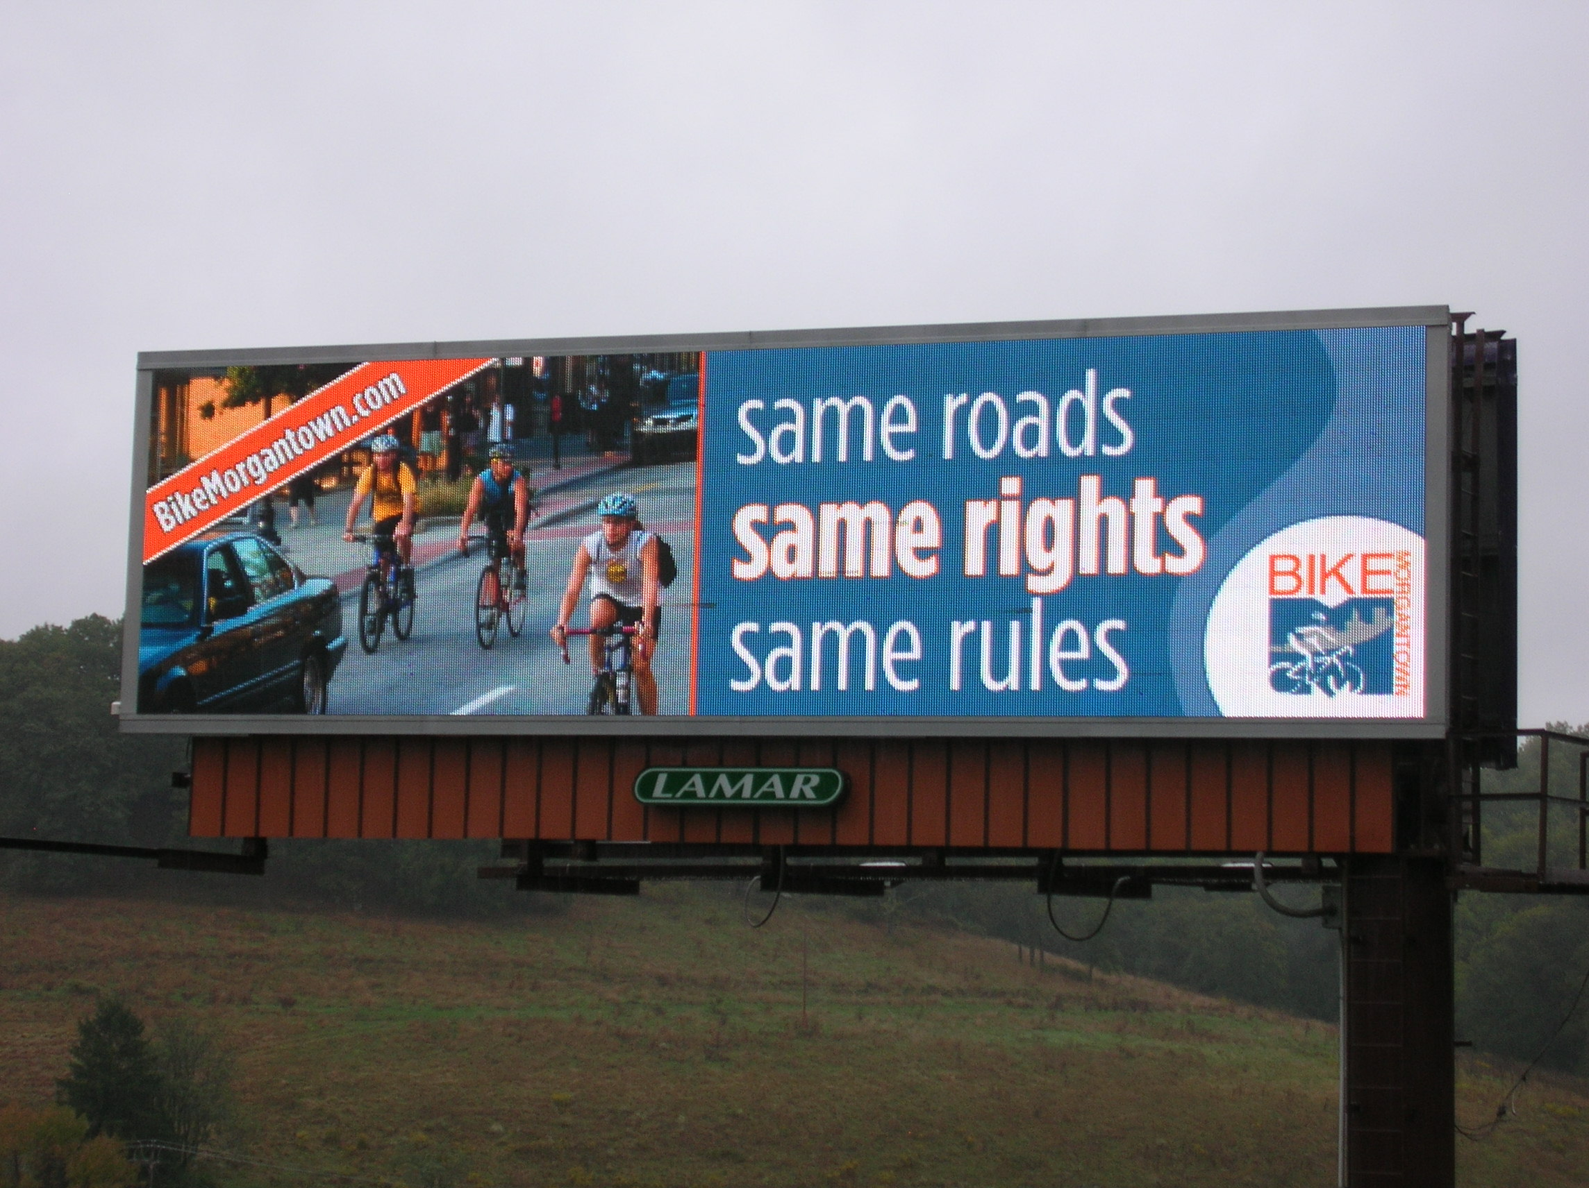
Cool, huh?!

Six other messages will be developed in the coming months. Following are the messages that will be on the billboards:
• 4 Wheels, 2 Wheels, 1 Road: Let’s Roll Together
• Drive Nice, Bike Nice
• A Bicycle Friendly Morgantown is a (changing adjective) Community
Changing adjective: Healthier, Greener, Smarter
- For Confident City Cycling
CLICK
(downward pointing arrow)
BikeMorgantown.com

WVU Info Kiosks
We’re still working on getting the Same Roads, Same Rights, Same Rules billboard produced in the correct aspect ration to enable WVU to display it on their info kiosks located at PRT stations and in high pedestrian traffic campus buildings such as the Mountainlair.

Bumper Stickers
Thanks to Aira, we have 1,000 bumper stickers and now we need a distribution plan. Frank asked for your ideas or feedback on the following proposal, giving:
- a few to each of you at next Thursday's BB meeting;
- a few to each Traffic Commission member at next Wednesday's TC meeting;
- a hundred or so to Pathfinder and Wamsley Cycles;
- fifty or so to the Greater Morgantown Commerce and Visitor's Bureau.
Jim liked 1-4. Ryan (who is not a BB member but should be) suggested giving them to participants at upcoming races. Derek suggested that we post their availability on BikeMorgantown.com and monbikeclub google group.

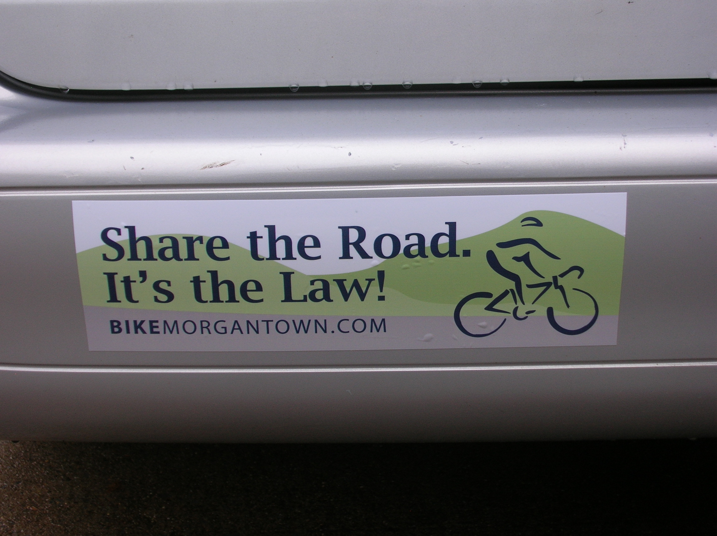
Thanks, Aira!

Bicycle Route Map / Signage Plan
Derek’s working on combining the Bike Route map with the map that we produced to show the locations of the Shared Lane Markings and the Bicycles May Use Full Lane signs. He will replace the SLMs and BMUFL signs with Share the Road signs. On the Bike Route, we’ll identify locations for Bike Route signs. As usual, Derek’s handling this single-handed besides balancing a new baby, a job, cycling and playing guitar so he could use some help.
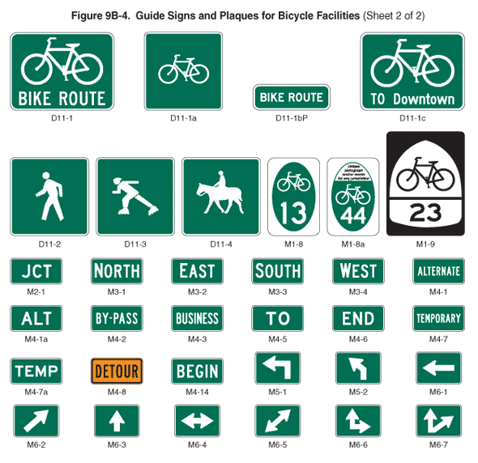
Bike Route and other irrelevant signs that I couldn’t figure out how to delete

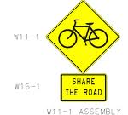

Shared Lane Marking

