May 4, 2011

Bicycle Board Report to Traffic Commission

HIGHLIGHTS

Recommendations
The Bicycle Board recommends that the Traffic Commission:
- Appoint Butch Graber to replace Paul Becker.
- Recognize Heidi Hockenberry as ex-officio representative of BOPARC replacing Ralph Larue.
- Approve revised Procedural Guidelines.
- Approve Police Information Card.

Accomplishments
- Mayor Byrne declared May Bike Month in Morgantown.
- In April, Comcast resumed airing Bicycle Education TV spots on CNN, Discovery, TBS, Comedy Central and Country Music Television networks.
- In-Site began to display billboards on Mileground and adjacent to Star City Bridge April through May.
- Submitted to the Assistant City Manager a completed application to Bikes Belong for a $10K grant to support the Mon Blvd. bicycle climbing lane.
- Updated draft resolution to require all Morgantown automatic traffic signals to detect bicycles.
- Met with Chief Ed Preston.

Plans for Next Month
- Continue to wait for resolution that requires all Morgantown automatic traffic signals to detect bicycles to be presented to City Council.
- Monitor status of $10K grant application to Bikes Belong for Mon Blvd. bicycle climbing lane. (Submitted completed application to City in March.)
- Continue to support City efforts to implement the Traffic Commission’s approved Bicycle Board June 2009 recommendations to install a bicycle climbing lane on Mon Blvd. and to install Share the Road signs along the Mon Blvd., Beechurst, Don Knotts, South University corridor.
- Complete negotiations with Lamar to display billboards on Mileground (2) and South University Avenue through September 4.
- Present bicycling education at May 9 WVU employee fest booth.
- Finalize Engineering section of comprehensive bicycle plan in preparation for distribution of plan to key stakeholders for review and comment.
- Continue to develop bike route map.
- Develop signage recommendation.
- Complete bike locker recommendation for parking garages.
- Continue to coordinate with WVDOH to replace in-line drainage grates.

City of Morgantown

Municipal Bicycle Board

Procedural Guidelines

Article I - Organization

  - Authority: Morgantown City Traffic Commission is authorized to appoint standing committees and thereby has acted to appoint a Municipal Bicycle Board. The Bicycle Board shall serve as a standing committee of the Traffic Commission. At least one member of the Traffic Commission shall be designated to serve as a member of the Bicycle Board. The Traffic Commission is responsible to the City Manager.

  - Purpose of the Bicycle Board: The purpose of the Bicycle Board shall be to:

- review and support the implementation of Article 373 on Bicycles of the Morgantown Municipal Code;
- work to make Morgantown a Bicycle Friendly Community as defined by the League of American Bicyclists so as to reduce traffic demands, afford better air quality, and improve public health;
- make recommendations for improving signage, safety, capacity and facilities for bicycles on streets, trails or other land design or use which supports cycling;
- advocate for the provision of bicycle travel opportunities to and from locations such as residential, employment, commercial, education, recreation and transit centers;
- promote the development of safe bicycle routes to schools;
- encourage use and enjoyment of bicycling and bicycle safety education.

1.3 Duties: The duties of the Bicycle Board shall be as follows:

- advise and consult with the Traffic Commission, the City Manager, and the City Engineer on any matter pertaining to the Ordinance;
- study the transportation problems and needs of the City and make specific recommendations to the Traffic Commission and the City Manager and to the City Council and Greater Morgantown Metropolitan Planning Organization as authorized;
- review City plans and policies which contain matters relating to roadways, transit, and non-motorized transportation;
- create a city bicycle plan which promises by specific time frames, all residents will have convenient access to a Bicycle route.
- facilitate the planning and implementation of public education on riding a bicycle
- coordinate City programs pertaining to bicycling.

Article II - Membership

  - Membership: The members of the Bicycle Board shall be appointed by the Traffic Commission and have an interest and experience in cycling as well as the ability to attend no less than four meetings per year. The membership of the Bicycle Board shall include ten members from the City, five members from the Greater Morgantown area, one member from the Youth Commission and a representative designated by the WVU Cycling Club. One or more of these members shall also be voting members of the Traffic Commission. Bicycle Board members shall serve three-year terms without compensation. Representatives of the Board of Park and Recreation Commissioners, the Transit Authority and other city departments or commissions may be invited to serve as ex-officio non-voting members.

Membership Summary

Regular voting members
10 City
5 Greater Morgantown
1 Youth Commission
1 WVU Cycling Club
17 Total regular voting members
One of these must also be a voting member of the Traffic Commission

Ex-officio non-voting members
1 BOPARC
1 Transit Authority
N Other
2+N Total ex-officio non-voting members

19 + N Total Bicycle Board members

Article III - Meetings

  - Regular Meetings: Meetings shall be conducted in compliance with the West Virginia Public Meetings Law and open to the general public. Meetings shall meet monthly or no less than quarterly. Dates of meetings will be decided upon at the previous meeting. All meetings will be publicized using whatever reasonable means available. Notices shall be distributed no less than seven (7) days before a meeting is to take place. However, failure by a member to receive a meeting notice does not mean that a meeting is invalidated.

  - Special Meetings: Special meetings of the members may be called upon the written request of a majority of the voting members to consider a specific subject. Meetings shall be conducted in a location owned and operated by the City of Morgantown which is handicapped accessible. Notice for time and place of any special meeting is to be given using whatever reasonable means available. No business other than the subject of the Special Meeting shall be transacted at said meeting.

  - Quorum: Fifty percent (50%) of the voting members shall constitute a quorum for the transaction of business. Meeting attendance reports shall be reported to the City Clerk by the Secretary

Article IV - Officers

  - Officers: The officers of the Bicycle Board shall be a Chairperson, Vice Chairperson, and Secretary, all of whom shall be elected from the Bicycle Board Membership. Officers elected shall hold term for one (1) year and be eligible for re-election. All nominees shall be inquired as to their willingness to serve if elected, prior to their name being placed in nomination.

  - Chairman: The Chairperson of the Bicycle Board shall prepare an agenda, call all meetings, preside at all meetings, and be a consulting member of all committees formed.

  - Vice-Chairman: The Vice Chairperson shall act as Chairperson in the absence of the Chairperson. The Vice-Chairperson shall have such other duties, as the Bicycle Board may authorize from time to time to be assigned to the office.

  - Secretary: The Secretary shall be responsible for keeping a recording of adequate records of all meetings of Bicycle Board and for submitting reports of the Bicycle Board to the City Manager as needed or requested.

Article V - Committees

5.1 Committees: The Bicycle Board may establish committees to carry out the functions related to its responsibilities.

5.2 Sponsorship of Events (amendment added April 2008): Whenever the Bicycle Board plans to sponsor a public event, the Board must review all program plans, publicity, and financial planning by the event committee in advance of any publicity. After reviewing the plans and giving its approval, the Bicycle Board must in turn receive approval for the complete plans by the Traffic Commission and receive authorization in advance of publicity for event sponsorship by the City Manager. A written report on the event shall be submitted to the Bicycle Board by the event committee. The Bicycle Board shall also submit a written report on the outcome of the event to the Traffic Commission and the City Manager.

Article VI - Finances

  - Fiscal Responsibilities: The Bicycle Board shall not have the authority to maintain any account or to receive any gifts, endowments, bequests and investments. Any such account shall be maintained as directed by the City Manager.

Article VII - Change to These Standards of Operation

7.1 Amendments: Changes to these procedures may be recommended by a two-thirds (2/3) vote of the Bicycle Board membership and must be approved by the Traffic Commission.

Approved by action of the Morgantown Traffic Commission,

Date: July12, 2006
Dr. Ron Eck
Traffic Commission Chair

Terry Hough
Director of Public Works

Date: May 4, 2011
Dr. Roy Nutter
Traffic Commission Chair

Terrence Moore
City Manager

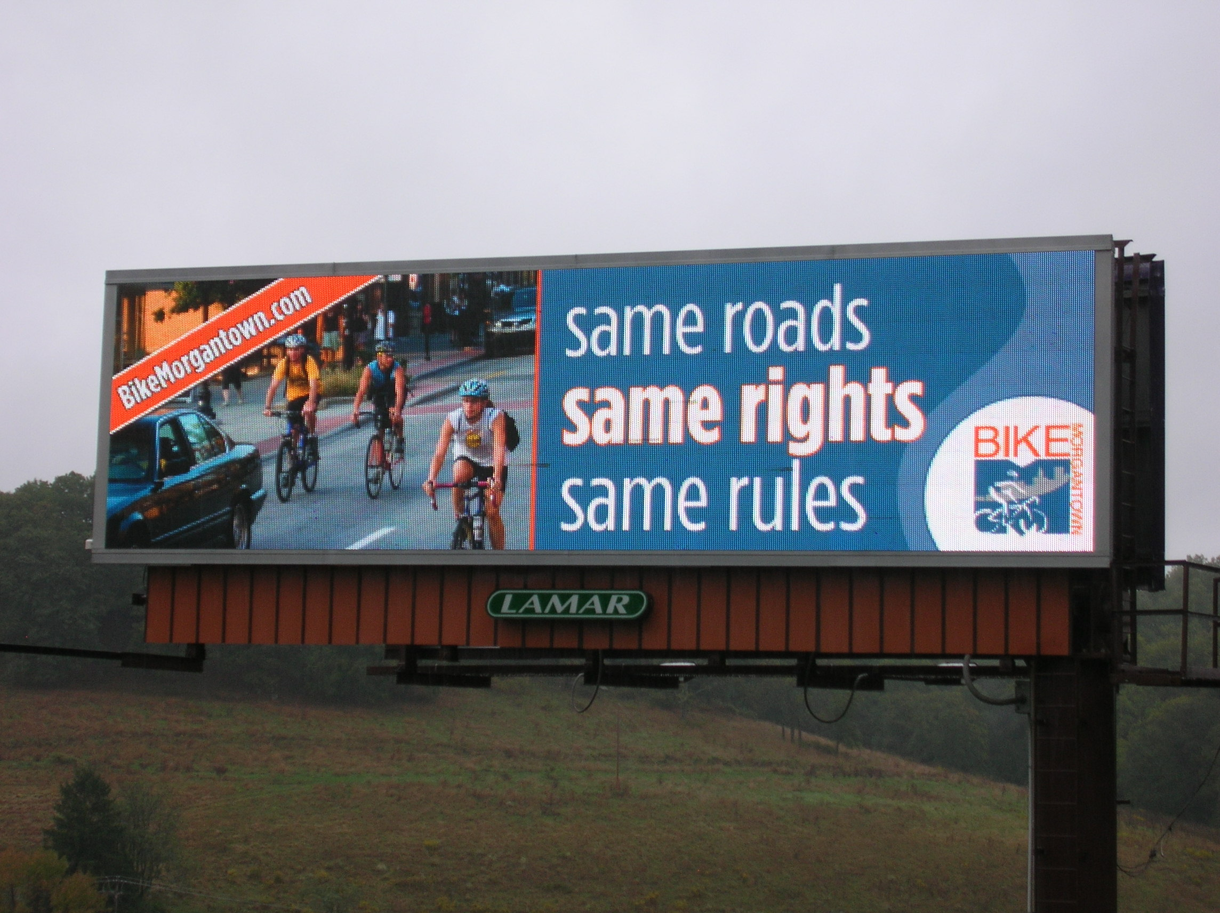
Figure 1 Billboard


Figure 2 Alternative Bumper Sticker
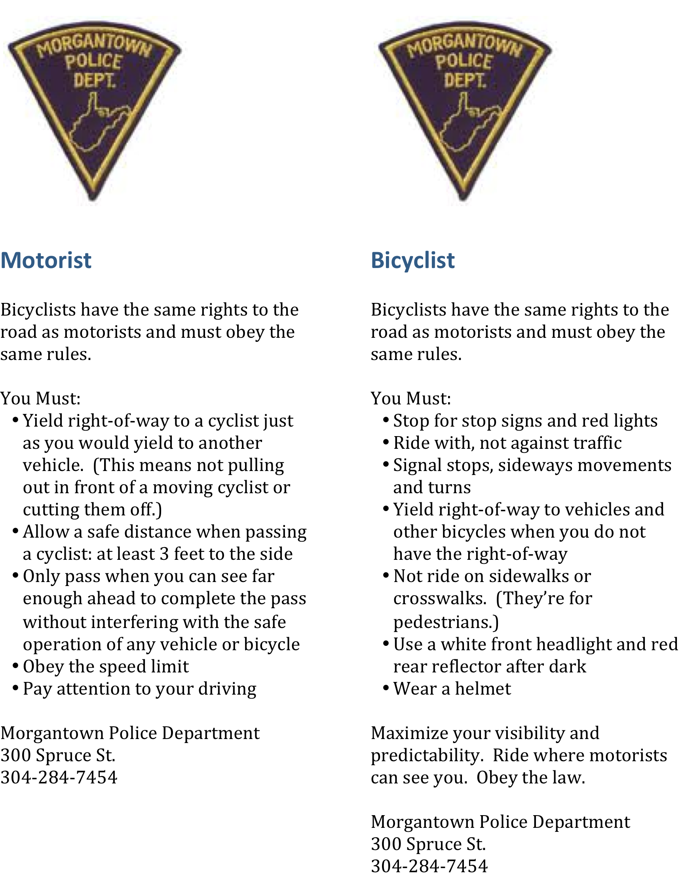
Figure 3 Police Information Card (two-sided)

