June 11, 2012
(For June 13, 2012 Traffic Commission meeting)

Bicycle Board Report to Traffic Commission

HIGHLIGHTS

Accomplishments
- Drafted and delivered to City Manager a draft resolution for City Council to adopt Greater Morgantown Bicycle Plan. City clerk read resolution to City Council May 1 and Council voted unanimously to adopt the plan.
- The League of American Bicyclists recognized Morgantown as a Bicycle Friendly Community at the bronze level.
- In collaboration with City Public Communications Manager, drafted press release and announced BFC award in several media statewide.
- Received LAB BFC application feedback and distributed to Traffic Commission and City Council.
- Identified locations for erecting BFC road signs. (LAB provided 2 free. Purchased 10 more and art. See Figure 1.)
- Participated in 2 interviews with WBOY about the BFC award.
- Drafted and provided to LAB a Morgantown bicycle friendly community profile including photos.
- Drafted and submitted to Mayor proclamation of May as Morgantown Bike Month. Mayor read proclamation at May 1 City Council meeting.
- Participated in interview with National Public Radio about Bike to Work Day.
- Cancelled Summer I WVU Confident City Cycling class due to lack of enrollment. (3 students are enrolled in Summer II).
- Participated in MPO sponsored May 18 Bike to Work Day; escorted approximately 12 riders to work from principal neighborhoods around the City to Mountaineer Station. City Manager participated and rode his bike to work.
- Participated in WVDOT Statewide Bicycle Connectivity workshop May 15, 4-7 pm at PSC and provided recommendations for bike routes in the Greater Morgantown area.
- Participated in City/MPO Crossroads regional visioning meeting workshop June 6.
- Received notification from Deputy City Manager that Bikes Belong rejected Morgantown’s application for a $10K grant to fund the Mon Blvd. bicycle-climbing lane.
- Responded to City Manager’s request for status of unicycle recommendations with a plan: present recommendations to Traffic Commission at July meeting and to City Council at July 31 Committee of the Whole meeting.
- Participated in MPO Citizens Advisory Committee meeting May 10.
- Participated in MPO Long Range Transportation Planning Steering Committee meeting.
- On May 19, at City Manager’s Admin Assistant, provided 50 police information cards. (Apparently, City Council will revise them.)

Plans for Next Month
- Continue to support City efforts to install a bicycle-climbing lane on Mon Blvd. and to install Share the Road signs along the Mon Blvd., Beechurst, Don Knotts, South University corridor.
- Continue to coordinate with WVDOH to replace in-line drainage grates.
- Complete study of unicycling in Morgantown and present conclusions and recommendations to Traffic Commission and City Council.
- Plan and organize to obtain funding for Bicycle Plan implementation.
- Participate in Tuesday, June 12, 2012 at 12:30 PM meeting with Walgreen’s developer and City planning and engineering officials to discuss Walgreen’s access to Decker Creek trail.
- Participate in June 14 MPO Citizens Advisory Committee meeting.
- Participate in Long Range Transportation Plan Workshop Thursday June 28.

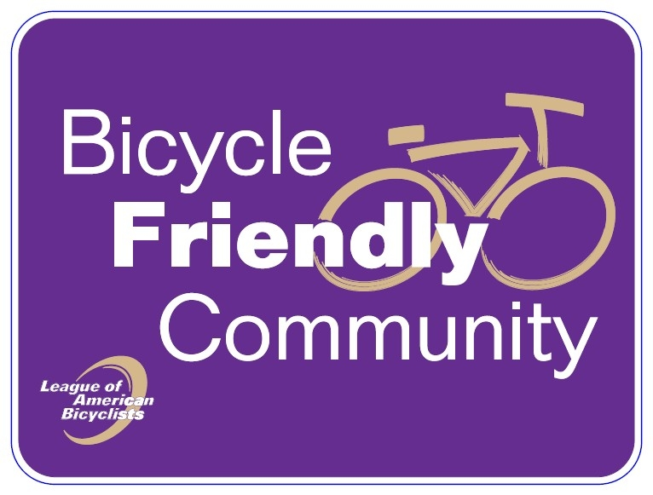
Figure 1 Bicycle Friendly Community Road Sign

Figure 2 Morgantown's Bicycle Friendly Community Seal

