December 2, 2009

Bicycle Board Report to Traffic Commission

Table of Contents
MEMBERSHIP 1
Youth Commission Member 1
EDUCATION 1
Morgantown Effective Bicycling Education Transportation Enhancement Program Grant: 1
ENFORCEMENT 3
Police Training 3
ENCOURAGEMENT 4
Downtown Bicycle Parking 4
Bike Route Map 6
ENGINEERING 6
Campus Connector 6
WV 705 “improvement” 7
MUB Closure of Rail Trail to Install New Sewer Line 7
Shared Lane Markings (Chevrons) 8
EVALUATION 11
EQUALITY 11
APPENDIX – CAMPUS CONNECTOR LETTER 1

MEMBERSHIP

Youth Commission Member
The Bicycle Board recommends that the Traffic Commission appoint Arpan Prabhu to fill the now vacant Youth Commission member seat on the Bicycle Board. Arpan is a senior at Morgantown High School and a strong cyclist. As biking is one of his favorite hobbies, he would like to encourage this active form of transportation among the teenage population of Morgantown. He would like to help the Bicycle Board's efforts to create a more "bicycle-friendly" community and to increase awareness of cyclists on the road.

EDUCATION

Morgantown Effective Bicycling Education Transportation Enhancement Program Grant:

- Arranged to deliver training for the four Driver Education Teachers in Monongalia County on the February 15th Staff Development Day. Driver Ed teachers will learn how to teach students how to drive automobiles in traffic with bicycles.
- Scheduled Confident City Cycling course for 1st, 2nd, and 3rd Saturday of every month through March.
- Ran ad in Dominion Post ad for Confident City Cycling course.

- Two people indicated interest in enrolling in the March class. Five WVU staff members inquired about course delivery at their work site: working out schedule.
- Cancelled November CCC class because of insufficient registration
- Identified LAB endorsed on-line capability for delivery of the classroom portion (approximately 4 hours) of the CCC course
- Will deliver this Saturday, parking lot and road part of CCC class to 3-6 WVU students who will have completed the on-line classroom work by this Saturday.
- Continued planning for outreach including: bringing CCC into local high school driver education, developing an on-line CCC course, TV and radio Public Service Announcements and web sites, forums, e-mail groups, wikis, blogs and twitter.

Grant background:
- On October 21, 2008 Governor Joe Manchin presented the City of Morgantown a Transportation Enhancement Program grant for the Morgantown Effective Bicycling Education Program. On September 4, 2009, WVDOT issued notice to proceed. The state will provide $54,417 and the City will provide a $13,605 required match for a grant total of $68,022. This grant is a response to the application that the City submitted January 2008. The proposed work includes using print and electronic media to educate the community about cyclist and motorist rights and duties with respect to the law and each other and classes in which the League of American Bicyclists’ Traffic Skills 101 course will be delivered.
- A Bicycle Board Education Committee formed and has been planning.
- Re-branded the program “Confident City Cycling”
- Established CCC in PEIA Pathways to Wellness program
- Scheduled regular courses the first 3 Saturdays of every month
- Assistant City Manager established a web site for course information and registration. WVU will cover full costs for WVU students, faculty and staff

ENFORCEMENT

Police Training
Reviewed police training materials and assessed for applicability in Morgantown. Materials include:
- National Highway Traffic Safety Administration training materials for police officers, including:
- A computer-based training program "Enhancing Bicycle Safety: Law Enforcement’s Role": http://bicycledriving.org/enforce
- Enhancing Bicycle Safety: Law Enforcement’s Role is also on CD-ROM: http://www.nhtsa.dot.gov/portal/site/nhtsa/template.MAXIMIZE/menuitem.b667872a33dbc6bbbf30811060008a0c/?javax.portlet.tpst=4670b93a0b088a006bc1d6b760008a0c_ws_MX&javax.portlet.prp_4670b93a0b088a006bc1d6b760008a0c_viewID=detail_view&itemID=77a9682bf9352110VgnVCM1000002c567798RCRD&overrideViewName=Article
- Law Enforcement's Roll Call Video: "Enforcing Law for Bicyclists"—short video was developed by NHTSA to provide a review of the importance of law enforcement for bicycle safety and highlight the steps officers can take to enhance the safety of all road users, especially cyclists. It describes common violations, discusses the importance of reporting bicycle crashes, and provides additional resources for officers: http://www.nhtsa.gov/multimedia/bicycles/bicycle_safety_LE.wmv
- Chicago training video developed by the Chicago police department for the Chicago police department: http://www.chicagobikes.org/video/index.php?loadVideo=police_training_2009 . This video is excellent as it shows Chicago laws that pertain to bicycling and exact officer procedures for citing violations.
- Florida Bicycle Law Enforcement Guide http://www.floridabicycle.org/resources/pdfs/FBLEG072007.pdf
- Massachusetts Massbike Police Officer Training: http://www.massbike.org/police/
- International Police Mountain Bike Association (IPMBA) training tool links: http://www.ipmba.org/newsletter-0509-enforcement.htm
- North Carolina NCDOT's bicycle driver manual, Streetwise Cycling: http://www.ncdot.org/transit/bicycle/safety/safety_Streetwise_cycling.html

ENCOURAGEMENT

Downtown Bicycle Parking
- Participated in informal November 11 Parking Authority meeting at which the Parking Authority Director presented post-and-loop parking rack design, the 17 proposed parking meters to which they will be attached and the 4 locations at the Public Safety Center where they will be installed under the building overhangs. All members appeared to favor the plan. The Parking Authority will formally vote on it at their December meeting. If they approve, the next step will be for the city to purchase the racks and the parking authority to install them.
- Presented High Street parking plan to Mainstreet Morgantown Design Committee November 12. In addition to the 17 racks that will be attached to parking meters, the plan includes 3 stand-alone racks that will need to be installed in the sidewalks at locations where there is a parking demand but no parking meters. Subsequently, the Design Committee recommended to the Mainstreet Morgantown Board of Directors that they approve the plan and they did. The Bicycle Board is expecting a letter of approval from Mainstreet Morgantown this week.

Background - Downtown Bicycle Parking
- Selected post-and-loop design for short-term on street bicycle parking.
Post-and-Loop Bicycle Parking Rack
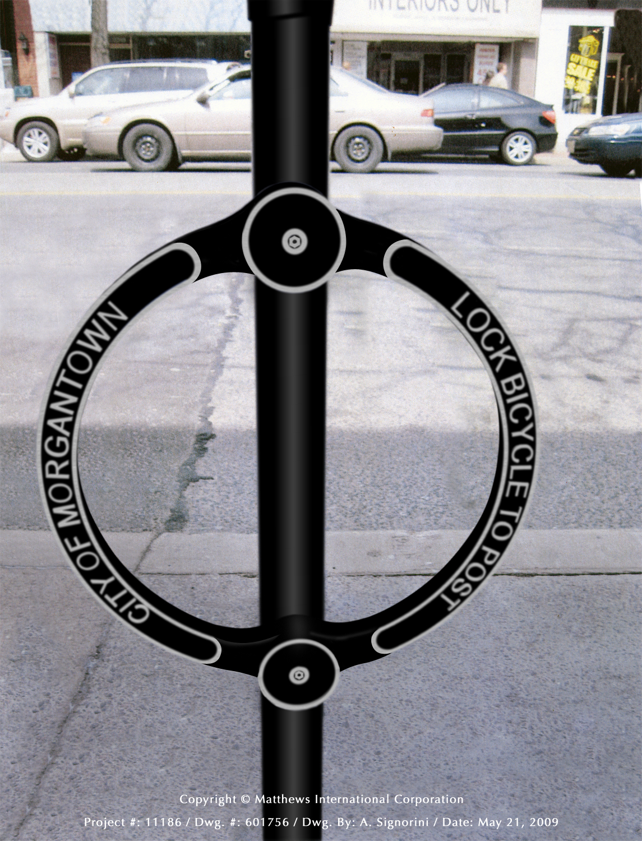
- Laid out recommended parking rack locations on High Street Streetscape map
- Created photo library on City web site http://www.morgantown.com/bike-board-documents/tm/index.htm of each planned location to reveal potential conflicts.
- Created estimate and City identified budget for the parking devices.
- Presented design and location plan to Mainstreet Morgantown Design Committee and received unanimous support.
- Reviewed design with City Public Works and Engineering. City Engineer reviewing locations and preparing final location map.
- Presented design and location plan to Mainstreet Morgantown Director and received letter of support.
- Presented parking device design and location plan to Mainstreet Morgantown merchants. Two merchants expressed concern that the parking devices will clutter High Street and that parked bicycles will interfere with pedestrian traffic.
- Received from City Engineer, drawings showing the proposed locations for the bicycle racks in downtown. The Bicycle Board originally proposed twenty-five. The City Engineer removed one due to its location. The remaining twenty-four are approved solely with respect to ADA requirements and structural requirements with respect to existing facilities within the sidewalk. No approval is being made with respect to the number of bicycle racks to be installed. These locations were based on the proposed locations submitted by the Bicycle Board and do not reflect any input from the City of Morgantown in regards to the number and placement of the racks other than the aforementioned requirements. A couple of notes include:
1. No posts can be installed within the stamped concrete portion of the sidewalks.
2. Two racks are proposed on private property. Prior to any placement, the appropriate agreements must be obtained from the property owner.
- Received letter in October 2009 from Mainstreet Morgantown Board of Directors approving Mainstreet Morgantown Design Committee recommendations that bike racks be located in offsets and setbacks that do not interfere with pedestrian traffic. This recommendation has three goals:

- Provide a safe, secure and convenient place for bicycles to be parked.

- Do not interfere with pedestrian traffic.

- Do not take up motor vehicle parking spaces.

- The Design Committee asks that the Bicycle Board present to the Design Committee locations that support these goals.
- Revised High Street locations of post-and-loop parking devices to move them from the simulated red brick to white concrete.
- Photographed each location.
- Provided revised locations to City Engineer’s office. Assistant City Engineer revised drawings to show revised locations.
- Met with Parking Authority Director and reached agreement to install bicycle parking loops on parking meter posts.
- Identified 17 parking meter posts that are in high bicycle parking demand locations, provide good security, minimize interference with sidewalk users and don’t interfere with other objects such as courtesy ticket collection boxes and tree boxes.
- Presented recommended meter posts to Parking Authority Director November 3.

Bike Route Map
- Developed preliminary route classification system that will consider Popularity among cyclists, Steepness of terrain, Motor vehicle speed, Motor traffic volume, Motor traffic capacity, Lane width, Visibility/Sight-line length, Road condition, Shoulder or no shoulder, etc.

Background – Bike Route Map
- Produced a map of Morgantown streets indicating those which bicyclists use most frequently.
- Presented the Bike Route map at the WVU Intermodal Transportation Facility, Mountaineer Station on October 19.

ENGINEERING

Campus Connector
- The Bicycle Board recommends that the Traffic Commission request of City Staff to investigate and identify property ownership within the general alignment of the Connector so that an earnest discussion with these area property owners and the City could commence. See letter in Appendix at the end of this report.

Background – Campus Connector
- The Campus Connector was included in the Bicycle Board’s February 7, 2007 Recommendations to the Traffic Commission (see page 2 at http://www.morgantown.com/bike-board-documents/Recommendations_070205_v2.0.pdf) . The Traffic Commission approved those recommendations.
- The Morgantown Pedestrian Safety Board also recommended the Campus Connector in the February 4, 2009 Pedestrian Safety Plan that it presented to the Traffic Commission (see project #56 on page 40 of http://www.morgantown.com/traffic-docs/Pedestrian_Safety_Board/MTown%20Ped%20Safety%20Plan%20FINAL%201_27_2009.pdf ). The Traffic Commission also approved that plan.

WV 705 “improvement”
- Waiting since October for WVDOH to install SHARE THE ROAD and YIELD TO BIKES signs.
- In informal communications, WVDOH representative said signs will be installed in “coming months”.

Background – WV 705
- Widening and repaving 705 between Stewartstown and Mileground eliminated shoulders and walkways.
- In October 2009, met with MPO and WVDOT officials and recommended SHARE THE ROAD and YIELD TO BIKES signs.

MUB Closure of Rail Trail to Install New Sewer Line
- Waiting since September for WVDOH evaluation of recommended bike lane and signage.

Background – Rail Trail Closure

- At the June 2009 Traffic Commission meeting, the Bicycle Board recommended and the Traffic Commission approved the following recommendations:

At least 6 months before the trail is closed:
- Install “Share the Road” and “Bike Route” signs every 250 feet on Beechurst Ave., Mon Blvd., Don Knotts Blvd. and University Ave.
- Install a bike lane going up the hill on Mon Blvd. between Eighth St. and Evansdale Drive. Keep the bike lane free of debris.

Also at the June 2009 meeting, the Bicycle Board provided the following recommendations which the Traffic Commission held in abeyance pending the Traffic Commission gathering additional information on the trail closure:
- Establish cycling detours around the trail but as close to the trail as reasonable. (Consider the businesses that depend on trail traffic. Remember Whitetail?)
- Complete the work in sections to minimize the impact on cyclists and businesses.
- Created specification for Bike Lane on the climbing side of Monongahela Blvd. between Eighth Street and Evansdale Drive.
- Met with City Manager, City Engineer and MPO Director to review the Bike Lane design and to define roles and responsibilities in getting WV DOH approval. MPO Director will take the lead.
- In August 2009, recommended to the Assistant City Engineer, specifications for a bike lane on the climbing side of Monongahela Blvd. and Share the Road signs on the descending side plus the length of Monongahela Blvd/Beechurst Ave/Don Knotts Blvd, the Assistant City Engineer. Assistant City Engineer developed drawings and a presentation package for presentation to the MPO TAC which includes WVDOT and WVDOH representatives.
- In September 2009, participated in Mon Blvd bike lane presentation to MPO TAC. The WVDOT agreed to review the Monongahela Blvd bike lane concept for conformance to prevailing standards but resists installing the bike lane or funding it.

Shared Lane Markings (Chevrons)
- Researching 15 other cities that have installed shared lane markings to develop a justification for applying them in Morgantown or to identify a useful experiment with them.

Background - Shared Lane Markings
On July 11, 2007, the Traffic Commission unanimously approved the Bicycle Board’s recommendation for the City to apply the Shared Lane Markings to specific roads in Morgantown.

On May 22, 2008 Paul Maddox, Secretary of the WV DOT, in a letter to Morgantown City Manager, Dan Boroff, authorized the City of Morgantown to apply Shared Lane Markings and to install Bicycles May Use Full Lane signs to guide bicyclists to the appropriate position on the roadway and to remind motorists that bicyclist have the same rights and are subject to the same duties as drivers of motor vehicles.

On June 13, 2008, Terry Hough requested the Bicycle Board to provide a map that she could include in the request for bids from contractors to install the Shared Lane Markings and Bicycles May Use Full Lane signs.

The Bicycle Board presents the map to the Traffic Commission at its December meeting.

The Shared Lane Markings are in the new FHWA Manual of Uniform Traffic Control Devices (MUTCD) slated for approval at the end of this year.

In other cities such as San Francisco in which the Shared Lane Markings have been used, scientifically conducted studies showed that bicyclists are more likely to

- Drive in the direction of traffic flow,
- Drive on the right side of the road,
- Not drive on sidewalks, and
- Position themselves on the roadway to avoid colliding with opening doors of parked cars.

The studies also showed that when Shared Lane Markings are present, motorists are more aware of bicycles and give them a little more room when passing. Almost 2 years ago, Pittsburgh installed Shared Lane Markings on select streets and bicycle use has increased.

The new signs state that “Bicycles May Use Full Lane.” These signs are also in the new MUTCD. When the City sought WVDOH approval for the Shared Lane Markings, the WVDOH required a Bicycles May Use Full Lane sign to be placed along with the Shared Lane Markings. However, to minimize costs, the City negotiated to place the signs at the beginning of each run of Shared Lane Markings and in locations in which the sign would convey a clearer message than the Shared Lane Markings.

The Shared Lane Markings and Bicycles May Use Full Lane signs would be placed on Morgantown streets that bicyclists would use more if they knew they could ride on them. These streets include University Avenue, Patteson Drive, Van Voorhis Road, Collins Ferry Road, Beechurst Avenue, High Street, Spruce Street, Stewart Street, Willowdale Road, South University Avenue, Dorsey Avenue, Willey Street, Charles Avenue, Richwood Avenue, Rt. 7 in Sabraton, and Decker Boulevard.

In the process of approving the City’s plan for Shared Lane Markings, the WVDOH also agreed to install Share The Road signs on state routes leading into and around the City including Monongahela Boulevard, South University Avenue, the Mileground, and Greenbag Road.

Since the WVDOH approved our application, personnel changes have led to their reconsidering their approval. An October 30, 2008 letter from Paul Maddox retracted his May 22 approval.

In a December 17, 2008 e-mail from Ray Lewis, WVDOH Staff Engineer Traffic Research and Special Projects to Bill Robinson, WVDOH Trails Coordinator, Lewis said, “From our perspective, the City presently has two alternatives open to them:

1) Apply for a permit (where State-maintained streets are involved and install SHARE THE ROAD signs, which are an approved traffic control device; or

2) File a request with the FHWA for Permission to Experiment with either or both of these new traffic control devices; the DOH would entertain a permit application for any affected State facilities, once the City has this in hand.”

EVALUATION
No activity

EQUALITY
The League of American Bicyclists has adopted a 6th E: Equality, defined as equal legal status and equal treatment of cyclists in traffic law. All US states must adopt fair, equitable and uniform traffic laws that are “vehicle-neutral” to the greatest extent possible. Cyclists’ ability to access all destinations must be protected. State and local laws that discriminate against cyclists, or restrict their right to travel, or reduce their relative safety, must be repealed.
- Reviewed Morgantown Bicycle Code article 373 and identified preliminary changes.
- Reviewed unofficial preliminary draft WVDOH Bicycle/Pedestrian plan and provided comments to WVDOH.

APPENDIX – CAMPUS CONNECTOR LETTER

TO: Morgantown Traffic Commission

FROM: Morgantown Municipal Bicycle Board

SUBJECT: Campus Connector

DATE: November 30, 2009

Transportation between the Evansdale and Downtown campuses as well as throughout the Sunnyside area has been problematic for years. The lack of a convenient option to connect these two areas discourages citizens from using alternative modes such as walking and bicycling and creates increased pressure on the street system as many residents of the Sunnyside area and those commuting between the two campuses are compelled to use cars to travel back and forth within this short distance.

A long standing goal has been to construct a connection from Sunnyside directly to the Evansdale campus. The Campus Connector that would provide this unburdened route extending from 8th Street up a Grant street alignment to the top of the hill by the water tower and WVU greenhouses provides that path and has been discussed for years. The major stumbling block to seeing the Connector a reality has always been obtaining adequate right-of-way from private land owners. Obviously without the correct right-of-way and alignment, the construction cannot occur.

The Morgantown Municipal Bicycle Board at their regularly scheduled November 5, 2009 meeting discussed several methods to promote the Campus Connector and move the project forward. It was the consensus of the Bicycle Board that a clear and positive approach in this matter would be to recommend that the Traffic Commission request of City Staff to investigate and identify property ownership within the general alignment of the Connector so that an earnest discussion with these area property owners and the City could commence. Once ownership has been identified, the Bicycle Board believes a planning process can begin that would move the project forward.

It is the Bicycle Board’s hope that the Traffic Commission holds this same interest in the Campus Connector and can move this request directly to the City Council and City Staff for their consideration and action.

