Agenda

EDucation Committee
Date: | Tue Feb. 15, 2011 |  | Objective: | 2011 plans completed so they can be implemented immediately
Time: | 8:30-10:30 am |  | Participants: | Chip Wamsley, Ryan Post, gunnar Shogren, Hugh Kierig, Frank Gmeindl
Location: | PSC Training Room |  | Leader: | Frank Gmeindl
Location: | PSC Training Room |  | Facilitator:
Location: | PSC Training Room |  | Scribe: | Frank Gmeindl

Start Time | Duration (min.) | Topic | Discussion Leader | Desired Outcome
8:30 AM | 5 | - Agenda | Gmeindl | All understand and agree on agenda
8:35 AM | 15 | - Billboards | “ | Locations and schedule defined
8:50 AM | 15 | - Video spots | “ | Stations and schedule defined
9:05 AM | 10 | - Newspaper ads | “ | Publishers, content and schedule defined
9:15 AM | 15 | - Courses and course delivery | “ | Confirmation
9:30 AM | 60 | - Course marketing | “ | Marketing plan defined
10:30 AM |  | - Newspaper Articles | “ | Remaining articles confirmed. New DP section confirmed.
10:30 AM |  | - Anything else | “
10:30 AM |  | - Adjourn | “

Minutes
ACTION ITEMS
Due Date | Responsibility | Action Item
3/31/11 | Wamsley | 70. Negotiate deals with the various owners of billboards
3/31/11 | Wamsley | 71. Negotiate a deal with Comcast for video spots
2/15/11 | Gmeindl | 72. Work with Gary Rodosta to modify the newspaper ad
2/15/11 | Kierig | 73. Arrange for Commuter class press release in DA.
TBD | Gmeindl | 74. Develop Commuter class press release with WVU
2/15/11 | Kierig | 75. Reserve BikeMorgantown booth for May 9 WVU Employee Fest
2/17/11 | Gmeindl | 76. Work with Jeff Mikorski to get the ads published in the Dominion Post and the DA
2/15/11 | Gmeindl | 77. Write gunnar a description and set a time for the Commuter course
2/15/11 | g. Shogren | 78. Add Commuter course to BikeMorgantown.com calendar
2/28/11 | Wamsley | 79. Investigate options with the SignFactory to make a banner out of our current billboard
2/15/11 | g. Shogren | 80. Put National Bike Week and National Bike to Work Day on the BikeMorgantown.com calendar

DISCUSSION

Billboards
- Electronic billboards will be located at 4 locations: 1) North end Star City Bridge heading out of town; 2) Mileground near 705 heading into town; 3) Easton Hill heading out of town; 4) 119 coming into town from I-68 exit 1.
- Billboards will be displayed April-May and mid-August – mid-September.
- Chip will negotiate deals with the various owners of the various billboards.
The first billboard up will be the same billboard we displayed on Easton Hill last year. 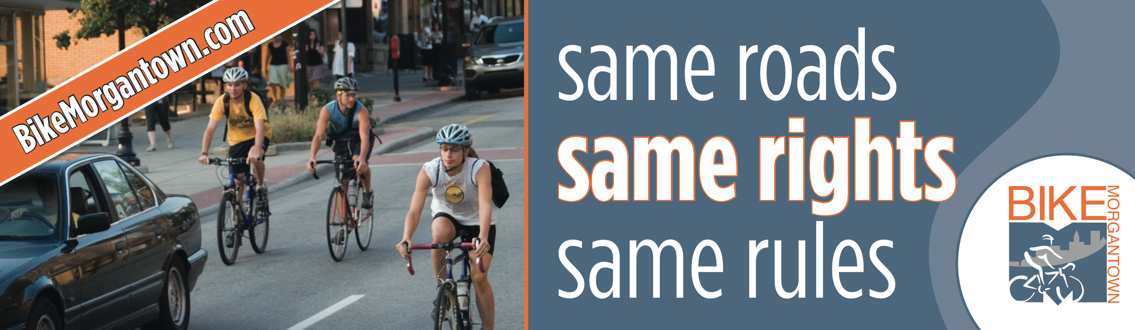 We will continue to work with Gary Rodosta to create billboards with other messages:
• 4 Wheels, 2 Wheels, 1 Road: Let’s Roll Together
• Drive Nice, Bike Nice
• A Bicycle Friendly Morgantown is a (changing adjective) Community
Changing adjective: Healthier, Greener, Smarter
- For Confident City Cycling
CLICK
(downward pointing arrow)
BikeMorgantown.com

Video Spots
- We will run the same 7 spots on the same channels as last year: Discovery, tbs, CNN, Comedy Central, CMT and Travel Channel on Comcast and Morgantown public access channel 15.
- Spots will be aired nominally the same time as the billboards: April-May and mid-August – mid-September.
- Chip will negotiate a deal with Comcast.

Newspaper Ads
- We will run ads in the Dominion Post and the Daily Athenaeum ASAP to announce the classes beginning in March.
- We will use the same ad that we ended up last year but with the following modifications:
  - Replace the photo of the kid with the photo on taken on High St. of gunnar, Betsy and Ryan that appears on the Same Roads, Same Rights, Same Rules billboard (attached).
  - Replace "REDISCOVER the JOY and FREEDOM of riding your bicycle!" with the "Lose Your Fear and Learn to Ride with Confidence"
- Frank will work with Gary Rodosta to modify the ad.
- Frank will work with Jeff Mikorski to get the ads published in the Dominion Post and the DA.

Courses and Course Delivery
- We will add a Confident City Cycling Commuter Cycling course Saturday, May 14. This is in addition to the Confident City Cycling Traffic Skills 101 classes scheduled in bite-size chunks every Monday night or full-course weekends one weekend each month March – September.
- WVU will conduct Employee Fest 10 am – 10 pm May 9 in the Mountainlair. Hugh will reserve a BikeMorgantown booth at which we will advertise Confident City Cycling and the new Commuter course.
- According to LAB TS101 is a prerequisite for Commuter but we plan to make it a soft prerequisite.
- gunnar will show National Bike Week and National Bike to Work Day on the calendar at BikeMorgantown.com
- Frank will write gunnar a description and set a time for the Commuter course
- gunnar will add the Commuter course to the BikeMorgantown.com calendar.
- We discussed making for the WVU Employee Fest a banner of the current billboard but didn’t decide who would do it. Chip agreed to investigate options with the SignFactory.

Course Marketing
- We decided to increase the price of TS101 to $60 offer a discount to $45 for groups of 2 or more but we didn’t decide how that would work out for the Monday night classes.
- We discussed posters and decided at a minimum to make a poster of the revised newspaper ad described above. The poster will have a pocket with the CCC business cards that people can take.
- We discussed some symbol of TS101 successful completion that others would lust after and that would incentivize them to take the course. We discussed water bottles. We didn’t make any decisions.

