April 23, 2012
(For May 2, 2012 Traffic Commission meeting)

Bicycle Board Report to Traffic Commission

HIGHLIGHTS

Accomplishments
- Parking Authority installed 2 bicycle lockers at 2 city garages: Public Safety Center and Wharf Street.
- Presented Greater Morgantown Bicycle Plan to City Council Committee of the Whole March 27.
- Presented Greater Morgantown Bicycle Plan to City Council Committee at the regular meeting May 1.
- Delivered Confident City Cycling course to 12 WVU students at WVU Coliseum the weekend of March 10-11.
- Delivered Confident City Cycling course to 15 WVU students every Tuesday and Thursday March 20 – April 26.
- Arranged to have Confident City Cycling offered both WVU Summer sessions.
- On April 17, met with City government and MPO to plan May 1 presentation of Greater Morgantown Bicycle Plan to City Council.
- On April 20, met with the City, Pedestrian Safety Board, Mon River Trails Conservancy, BOPARC and WVU extension to ensure safety and accommodation of bicyclists and pedestrians at the new Walgreen’s that will replace Southern States at the intersection of Rt. 7 and Green Bag Rd.

Plans for Next Month
- May is National Bike Month;
May 9 is National Bike to School Day;
May 14-18 is National Bike to Work week and
May 18 is National Bike to Work Day!
- Participate in WVDOT Statewide Bicycle Connectivity workshop May 15, 4-7 pm in Council Chambers.
- Monitor and support City Council action on Greater Morgantown Bicycle Plan.
- Attend next SPAN meeting and develop requested bicycle safety program.
- Support MPO-led Bike to Work Week, May 14-18.
- Monitor status of grant application due February 29 to Bikes Belong for $10K to support Mon Blvd. bicycle climbing lane from Eighth St. to Evansdale Dr.
- Receive League of American Bicyclists evaluation of Morgantown’s application for Bicycle Friendly Community recognition. (Official LAB announcement due May 14.)
- Continue to support City efforts to install a bicycle-climbing lane on Mon Blvd. and to install Share the Road signs along the Mon Blvd., Beechurst, Don Knotts, South University corridor.
- Continue to coordinate with WVDOH to replace in-line drainage grates.
- Continue to study unicycling in Morgantown and develop recommendations.
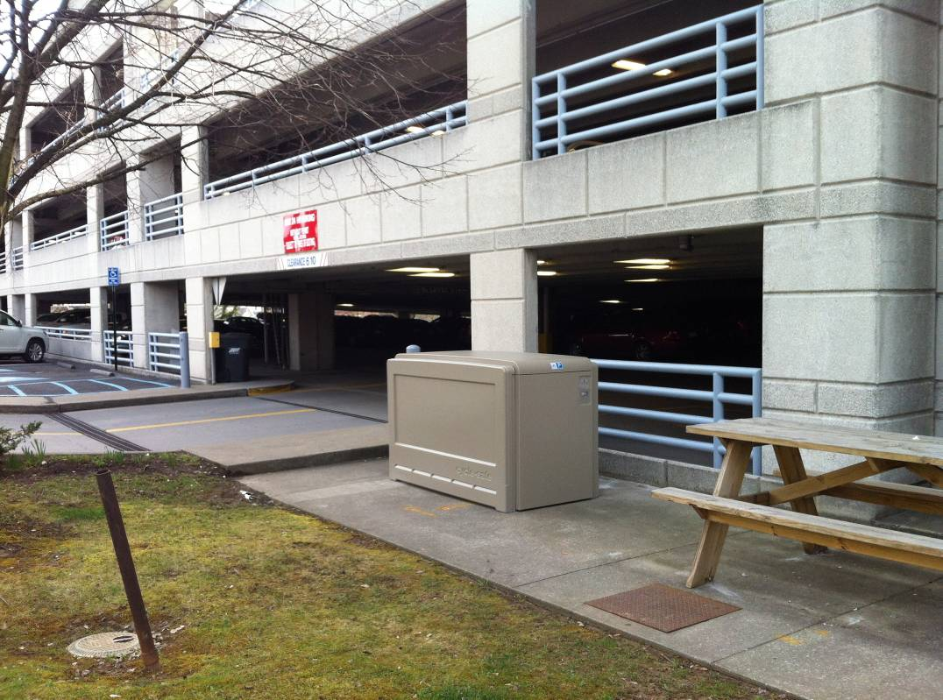
Figure 1 Bicycle locker at Public Safety Center Garage

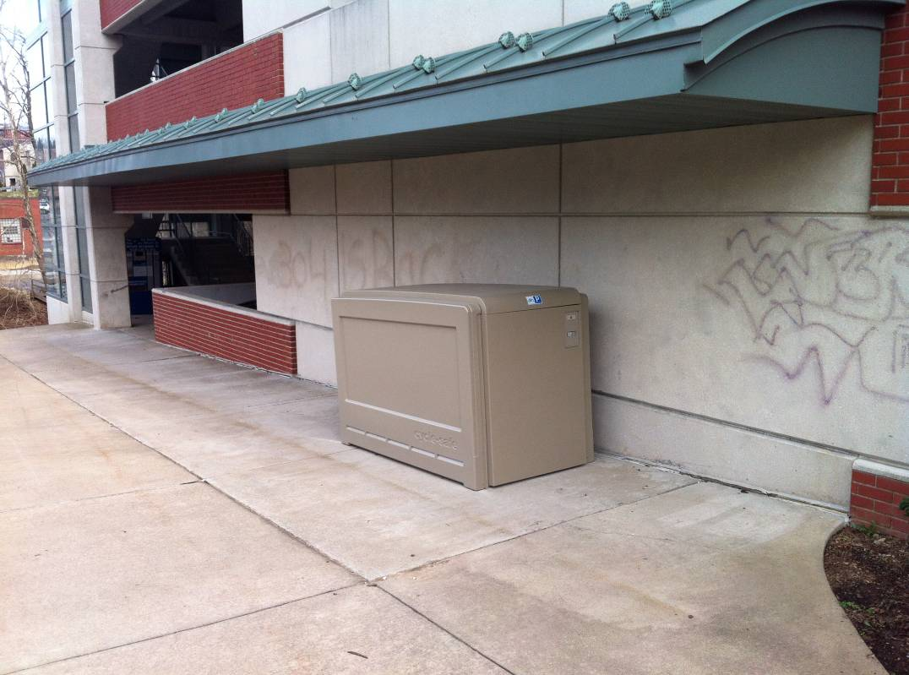
Figure 2 Bicycle locker at Wharf Street Garage

