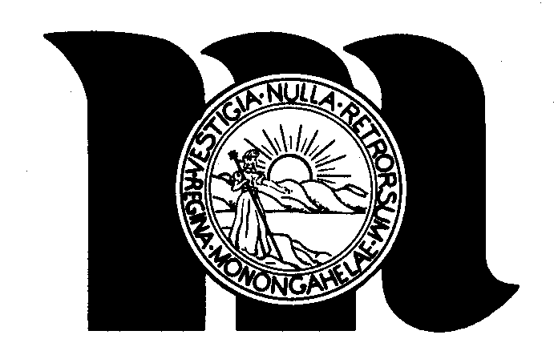
The City of Morgantown
389 Spruce Street
Morgantown, West Virginia 26505
(304) 284-7439
Office of the Mayor

Proclamation

Whereas, for more than a century, the bicycle has been an important part of the lives of most Americans; and

Whereas, today, millions of Americans engage in bicycling as an environmentally sound form of transportation, an excellent form of fitness, and provides quality family recreation; and

Whereas, the education of cyclists and motorists as to the proper and safe operation of bicycles is important to ensure the safety and comfort of all users; and

Whereas, the League of American Bicyclists and independent cyclists throughout our state are promoting greater public awareness of bicycle operation and safety education in an effort to reduce accidents, injuries and fatalities; and

Whereas, The City of Morgantown has established a Municipal Bike Board to provide guidance and leadership in improving the friendliness and safety of the City for bicycling; and

Whereas, Morgantown is working to become recognized as a bronze level Bicycle Friendly Community by the League of American Bicyclists;

Now Therefore, I, Bill Byrne, Mayor of the City of Morgantown do hereby proclaim the month of May 2010 as

Bike Month

In the City of Morgantown and encourage all citizens to support bicycling within our community and to enjoy this activity’s many benefits.

In Witness Thereof, I hereunto set my hand and caused the seal of the City of Morgantown to become hereto affixed this 4th day of May 2010.

Seal:
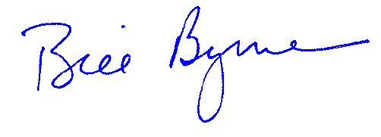

__________________________________
Bill Byrne, Mayor

