November 4, 2009

Bicycle Board Report to Traffic Commission

Table of Contents
MEMBERSHIP 1
EDUCATION 1
Morgantown Effective Bicycling Education Transportation Enhancement Program Grant: 1
ENFORCEMENT 3
ENCOURAGEMENT 4
Downtown Bicycle Parking 4
Bike Route Map 7
ENGINEERING 8
WV 705 “improvement” 8
MUB Closure of Rail Trail to Install New Sewer Line 8
Shared Lane Markings (Chevrons) 9
EVALUATION 1

MEMBERSHIP

- Youth Commission Member

Two Youth Commission members have expressed interest in serving on the Bicycle Board. They will attend tomorrow’s regular Bicycle Board meeting. The Youth Commission may select one this month.

EDUCATION

Morgantown Effective Bicycling Education Transportation Enhancement Program Grant:

- Branded the program “Confident City Cycling”
- Established CCC in PEIA Pathways to Wellness program
- Dominion Post ad for CCC course runs this week
- Classes begin Saturday
- Scheduled regular courses the first 3 Saturdays of every month
- Assistant City Manager established a web site for course information and registration
- WVU will cover full costs for WVU students, faculty and staff
- Continued planning for outreach including: bringing CCC into local high school driver education, developing an on-line CCC course, TV and radio Public Service Announcements and web sites, forums, e-mail groups, wikis, blogs and twitter.

Grant background:

On October 21, 2008 Governor Joe Manchin presented the City of Morgantown a Transportation Enhancement Program grant for the Morgantown Effective Bicycling Education Program. On September 4, 2009, WVDOT issued notice to proceed. The state will provide $54,417 and the City will provide a $13,605 required match for a grant total of $68,022. This grant is a response to the application that the City submitted January 2008. The proposed work includes using print and electronic media to educate the community about cyclist and motorist rights and duties with respect to the law and each other and classes in which the League of American Bicyclists’ Traffic Skills 101 course will be delivered.

ENFORCEMENT

ENCOURAGEMENT

Downtown Bicycle Parking
- Met with Parking Authority Director and reached agreement to install bicycle parking loops on parking meter posts.
- Identified 21 parking meter posts that are in high bicycle parking demand locations, provide good security, minimize interference with sidewalk users and don’t interfere with other objects such as courtesy ticket collection boxes and tree boxes.
- Presented recommended meter posts to Parking Authority Director.
- Parking Authority Director will present to Parking Authority at their 3 pm November 11 regular monthly meeting.
- Revised High Street locations of post-and-loop parking devices to move them from the simulated red brick to white concrete.
- Photographed each location.
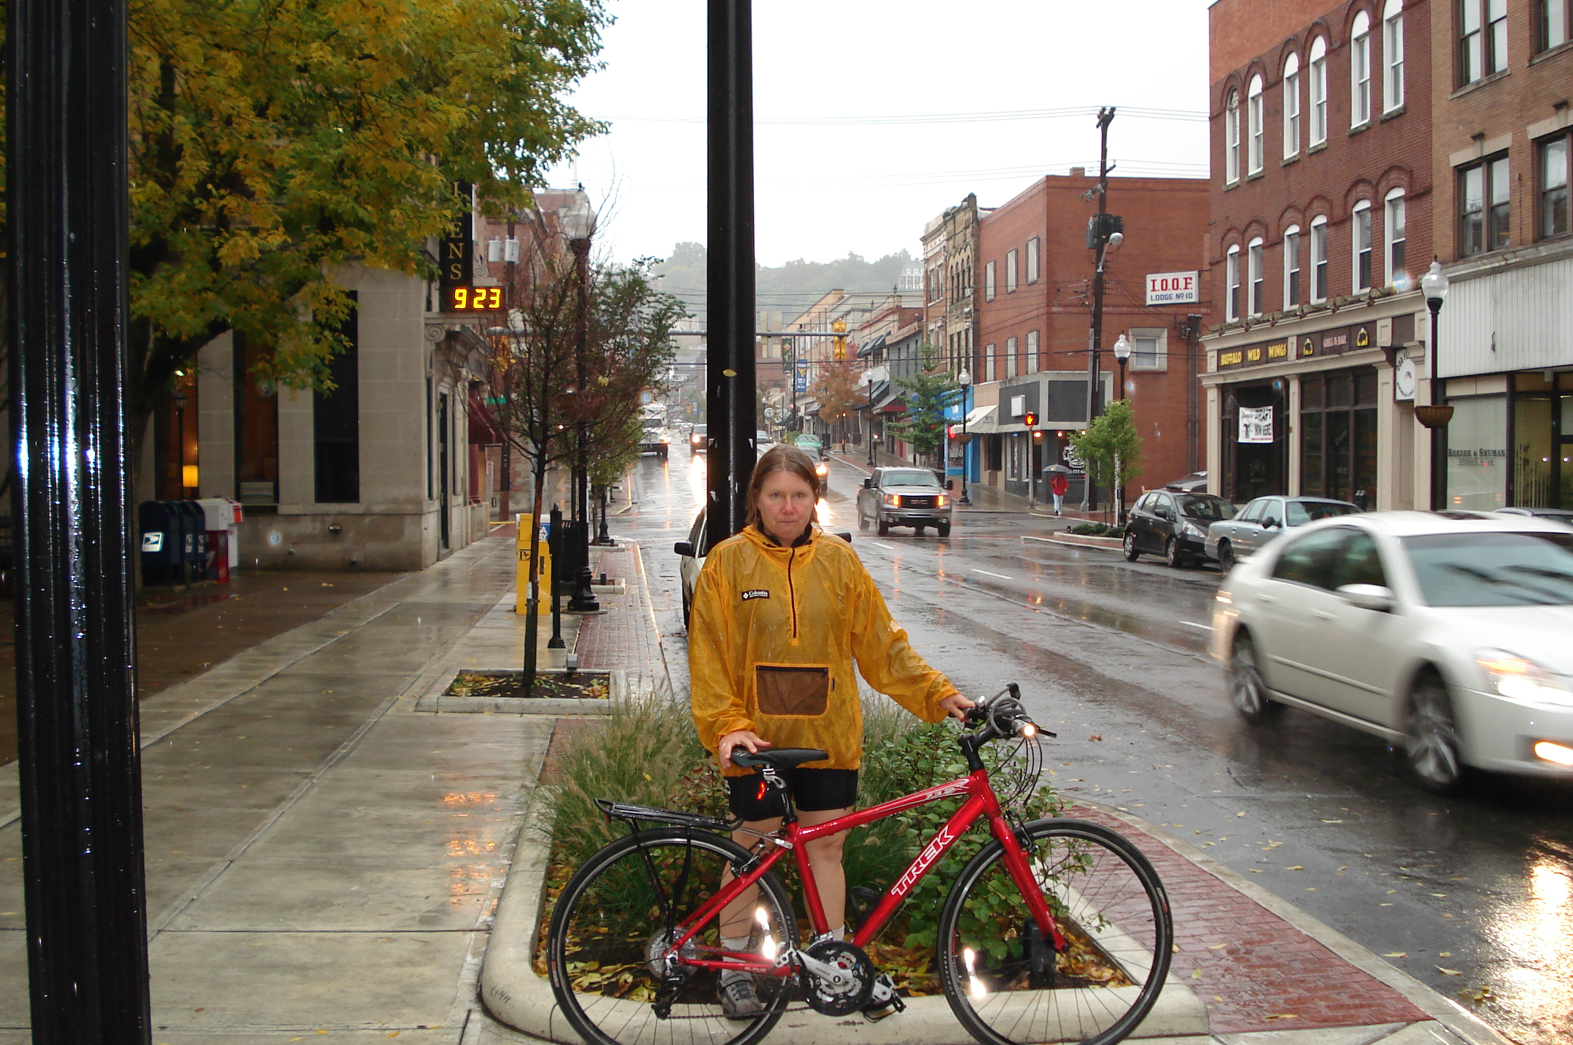
- Provided revised locations to City Engineer’s office. Assistant City Engineer revised drawings to show revised locations.
- Scheduled to present revised locations to Mainstreet Morgantown Design Committee November 12.

Downtown Bicycle Parking Background (most recent first)
- Received letter in October 2009 from Mainstreet Morgantown Board of Directors approving Mainstreet Morgantown Design Committee recommendations that bike racks be located in offsets and setbacks that do not interfere with pedestrian traffic. This recommendation has three goals:

- Provide a safe, secure and convenient place for bicycles to be parked.

- Do not interfere with pedestrian traffic.

- Do not take up motor vehicle parking spaces.

The Design Committee asks that the Bicycle Board present to the Design Committee locations that support these goals.
- Received from City Engineer, drawings showing the proposed locations for the bicycle racks in downtown. The Bicycle Board originally proposed twenty-five. The City Engineer removed one due to its location. The remaining twenty-four are approved solely with respect to ADA requirements and structural requirements with respect to existing facilities within the sidewalk. No approval is being made with respect to the number of bicycle racks to be installed. These locations were based on the proposed locations submitted by the Bicycle Board and do not reflect any input from the City of Morgantown in regards to the number and placement of the racks other than the aforementioned requirements. A couple of notes include:
1. No posts can be installed within the stamped concrete portion of the sidewalks.
2. Two racks are proposed on private property. Prior to any placement, the appropriate agreements must be obtained from the property owner.
- Presented parking device design and location plan to Mainstreet Morgantown merchants. Two merchants expressed concern that the parking devices will clutter High Street and that parked bicycles will interfere with pedestrian traffic.
- Presented design and location plan to Mainstreet Morgantown Director and received letter of support.
- Reviewed design with City Public Works and Engineering. City Engineer reviewing locations and preparing final location map.
- Presented design and location plan to Mainstreet Morgantown Design Committee and received unanimous support.
- Created estimate and City identified budget for the parking devices.
- Created photo library on City web site http://www.morgantown.com/bike-board-documents/tm/index.htm of each planned location to reveal potential conflicts.
- Laid out recommended parking rack locations on High Street Streetscape map
- Selected post-and-loop design for short-term on street bicycle parking.

Post-and-Loop Bicycle Parking Rack
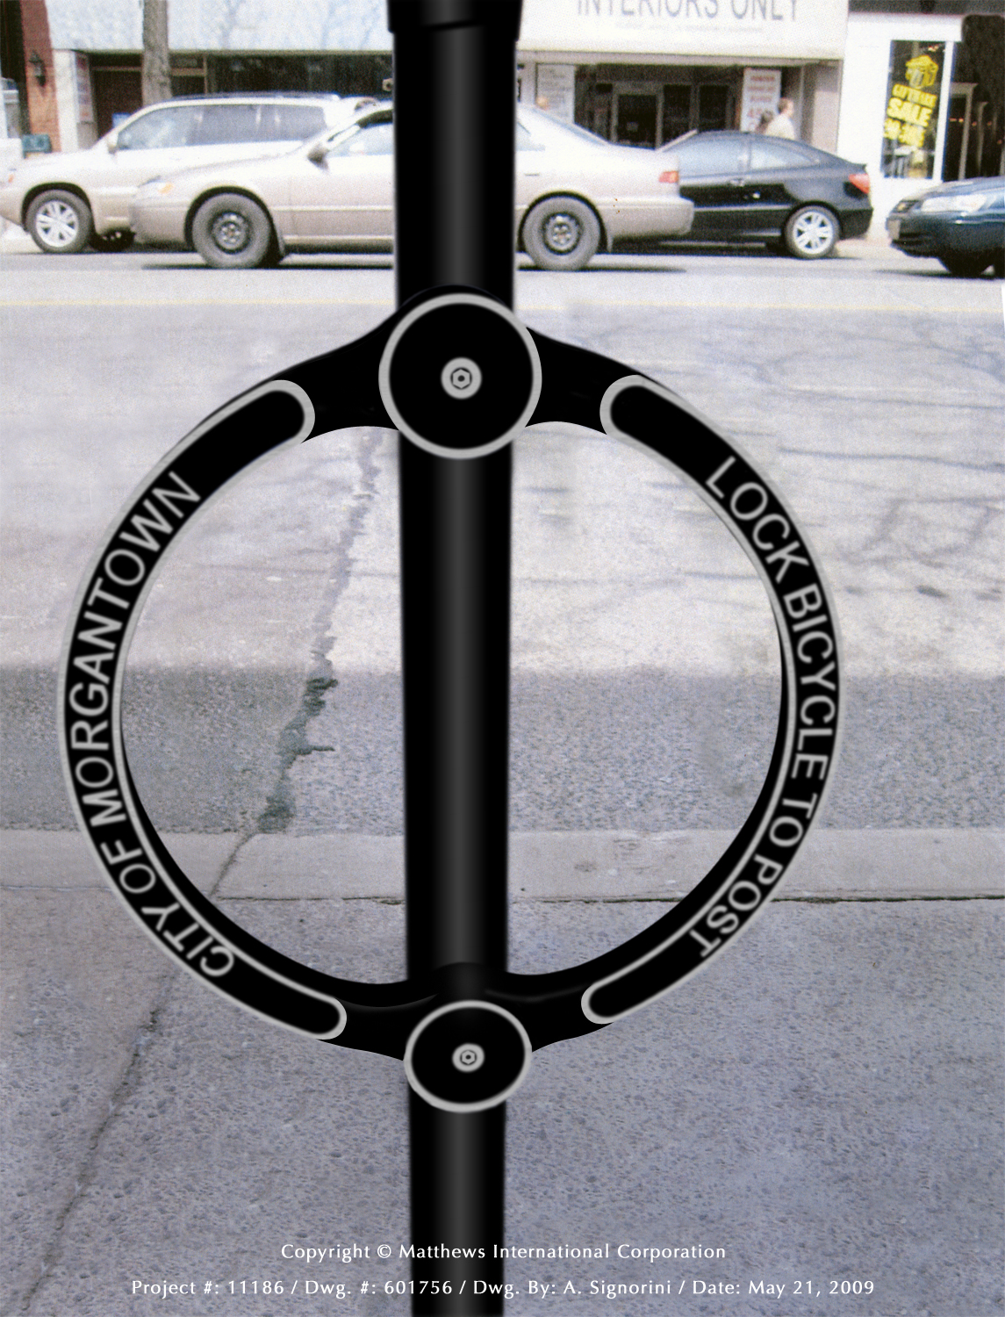

Bike Route Map
- Produced a map of Morgantown streets and indicating those which bicyclists use most frequently.
- Presented the Bike Route map at the WVU Intermodal Transportation Facility, Mountaineer Station on October 19.
- At tomorrow’s regular monthly Bicycle Board meeting, will finalize a route classification system and plan route classification activity.

ENGINEERING

WV 705 “improvement”
- Met with MPO and WVDOT officials and recommended SHARE THE ROAD and YIELD TO BIKES signs.
- Widening and repaving 705 between Stewartstown and Mileground eliminated shoulders and walkways.

MUB Closure of Rail Trail to Install New Sewer Line
- Awaiting WVDOT evaluation of recommended bike lane and signage

Background

- In September 2009, participated in Mon Blvd bike lane presentation to MPO TAC. The WVDOT agreed to review the Monongahela Blvd bike lane concept for conformance to prevailing standards but resists installing the bike lane or funding it.
- In August 2009, recommended specifications for a bike lane on the climbing side of Monongahela Blvd. and Share the Road signs on the descending side plus the length of Monongahela Blvd/Beechurst Ave/Don Knotts Blvd, the Assistant City Engineer. Assistant City Engineer developed drawings and a presentation package for presentation to the MPO TAC which includes WVDOT and WVDOH representatives.
- At the June 2009 Traffic Commission meeting, the Bicycle Board recommended and the Traffic Commission approved the following recommendations:

At least 6 months before the trail is closed:
- Install “Share the Road” and “Bike Route” signs every 250 feet on Beechurst Ave., Mon Blvd., Don Knotts Blvd. and University Ave.
- Install a bike lane going up the hill on Mon Blvd. between Eighth St. and Evansdale Drive. Keep the bike lane free of debris.

Also at the June 2009 meeting, the Bicycle Board provided the following recommendations which the Traffic Commission held in abeyance pending the Traffic Commission gathering additional information on the trail closure:
- Establish cycling detours around the trail but as close to the trail as reasonable. (Consider the businesses that depend on trail traffic. Remember Whitetail?)
- Complete the work in sections to minimize the impact on cyclists and businesses.

- Created specification for Bike Lane on the climbing side of Monongahela Blvd. between Eighth Street and Evansdale Drive.
- Met with City Manager, City Engineer and MPO Director to review the Bike Lane design and to define roles and responsibilities in getting WV DOH approval. MPO Director will take the lead.

Shared Lane Markings (Chevrons)
- Researching 15 other cities that have installed shared lane markings to develop a justification for applying them in Morgantown or to identify a useful experiment with them.

SLM Background:
On July 11, 2007, the Traffic Commission unanimously approved the Bicycle Board’s recommendation for the City to apply the Shared Lane Markings to specific roads in Morgantown.

On May 22, 2008 Paul Maddox, Secretary of the WV DOT, in a letter to Morgantown City Manager, Dan Boroff, authorized the City of Morgantown to apply Shared Lane Markings and to install Bicycles May Use Full Lane signs to guide bicyclists to the appropriate position on the roadway and to remind motorists that bicyclist have the same rights and are subject to the same duties as drivers of motor vehicles.

On June 13, 2008, Terry Hough requested the Bicycle Board to provide a map that she could include in the request for bids from contractors to install the Shared Lane Markings and Bicycles May Use Full Lane signs.

The Bicycle Board presents the map to the Traffic Commission at its December meeting.

The Shared Lane Markings are in the new FHWA Manual of Uniform Traffic Control Devices (MUTCD) slated for approval at the end of this year.

In other cities such as San Francisco in which the Shared Lane Markings have been used, scientifically conducted studies showed that bicyclists are more likely to

- Drive in the direction of traffic flow,
- Drive on the right side of the road,
- Not drive on sidewalks, and
- Position themselves on the roadway to avoid colliding with opening doors of parked cars.

The studies also showed that when Shared Lane Markings are present, motorists are more aware of bicycles and give them a little more room when passing. Almost 2 years ago, Pittsburgh installed Shared Lane Markings on select streets and bicycle use has increased.

The new signs state that “Bicycles May Use Full Lane.” These signs are also in the new MUTCD. When the City sought WVDOH approval for the Shared Lane Markings, the WVDOH required a Bicycles May Use Full Lane sign to be placed along with the Shared Lane Markings. However, to minimize costs, the City negotiated to place the signs at the beginning of each run of Shared Lane Markings and in locations in which the sign would convey a clearer message than the Shared Lane Markings.

The Shared Lane Markings and Bicycles May Use Full Lane signs would be placed on Morgantown streets that bicyclists would use more if they knew they could ride on them. These streets include University Avenue, Patteson Drive, Van Voorhis Road, Collins Ferry Road, Beechurst Avenue, High Street, Spruce Street, Stewart Street, Willowdale Road, South University Avenue, Dorsey Avenue, Willey Street, Charles Avenue, Richwood Avenue, Rt. 7 in Sabraton, and Decker Boulevard.

In the process of approving the City’s plan for Shared Lane Markings, the WVDOH also agreed to install Share The Road signs on state routes leading into and around the City including Monongahela Boulevard, South University Avenue, the Mileground, and Greenbag Road.

Since the WVDOH approved our application, personnel changes have led to their reconsidering their approval. An October 30, 2008 letter from Paul Maddox retracted his May 22 approval.

In a December 17, 2008 e-mail from Ray Lewis, WVDOH Staff Engineer Traffic Research and Special Projects to Bill Robinson, WVDOH Trails Coordinator, Lewis said, “From our perspective, the City presently has two alternatives open to them:

1) Apply for a permit (where State-maintained streets are involved and install SHARE THE ROAD signs, which are an approved traffic control device; or

2) File a request with the FHWA for Permission to Experiment with either or both of these new traffic control devices; the DOH would entertain a permit application for any affected State facilities, once the City has this in hand.”

EVALUATION

