October 10, 2009

Bicycle Board Report to Traffic Commission

Table of Contents
MEMBERSHIP 1
EDUCATION 1
Morgantown Effective Bicycling Education Transportation Enhancement Program Grant: 1
ENFORCEMENT 3
ENCOURAGEMENT 4
Downtown Bicycle Parking 4
State College Bicycle Parking 7
Bike Route Map 8
ENGINEERING 9
Shared Lane Markings (Chevrons) 9
MUB Closure of Rail Trail to Install New Sewer Line 12
EVALUATION 13
Trip Report: State College PA, September 11, 2009 1

MEMBERSHIP

- Youth Commission Member

Two Youth Commission members have expressed interest in serving on the Bicycle Board. The Youth Commission may select one next month.

EDUCATION

Morgantown Effective Bicycling Education Transportation Enhancement Program Grant:

- Received authorization from WVDOT to proceed.
- Continued planning for outreach and course delivery.
- Expect to begin spending grant funds in November with offerings of Traffic Skills 101 course.
- Working with City Manager’s office to create Bicycling Education page on City web site.

Grant background:

On October 21, 2008 Governor Joe Manchin presented the City of Morgantown a Transportation Enhancement Program grant for the Morgantown Effective Bicycling Education Program. The state will provide $54,417 and the City will provide a $13,605 required match for a grant total of $68,022. This grant is a response to the application that the City submitted last January. The proposed work includes using print and electronic media to educate the community about cyclist and motorist rights and duties with respect to the law and each other and classes in which the League of American Bicyclists’ Traffic Skills 101 course will be delivered.

ENFORCEMENT

ENCOURAGEMENT

Downtown Bicycle Parking
- Mainstreet Morgantown and the City are converging on acceptable locations for bicycle parking on High Street.

- Received letter from Mainstreet Morgantown Board of Directors approving Mainstreet Morgantown Design Committee recommendations that bike racks be located in offsets and setbacks that do not interfere with pedestrian traffic. This recommendation has three goals:

- Provide a safe, secure and convenient place for bicycles to be parked.

- Do not interfere with pedestrian traffic.

- Do not take up motor vehicle parking spaces.

The Design Committee asks that the Bicycle Board present to the Design Committee locations that support these goals.
- Received from City Engineer, drawings showing the proposed locations for the bicycle racks in downtown. The Bicycle Board originally proposed twenty-five. The City Engineer removed one due to its location. The remaining twenty-four are approved solely with respect to ADA requirements and structural requirements with respect to existing facilities within the sidewalk. No approval is being made with respect to the number of bicycle racks to be installed. These locations were based on the proposed locations submitted by the Bicycle Board and do not reflect any input from the City of Morgantown in regards to the number and placement of the racks other than the aforementioned requirements. A couple of notes include:
1. No posts can be installed within the stamped concrete portion of the sidewalks.
2. Two racks are proposed on private property. Prior to any placement, the appropriate agreements must be obtained from the property owner.

Downtown Bicycle Parking Background
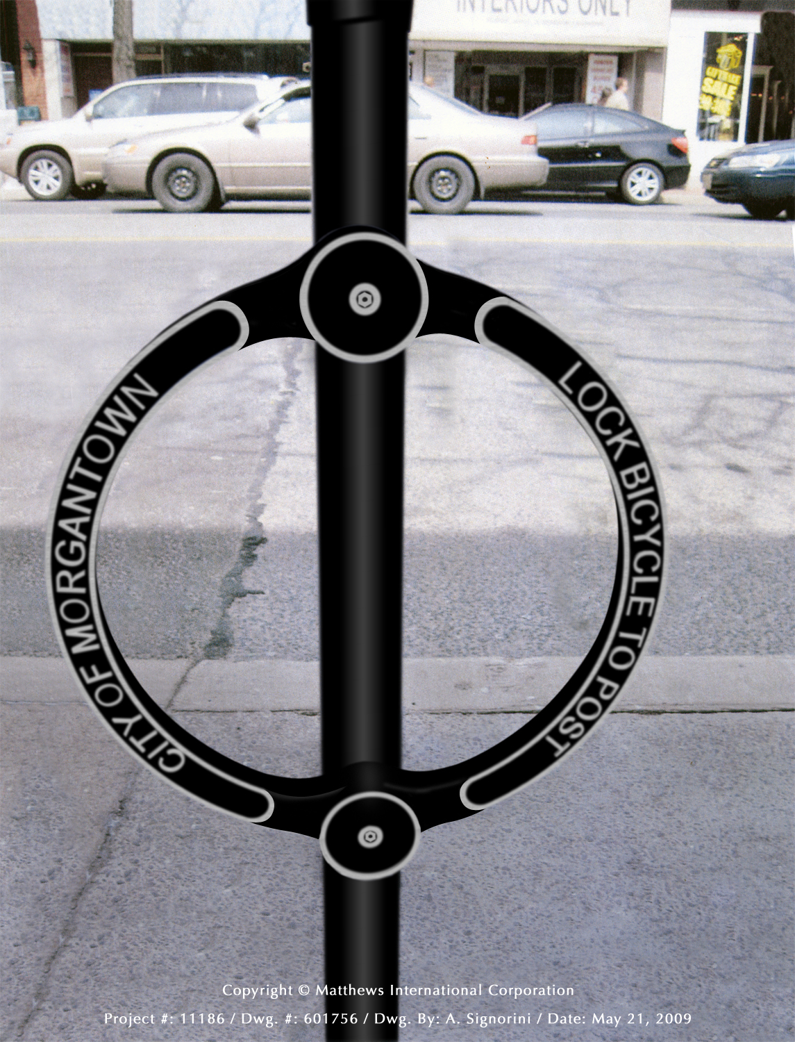
.

- Presented design and location plan to Mainstreet Morgantown Director and received letter of support.
- Reviewed design with City Public Works and Engineering. City Engineer reviewing locations and preparing final location map.
- Presented design and location plan to Mainstreet Morgantown Design Committee and received unanimous support.
- Created estimate and City identified budget for the parking devices.
- Created photo library on City web site http://www.morgantown.com/bike-board-documents/tm/index.htm of each planned location to reveal potential conflicts.
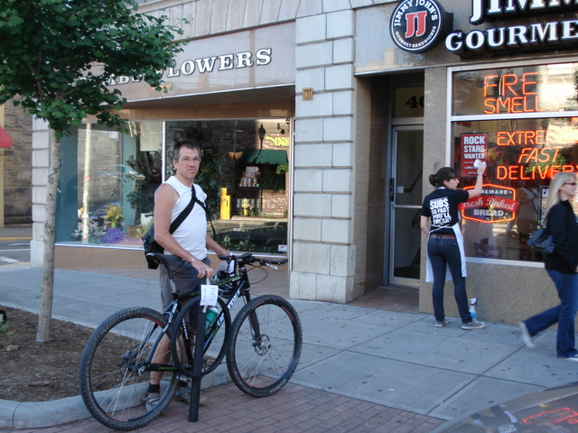
- Presented parking device design and location plan to Mainstreet Morgantown merchants. Two merchants had expressed concern that the parking devices will clutter High Street and that parked bicycles will interfere with pedestrian traffic.

State College Bicycle Parking
- Bill Austin, MPO Director and Frank Gmeindl, Bicycle Board Chairman visited State College PA to review bicycle parking and bike lanes there. Trip report is attached at the end of this report. State College has >100 post-and-loop racks and a bike corral on a main street.
Bike Corral
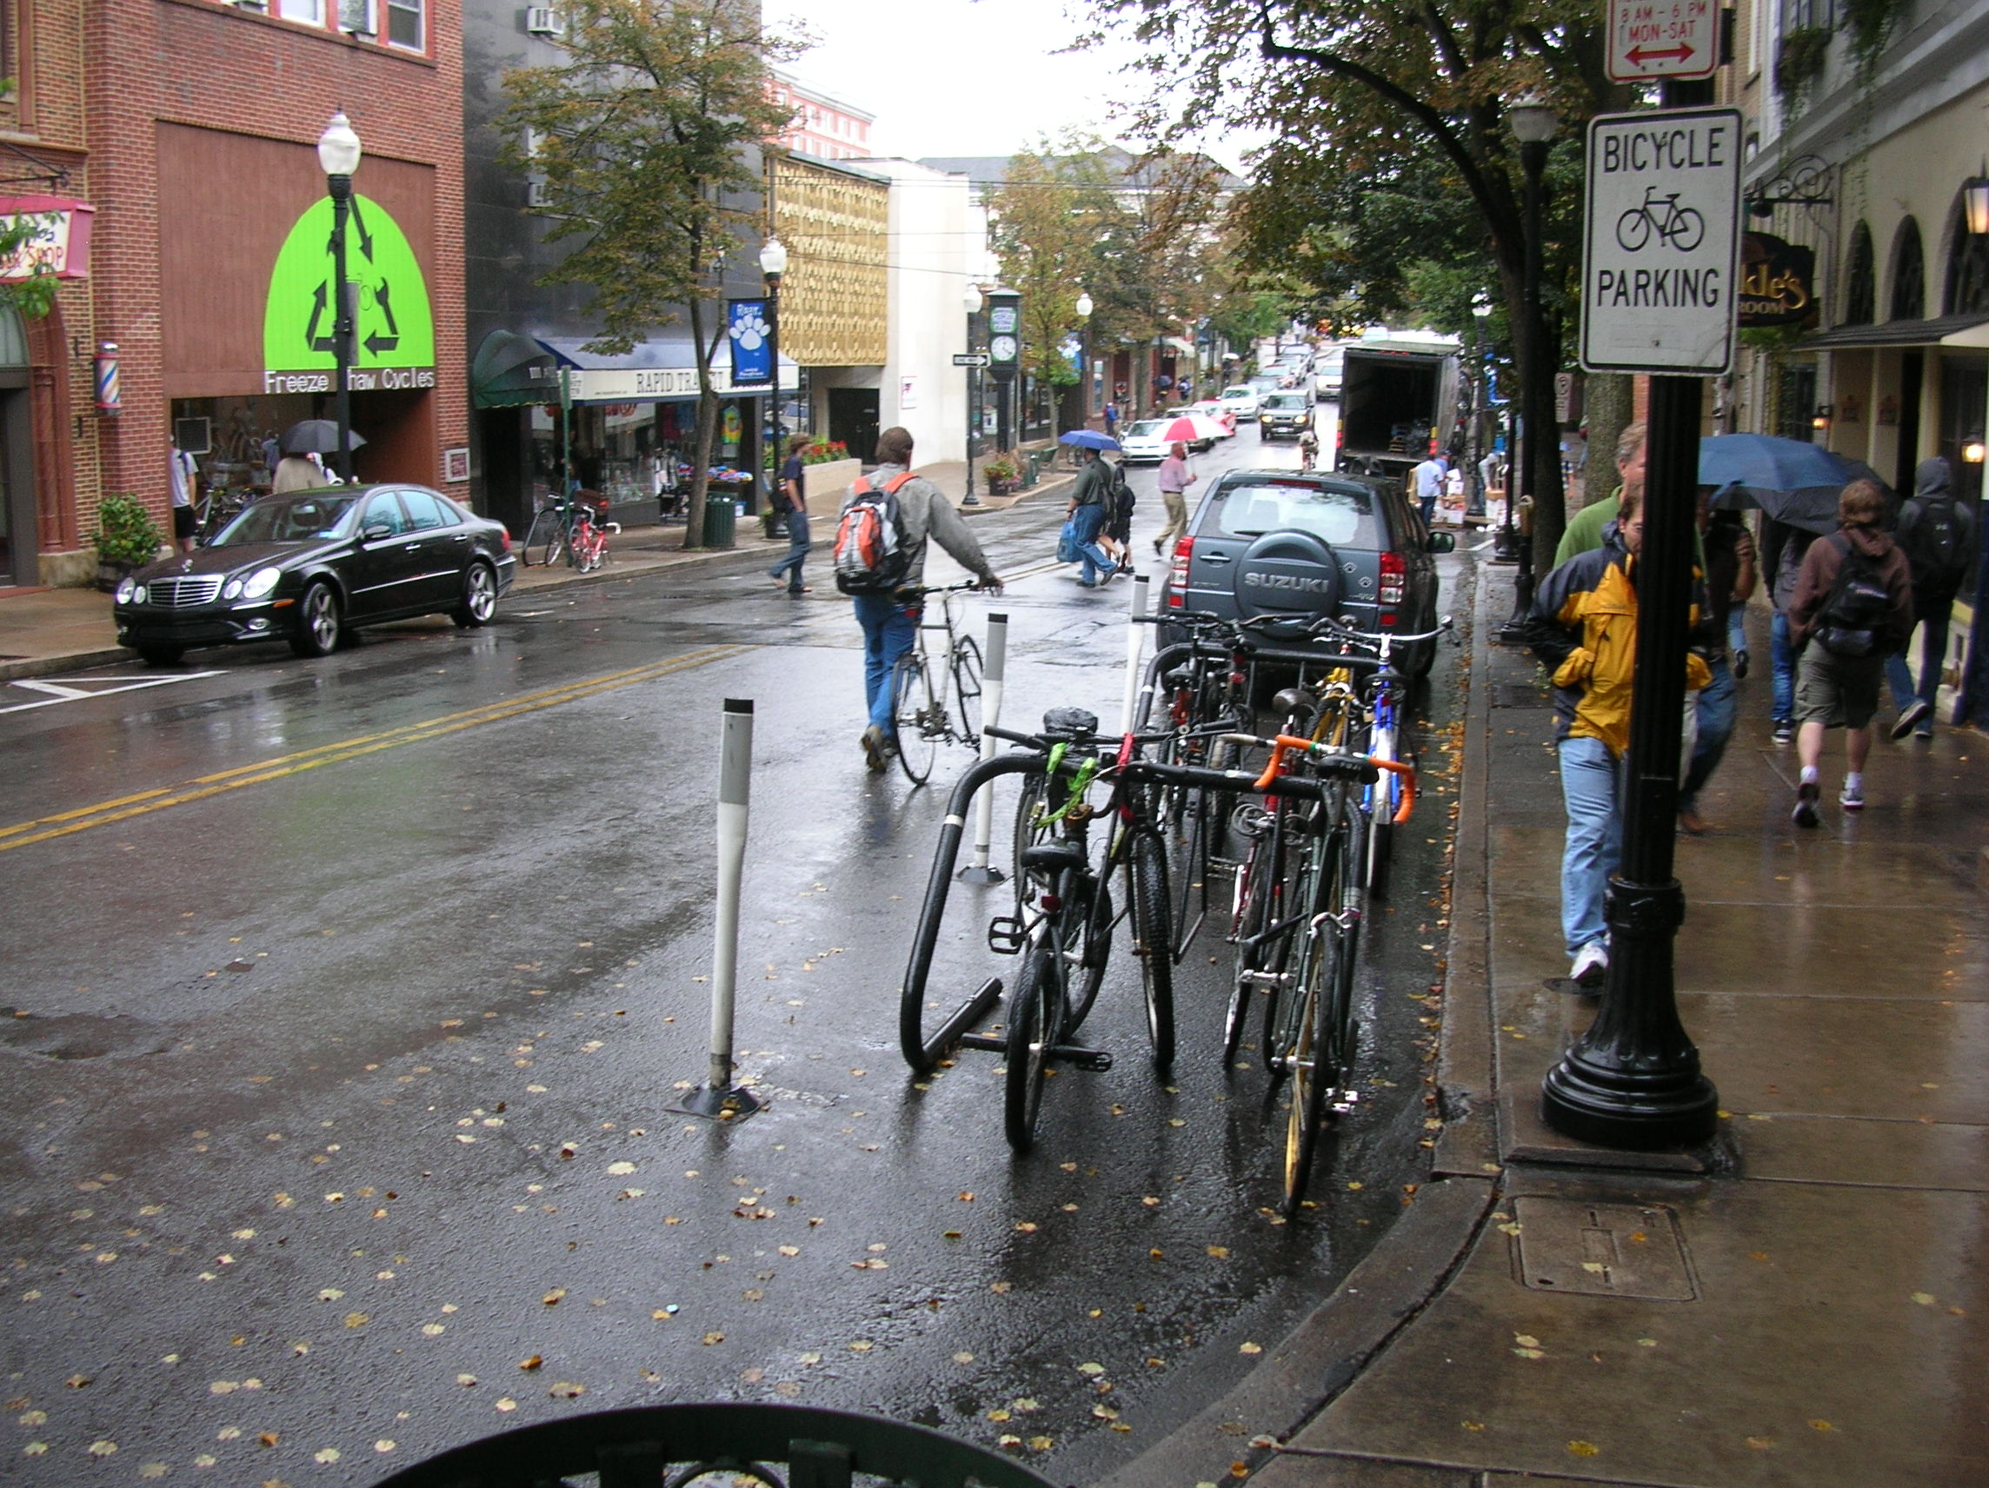
Post-and-Loop Bike Rack
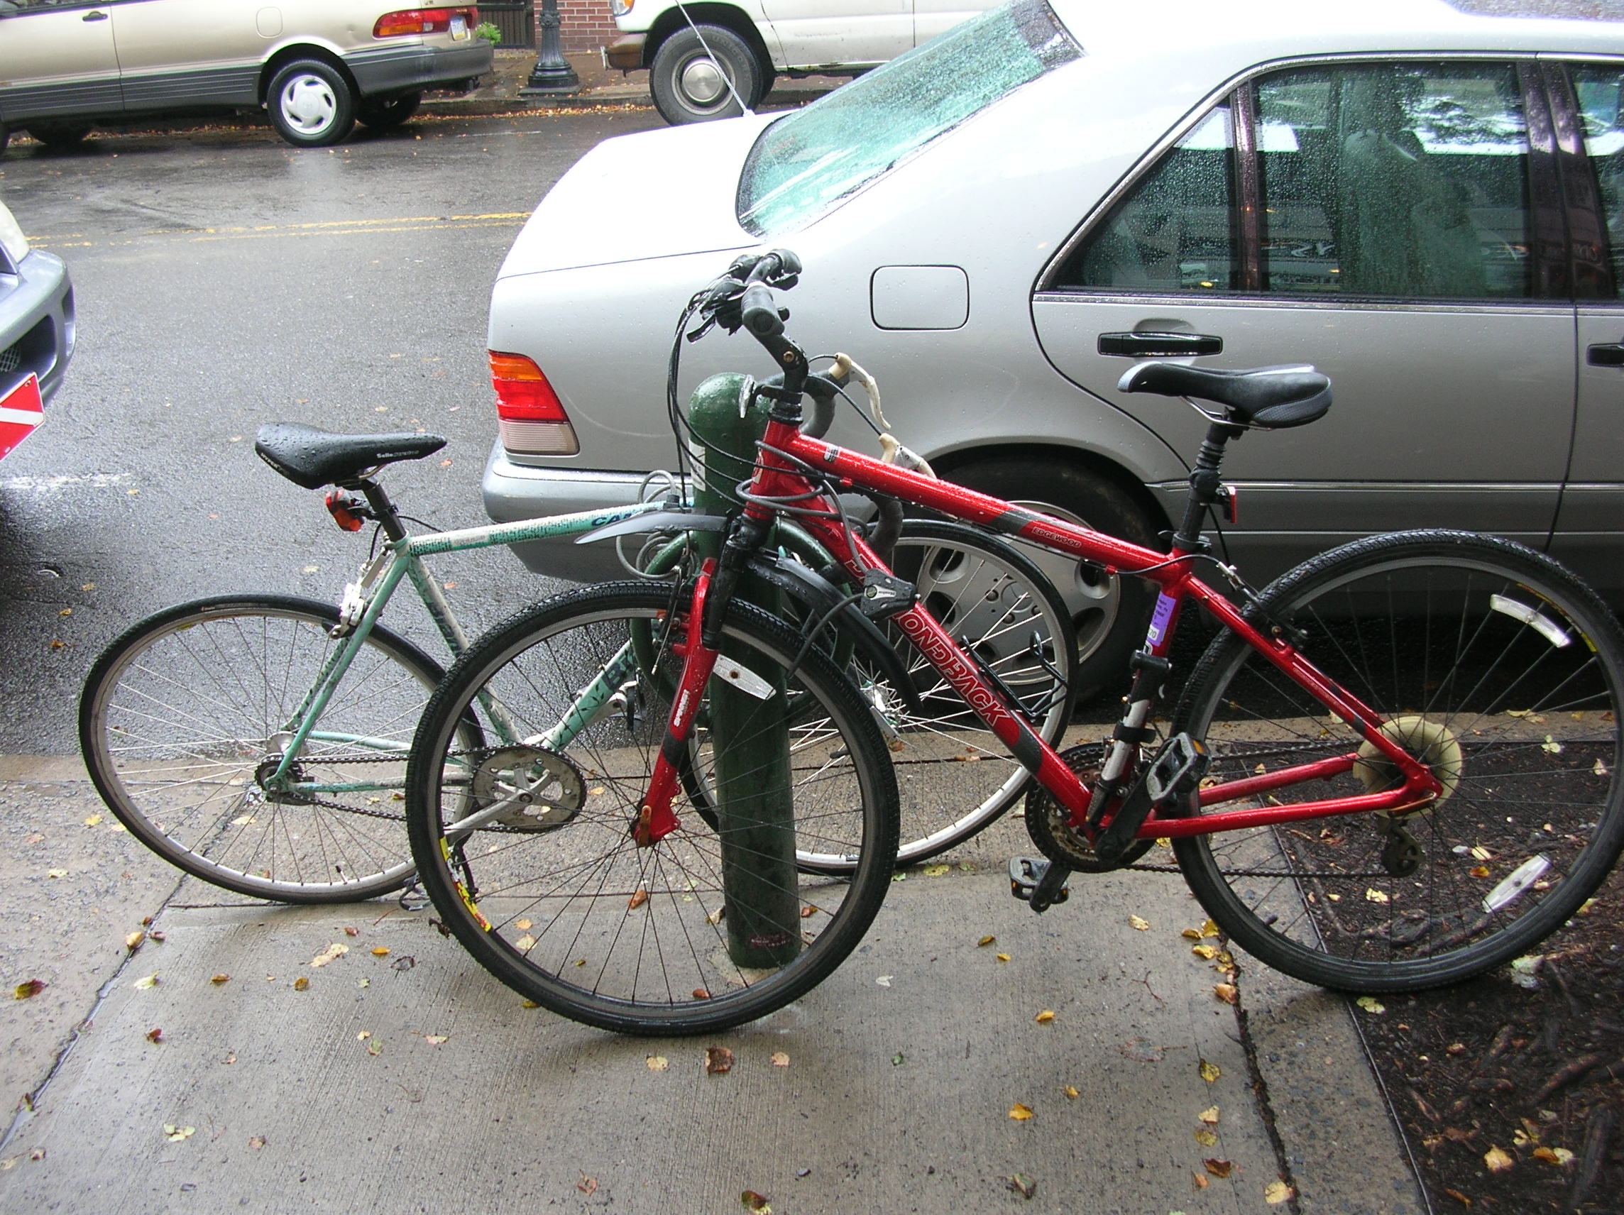

Bike Route Map
- The Bicycle Board has produced a map of Morgantown streets and indicating those which bicyclists use most frequently. The Bicycle Board is targeting having a completed first version available at the WVU Intermodal Transportation Facility, Mountaineer Station, on October 19.

ENGINEERING

Shared Lane Markings (Chevrons)
- Continued to develop strategy and plan.
- Received information from NCUTCD member that interim approval of shared lane markings may occur before full new MUTCD is approved.

SLM Background:
On July 11, 2007, the Traffic Commission unanimously approved the Bicycle Board’s recommendation for the City to apply the Shared Lane Markings to specific roads in Morgantown.

On May 22, 2008 Paul Maddox, Secretary of the WV DOT, in a letter to Morgantown City Manager, Dan Boroff, authorized the City of Morgantown to apply Shared Lane Markings and to install Bicycles May Use Full Lane signs to guide bicyclists to the appropriate position on the roadway and to remind motorists that bicyclist have the same rights and are subject to the same duties as drivers of motor vehicles.

On June 13, 2008, Terry Hough requested the Bicycle Board to provide a map that she could include in the request for bids from contractors to install the Shared Lane Markings and Bicycles May Use Full Lane signs.

The Bicycle Board presents the map to the Traffic Commission at its December meeting.

The Shared Lane Markings are in the new FHWA Manual of Uniform Traffic Control Devices (MUTCD) slated for approval at the end of this year.

In other cities such as San Francisco in which the Shared Lane Markings have been used, scientifically conducted studies showed that bicyclists are more likely to

- Drive in the direction of traffic flow,
- Drive on the right side of the road,
- Not drive on sidewalks, and
- Position themselves on the roadway to avoid colliding with opening doors of parked cars.

The studies also showed that when Shared Lane Markings are present, motorists are more aware of bicycles and give them a little more room when passing. Almost 2 years ago, Pittsburgh installed Shared Lane Markings on select streets and bicycle use has increased.

The new signs state that “Bicycles May Use Full Lane.” These signs are also in the new MUTCD. When the City sought WVDOH approval for the Shared Lane Markings, the WVDOH required a Bicycles May Use Full Lane sign to be placed along with the Shared Lane Markings. However, to minimize costs, the City negotiated to place the signs at the beginning of each run of Shared Lane Markings and in locations in which the sign would convey a clearer message than the Shared Lane Markings.

The Shared Lane Markings and Bicycles May Use Full Lane signs would be placed on Morgantown streets that bicyclists would use more if they knew they could ride on them. These streets include University Avenue, Patteson Drive, Van Voorhis Road, Collins Ferry Road, Beechurst Avenue, High Street, Spruce Street, Stewart Street, Willowdale Road, South University Avenue, Dorsey Avenue, Willey Street, Charles Avenue, Richwood Avenue, Rt. 7 in Sabraton, and Decker Boulevard.

In the process of approving the City’s plan for Shared Lane Markings, the WVDOH also agreed to install Share The Road signs on state routes leading into and around the City including Monongahela Boulevard, South University Avenue, the Mileground, and Greenbag Road.

Since the WVDOH approved our application, personnel changes have led to their reconsidering their approval. An October 30, 2008 letter from Paul Maddox retracted his May 22 approval.

In a December 17, 2008 e-mail from Ray Lewis, WVDOH Staff Engineer Traffic Research and Special Projects to Bill Robinson, WVDOH Trails Coordinator, Lewis said, “From our perspective, the City presently has two alternatives open to them:

1) Apply for a permit (where State-maintained streets are involved and install SHARE THE ROAD signs, which are an approved traffic control device; or

2) File a request with the FHWA for Permission to Experiment with either or both of these new traffic control devices; the DOH would entertain a permit application for any affected State facilities, once the City has this in hand.”

MUB Closure of Rail Trail to Install New Sewer Line

- Starting with Bicycle Board recommended specifications for a bike lane on the climbing side of Monongahela Blvd. and Share the Road signs on the descending side plus the length of Monongahela Blvd/Beechurst Ave/Don Knotts Blvd, the Assistant City Engineer developed drawings and a presentation package for presentation to the MPO TAC which includes WVDOT and WVDOH representatives.
- Participated in Mon Blvd bike lane presentation to MPO TAC. The WVDOT agreed to review the Monongahela Blvd bike lane concept for conformance to prevailing standards but resists installing the bike lane or funding it.

Background

- At the June 2009 Traffic Commission meeting, the Bicycle Board recommended and the Traffic Commission approved the following recommendations:

At least 6 months before the trail is closed:
- Install “Share the Road” and “Bike Route” signs every 250 feet on Beechurst Ave., Mon Blvd., Don Knotts Blvd. and University Ave.
- Install a bike lane going up the hill on Mon Blvd. between Eighth St. and Evansdale Drive. Keep the bike lane free of debris.

Also at the June 2009 meeting, the Bicycle Board provided the following recommendations which the Traffic Commission held in abeyance pending the Traffic Commission gathering additional information on the trail closure:
- Establish cycling detours around the trail but as close to the trail as reasonable. (Consider the businesses that depend on trail traffic. Remember Whitetail?)
- Complete the work in sections to minimize the impact on cyclists and businesses.

- Created specification for Bike Lane on the climbing side of Monongahela Blvd. between Eighth Street and Evansdale Drive.
- Met with City Manager, City Engineer and MPO Director to review the Bike Lane design and to define roles and responsibilities in getting WV DOH approval. MPO Director will take the lead.

EVALUATION

Trip Report: State College PA, September 11, 2009
by Frank Gmeindl & Bill Austin

See photos at http://s935.photobucket.com/albums/ad193/cyclm8/State_College/?albumview=slideshow

On 9/11, a day when the DA proclaimed, “Morgantown named 19th best college town in the nation”, Frank Gmeindl and Bill Austin traveled to the 2nd best college town, State College Pennsylvania to review their bike lanes and bicycle parking.

Participants
- Frank Gmeindl - Chairman of the Morgantown Municipal Bicycle Board
- Bill Austin - Director Greater Morgantown Metropolitan Planning Organization
- Chuck Anderson - President of the Centre County Bicycle Coalition, PSU geology professor, League of American Bicyclists Certified Bicycling instructor.
- Tom Flynn – PSU Landscape Architect, WVU grad. Developed PSU comprehensive bicycle plan.
- Mark Whitfield – State College Public Works Director. Developed State College comprehensive bicycle plan. Commutes to work by bike.

State College compared with Morgantown
State College has a population of approximately 40K students and 40K permanent residents, similar to Morgantown. However, most of State College appears to have been recently constructed and therefore appears to be newer and more prosperous. Penn State University seems to be a more prominent part of the city. State College does not have Morgantown’s steep hills and most of the streets are much wider.

Agenda
We met Chuck and walked a bit around downtown on our way to lunch with Tom at the Corner restaurant.

After lunch, we walked the few blocks to the Public Works building where Mark joined us for two hours while we reviewed plans and maps for bicycle routes, lanes and paths and discussed parking.

Then, Chuck gave Frank and Bill a tour of downtown, the suburbs and a little bit of the campus to show us planned bike lane locations, current bike paths, current bike routes and bicycle parking.

Bicycle Use
It rained continuously while we were there. Despite the rain, everywhere we looked around town and on campus, people were riding bikes. State College has 6 bike shops. Most cyclists we saw were student age. Most were riding in everyday clothes and without helmets. Downtown, most cyclists were riding on the streets in the same direction as traffic and outside of the door zone. We saw a few cyclists riding on sidewalks. Most of the bike paths and bike routes are multi-use. In some cases, the bike paths were essentially sidewalks with many traffic crossings.

Plans
PSU has a bicycle master plan http://www.opp.psu.edu/about-opp/divisions/cpd/images/Bicycle%20Master%20Plan.pdf that is essentially a map of the campus and surrounding area showing existing roadways, bike routes, bike lanes and shared pathways. The plan also shows 17 proposed route improvements and 4 proposed covered bike parking areas. The route improvements include 2 climbing lanes (Burrowes Road and Shortlidge Road), 1 bike lane, 3 bike paths, and other improvements including a greenway, 6 connectors and a by-pass.

In 2008, State College hired a consultant to complete a two part Comprehensive Pedestrian and Bicycle Program for the Borough. Part I provides background information on pedestrian safety. It identifies the areas of concern based upon crash analysis techniques, and it provides recommendations to improve safety at the top five sites based on a detailed engineering study. Part II of the Comprehensive Pedestrian and Bicycle program includes the development of a comprehensive educational, engineering, and enforcement program to address pedestrian and bicycle safety in the Borough.

The Borough of State College capital improvement plan (http://www.statecollegepa.us/DocumentView.aspx?DID=1665) pp. 45-48 that includes plans for 2 bike lanes (striping $500), additional downtown bike racks ($7,000) and construction of a bike path connector ($30,000). The plan also includes $100/year for bike lane striping repainting and $50/mile/snowfall for bike path snow removal!

Bike Lanes
State College does not have Morgantown’s steep hills and most of the streets are much wider. Our main reason for travelling to State College was to observe the climbing lane bike lane that we understood from their web site was installed and operational. We learned that State College is actually planning to put climbing side bike lanes on three streets: S. Allen St., Waupelani Dr. and Sparks St. Unfortunately, the lanes have only been designed and haven’t been installed yet. We drove over those two streets. Their situation is quite different from any in Morgantown. Both streets are very wide: 32 feet with 16 foot lanes. The speed limit is 25 mph. When I questioned why they want to install bike lanes when the lanes are plenty wide for bicycles and motor vehicles to travel safely side by side, Mark said they were more for traffic calming and to raise awareness that bicycles would be on those roads. To accommodate bicycles on certain narrower streets, the Public Works Dept. has already eliminated on-street parking. The Public Works Dept. plans to install “sharrows” (shared lane markings) using a stencil. They will paint them rather than use retro-reflective vinyl that is melted into the asphalt. Mark was not sure of where exactly they will be installed or the principles for selecting locations for installation.

Bike Paths
Penn State has numerous segregated 10-foot wide paved bike paths that connect high-density campus locations such as multi-family dwellings.

Bicycle Parking
Bicycles are parked everywhere in State College. Most official bike racks are heavily used. Bikes are also locked to trash cans, trees, light poles and parking meters. In State College, parking meters are attached to the light poles. Apparently, cyclists park their bicycles as close as they can to their destination.

The parking garages have bicycle racks that are hardly used. Even though the parking garages are only a few blocks from main street they are apparently far enough away that cyclists don’t use the bike racks in them.

State College has approximately 100 post-and-loop bicycle racks. They are very simple: loop welded to post. The Borough has them manufactured by Dumar in Carlyle PA.

They also have 12-18 “Cora” racks 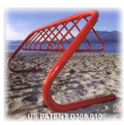.

State College also has a bike corral in arguably the premier parking spot in town at the corner of College Ave. and Allen St. right beside the front entrance of The Corner Room restaurant, a State College landmark. Mike Desmond, the owner of the Corner Room loves the corral and bike racks.

The Borough removes the corral in the winter to ease snowplowing. The corral bollards are removable. The bike corral has two Cora racks. The long range plan is to elevate the corral to the same grade as the sidewalk so that it can be permanent. The Borough has the Cora racks manufactured by Spicer Welding in Bellefonte PA at a cost of $650/each for 5 or more. The racks are also somewhat easily removable.

Mark Whitfield advised only putting bike racks where they will be used. In one case, they installed a post-and-loop rack in front of an upscale ladies clothing store and the owner asked them to remove it, which they did. On the other hand, they currently have merchants who operate businesses such as restaurants cyclists are more likely to frequent requesting racks in front of their stores.

Bicycle Parking Enforcement
Parking at racks on the Burough streets is limited to 72 hours. Parking at the racks in the parking garages is limited to 30 days. The police department controls the bike parking. When a bicycle is observed to have been parked longer than the maximum allowed time, an officer tags the bike with a tag indicating the date and time. If the bike is not removed in a reasonable time, the police cut the lock and impound the bike.

Students on campus are required to register their bikes. Easy on-line registrations is available at the PSU Transportation Services web site. Student auxiliary to the campus police patrol bicycle parking on campus. Overnight parking is not allowed outside of classroom buildings. Police may impound a bicycle if they observe that it is parked repeatedly overnight. Outside of residences a bicycle can be left parked for the whole year. The police do not have space to store impounded bicycles. They have an annual auction of impounded bicycles. The proceeds are used to support the patrolling effort.

Conclusions
State College has established very impressive bicycle parking in just a few years and they seem to have a logical plan to keep improving it. Through cooperation between the City and the University they seem to be able to quickly establish bike routes, bike lanes and bike paths. However, their planning and analysis of these facilities doesn’t appear to be very rigorous. On the other hand, they seem to have good communication among key stakeholders to ensure consensus before changing the infrastructure and they seem to be willing to quickly rework mistakes when they make them. Having experienced cyclists leading facility design, installation and maintenance ensures that the facilities meet the needs of cyclists. The fact that these experienced cyclists are also leaders in the community, good communicators and good consensus builders also ensures that the community understands and is committed to the facilities.

State College has experienced cyclists in key Borough and University positions. The Public Works Director who commutes to work by bike is enthusiastic about making State College a bicycle friendly community. He is very experienced and has a good understanding of bicyclist needs as well as the needs in his Borough. Most of his bicycle facility accomplishments did not require PennDOT approval. When PennDOT must be involved they appear to be very cooperative.

The PSU Landscape Architect who is also a cyclist developed the PSU bicycle master plan and got buy-in from all key stakeholders. Since the roadways on campus are private, he can implement the master plan without requiring PennDOT or Borough approval.

Most State College cyclists don’t lock their bikes properly: they don’t lock both wheels and frame to rack.

Cora racks don’t seem like the greatest idea. PSU has standardized on Cora racks. Locking the frame and both wheels to it seems difficult. They appear to damage head tubes and forks. (On the University of Pittsburgh campus, practically everywhere you look, you see Cora racks. Some locked bikes have missing wheels.)

Post-and-loop racks seem to work well in the right locations but have limited capacity for high use locations.

The rationale and justification for bike lanes and bike paths, particularly their impact on cyclist safety are not clear. The University has installed numerous bike paths and has plans for bike lanes and more bike paths. The Borough plans to install additional bike lanes for traffic calming and to raise awareness of bicycles. Bicycling is obviously far more prevalent in State College than in Morgantown and these facilities will probably get more people cycling. Whether they will decrease the crash rate/mile ridden still needs to be determined.

