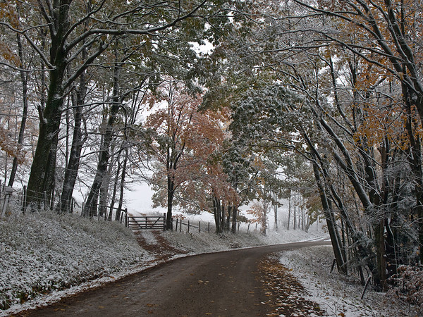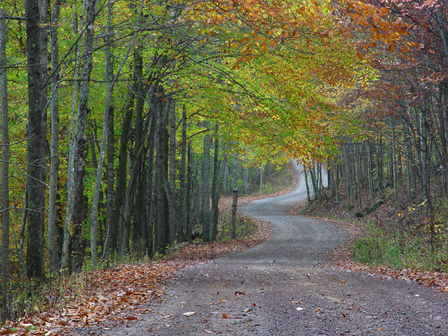

2010 WVDOT/MPO/FHWA Transportation Planning Conference
October 26-28, 2010
Clarion Hotel Morgan
127 High Street
Morgantown, WV 26505

We are pleased to invite you to participate in the 2010 WVDOT/MPO/FHWA Transportation Planning Conference. The conference will be held at the Clarion Hotel Morgan in Morgantown, WV (on High Street) and will begin at 10:00 am on October 26th and conclude at noon on October 28th. Registration will begin at 8:00 am on October 26th. We have an exciting agenda planned that we hope you will find stimulating and informative.

The conference fee is $25 for all non-government attendees who are not presenting at the conference. Please make the check out to the West Virginia Division of Highways, and mail it to the address listed on the form below.

Rooms can be reserved at the Clarion Hotel Morgan with a room rate of $76 per night plus tax. The telephone number for reservations is 304-292-8200. Please reference the conference name when making reservations.
A block of rooms has also been reserved at the Ramada Conference Center in Morgantown in case additional rooms are needed. The telephone number for reservations at the Ramada is 304-296-3431.

This year’s cookout is tentatively scheduled for the evening of October 27th at Marilla Park in Sabraton. Transportation from the hotel will be provided by Mountain Line Transit Authority. For those who would like to participate, a bike ride via the Deckers Creek Trail and local roads is scheduled from the hotel to Marilla Park. You may bring your own bike, or rent one from Wamsley Cycles in Morgantown. If you choose to rent a bike, you may contact Chip Wamsley at (304) 296-2447. Please contact him at least one week in advance of the conference. You will need to provide him with your height and inseam measurement. The website for Wamsley Cycles is www.Wamsleycycles.com. Fifteen bicycles are available for rental at a cost of $10 for two hours, or $15 for ½ day. The rental fee includes helmets. Transportation will be provided for participants and their bikes for the return trip to the hotel. Please note that helmets will be required to participate in the bike ride. A map and further details about the bike ride will be provided at the conference.

The cookout has been a great success in the past, and provides a wonderful opportunity to network with peers in a relaxed atmosphere. The cost of the cookout is tentatively set at $10 per person (More information will be provided later). Please indicate on the registration form if you plan to attend the cookout. In addition to the cookout, the Chamber of Commerce and the Morgantown Convention and Visitors Bureau will be hosting some special events (further information will be provided at a later date).

To register for the conference, you can complete the information below and return it to Elizabeth Lilly at the WVDOH or register online via the web address listed below. To assist the conference planners, please return your completed registration forms by no later than October 4th. If you have any questions, please contact Elizabeth Lilly at (304) 558-9602 or at elizabeth.a.lilly@wv.gov, or Bill Austin at the Morgantown Monongalia MPO at (304) 291-9571 or at baustin@moncpc.org.

Register Online at http://www.fhwa.dot.gov/wvdiv/wvplancon.htm
Or
Complete the information below and return by October 4th.

Registration Information:

Name: _______________________ Organization: _______________________

Address: _____________________ Email: _____________________________

______________________

Will you be joining us at the Wednesday cookout? ___________

Please return registration form to: Elizabeth Lilly
(Via mail, fax, or email) West Virginia Division of Highways
1900 Kanawha Blvd. East, Building 5
Room 816
Charleston, WV 25305
Fax: (304) 558-3783, Email: Elizabeth.a.lilly@wv.gov

