January 5, 2011

Bicycle Board Report to Traffic Commission

HIGHLIGHTS

Recommendations
- The Bicycle Board recommends that the Traffic Commission appoint Ryan Post to replace Don Dickerson.

Accomplishments
- Delivered presentation, Accommodating Bicycles and led bus tour of conference participants at October 22-28, statewide MPO planning conference. Presentation is available on BikeMorgantown.com website.
- Created business card size handout with Confident City Cycling contact info on front and safe bicycling tips on back. Awaiting printing.
- Two articles published in The Dominion Post: October 7, 2010, Teach Children the Ropes of Bicycling page 1-D; November 11, 2010, You Think You’re Mad at Cyclists?, page 8-D. Articles are available at BikeMorgantown.com in the Articles section
- Developed full “community page” of bicycling information published in Mountaineer Yellow Pages.
- Seven 15-second bicycle education TV spots continue to run on channel 15. Spots can also be viewed on the City website as well as at News on BikeMorgantown.com.
- Continued to update BikeMorgantown.com web site to provide more extensive educational materials and bicycling law as well as the Confident City Cycling course calendar.
- Suspended Confident City Cycling classes and advertising until spring.
- Submitted Intent-to-Propose form to WVDOT for follow-on to Morgantown Effective Bicycling Education Program grant.
- Continued to develop Morgantown bike route map including making available as Google map.
- Provided City Engineering copies of correspondence between WVDOH and the City that show WVDOH offer to install Share the Road signs on Morgantwon highways maintained by the State with >40 mph speed limits. This is to support installing Share the Road signs on South University Avenue before the rail trail closes for 6 months beginning February.
- Eighteen of twenty-three received parking rings (Figure 1 below) are installed on High St. and Walnut St. parking meters. Sleeves are on order for the remaining 5 that will be stand-alone units. Four will be on the sides of the Public Safety Building. The location of the last one needs to be determined. Articles on BikeMorgantown.com.
- Coordinated with Public Works, MUB and WVDOH to arrange to have in-line drain grates on Beechurst and Mon Blvd. replaced with bicycle safe grates. (Figure 2: In-line drain grate in front of Coliseum, below)
- Created first draft of Morgantown Comprehensive Bicycle Plan

Plans for Next Month
- Receive WVDOT decision on Intent-to-Propose and write grant application.
- Continue to develop comprehensive bicycle plan.
- Continue to develop education effectiveness metrics.
- Plan 2nd application for Bicycle Friendly Community award.
- Continue to improve bike route map.
- Develop signage recommendation follow-on to Shared Lane Marking recommendation.
- Develop bike locker proposal for parking garages.
- Continue to coordinate with Public Works, WVDOH and WVU to implement June 2009 recommendations for Mon Blvd., Beechurst, Don Knotts, So. University Av. corridor
- Continue to coordinate with WVDOH to replace in-line drainage grates
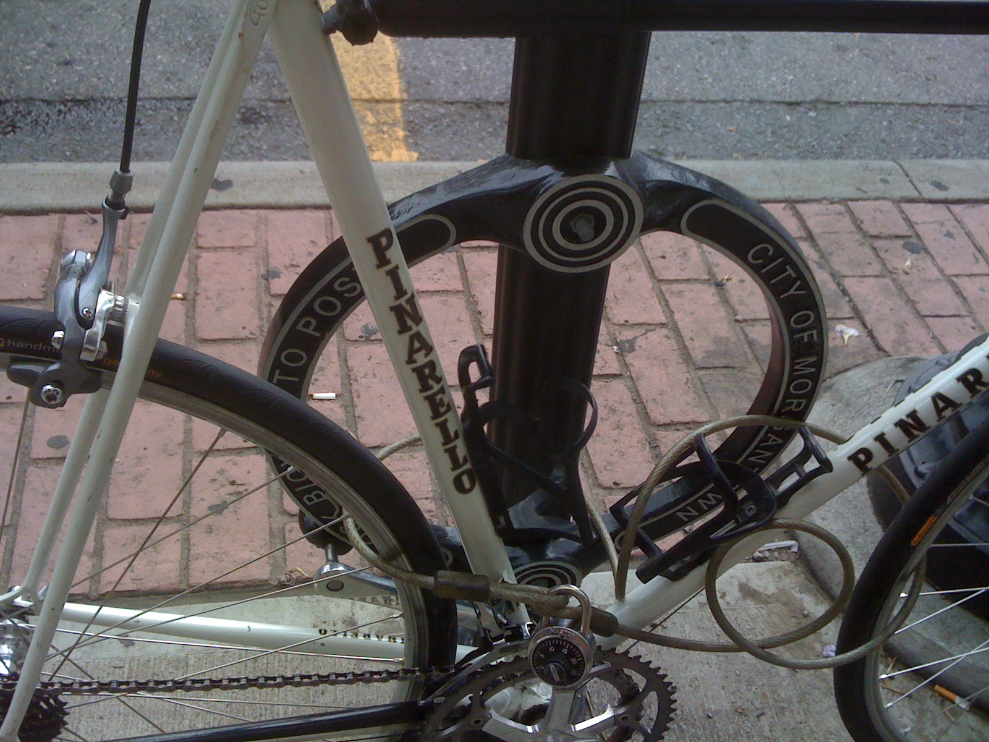
Figure 1. Downtown Bicycle Parking

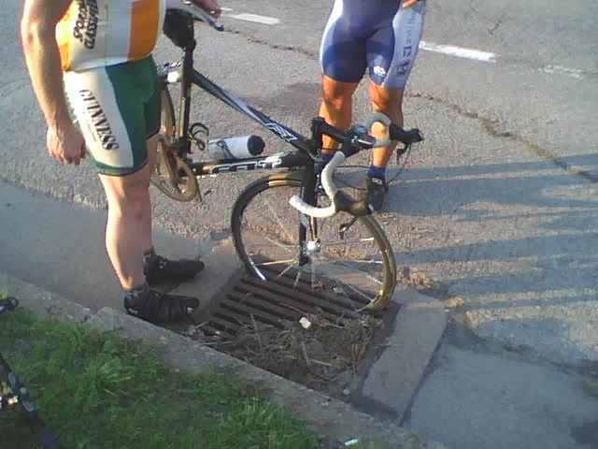
Figure 2: In-line drain grate in front of Coliseum

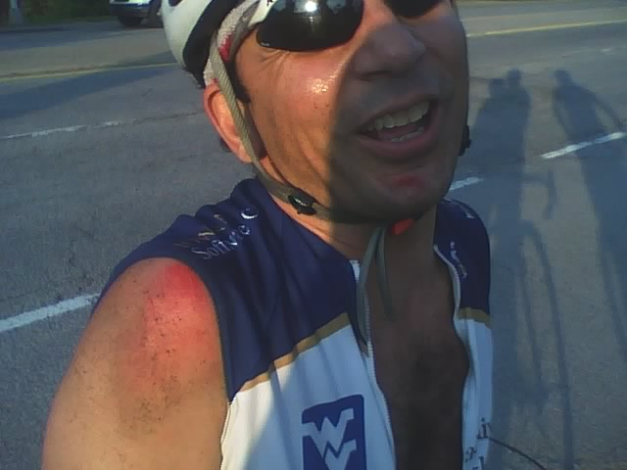
Figure 3: Lucky result of in-line grate crash

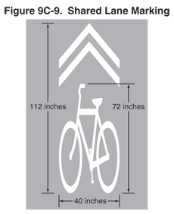
Figure 4: Shared Lane Marking

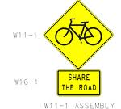
Figure 5: Share the Road sign

Figure 6: Bicycles May Use Full Lane sign

Newspaper Articles
Topic | Date Published
- ABC Quick Check | March 25, 2010
- May is National Bicycle Month | April 29, 2010
- Same Road, Same Rights, Same Rules | May 20, 2010
- Bicycling in Traffic | August 5, 2010
- Driving around Bicyclists | July 8, 2010
- Out and About on the Rail Trail | Sep. 2, 2010
- Bicycling and Pedestrians
- Bicycling with Children | Oct. 2, 2010
- Alternative Approaches: Bicycle Lanes, Road Share
- You Think You’re Mad at Cyclists? (Civility on the Road) | Nov. 11, 2010
- Green Bicycling
- Healthy Bicycling
- Morgantown Bicycle Route
- Bicycling Around the World (including US)
- Bicycling Trips Around Morgantown
- Bicycle Friendly City Award
- Bicycle Groups in Morgantown
- Bicycling for Parents
- Commuting

Accommodating Bicycles presentation to statewide MPO conference: http://bikemorgantown.com/articles.php?str=2010/10/mpo-presentation-report.html
Cycling with Children (DP renamed to Teach Children the Ropes of Cycling): http://bikemorgantown.com/articles.php?str=2010/10/cycling-with-children.html ; You Think You’re Mad at Cyclists?: http://bikemorgantown.com/articles.php?str=2010/11/you-think-youre-mad-at-cyclists.html
Video spots on City website: http://www.youtube.com/user/CityofMorgantown
TV spots on BikeMorgantown.com: http://bikemorgantown.com/articles.php?str=2010/08/psas-complete.html
Bike Racks article: http://bikemorgantown.com/articles.php?str=2010/09/bike-parking-installed-downtown.html
All these articles can be read at Articles on BikeMorgantown.com: http://bikemorgantown.com/articlefeed.php

