March 30, 2010

Bicycle Board Report to Traffic Commission

Table of Contents
HIGHLIGHTS 1
EDUCATION 3
Morgantown Effective Bicycling Education Transportation Enhancement Program Grant: 3
ENFORCEMENT 5
ENCOURAGEMENT 5
Downtown Bicycle Parking 5
Bike Route Map 7
ENGINEERING 8
Campus Connector 8
WV 705 “improvement” 8
MUB Closure of Rail Trail to Install New Sewer Line 8
Shared Lane Markings (Chevrons) 10
EVALUATION 13
Crash Study 13
EQUALITY 13

HIGHLIGHTS
- Morgantown now has 5 League of American Bicyclists Certified Instructors (LCI). Marilyn Newcome, Gunnar Shogren and Ryan Post successfully completed the 3-day LCI Seminar March 19-21 in Charlottesville, VA.
- Delivered 2 full-weekend Confident City Cycling courses March 6-7 and March 27-28. Ten participants were trained.
- A full-weekend CCC class is scheduled for each month through July. The next one is April 10-11.
- On March 15, began teaching Confident City Cycling in 1 hour segments followed by a ride every Monday night at 6 pm. Up to 4 participants have attended at one time.
- Ads running in Dominion Post every Thu-Sat for CCC TS101.
- Article on CCC published in March 26, 2010 Daily Athenaeum.
- Driver Ed training postponed because of snow remains to be rescheduled.
- May is National Bike Month. Billboards and www.BikeMorgantown.com website and BikeMorgantown Facebook page are on track for release.
- Confusion on the post-and-loop bicycle rack order may delay delivery and installation beyond the May target.
- Google Maps released a get directions By Bicycling feature March 10 that caused the Bicycle Board to reassess the Bike Route Map that was nearing completion.
- On March 9, WVDOH approved the bike climbing lane on Mon Blvd. between Eighth St. and Evansdale Dr. on the condition that the University and City eliminate parking on the shoulder there.
- Surveying 73 communities that already have Shared Lane Markings or plan to use them.

EDUCATION

Morgantown Effective Bicycling Education Transportation Enhancement Program Grant:

- Morgantown now has 5 League of American Bicyclists Certified Instructors (LCI). Marilyn Newcome, Gunnar Shogren and Ryan Post successfully completed the 3-day LCI Seminar March 19-21 in Charlottesville, VA.
- Delivered 2 full-weekend Confident City Cycling courses March 6-7 and March 27-28. Ten participants were trained.
- A full-weekend CCC class is scheduled for each month through July. The next one is April 10-11.
- On March 15, began teaching Confident City Cycling in 1 hour segments followed by a ride every Monday night at 6 pm. Up to 4 participants have attended at one time.
- Ads running in Dominion Post every Thu-Sat for CCC TS101.
- Article on CCC published in March 26, 2010 Daily Athenaeum.
- Driver Ed training postponed because of snow remains to be rescheduled.

Grant background:
- On October 21, 2008 Governor Joe Manchin presented the City of Morgantown a Transportation Enhancement Program grant for the Morgantown Effective Bicycling Education Program. On September 4, 2009, WVDOT issued notice to proceed. The state will provide $54,417 and the City will provide a $13,605 required match for a grant total of $68,022. This grant is a response to the application that the City submitted January 2008. The proposed work includes using print and electronic media to educate the community about cyclist and motorist rights and duties with respect to the law and each other and classes in which the League of American Bicyclists’ Traffic Skills 101 course will be delivered.
- A Bicycle Board Education Committee formed and has been planning.
- Re-branded the program “Confident City Cycling”
- Established CCC in PEIA Pathways to Wellness program
- Assistant City Manager established a web site for course information and registration. WVU will cover full costs for WVU students, faculty and staff
- Identified LAB endorsed on-line capability for delivery of the classroom portion (approximately 4 hours) of the CCC course
- Delivered 12/12, hands-on Confident City Cycling training to 4 WVU students who completed the classroom work on-line.
- Developed a logic model to measure effectiveness of social marketing and course deliveries.
- City purchased BikeMorgantow.com domain for education program web site.
- In collaboration with League of Illinois Bicyclists, completed curriculum and materials for a Share the Road course to be included in Monongalia County Schools Driver Education program.
- Developed a preliminary logo to represent the Education Program.
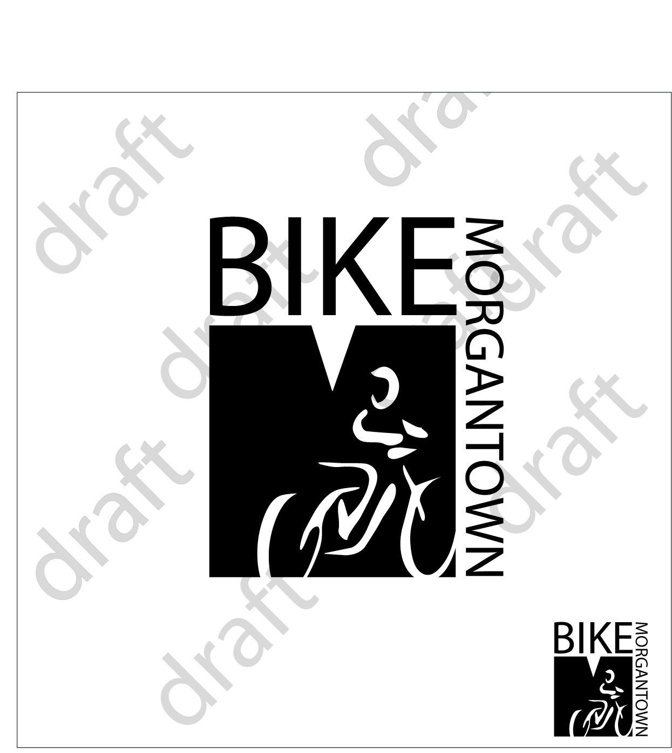
- Developed web site home page layout and top level topics for BikeMorgantown.com.
- Developed preliminary messages for bumper stickers and billboards
Examples:
  - Same Roads, Same Rights, Same Rules
  - 4 Wheels, 2 Wheels, 1 Road: let’s roll together
  - Stopping is Part of Riding
  - Ride Predictably: Obey the Rules of the Road
  - Ride Nice, Drive Nice
  - Bike Friendly: Good for Morgantown
  - Bike Friendly for a Healthier Morgantown
  - Bike Friendly for a Greener Morgantown

ENFORCEMENT
No activity this month.

Background - Enforcement
Reviewed police training materials, assessed for applicability in Morgantown and delivered list to Traffic Commission on December 2, 2009.

ENCOURAGEMENT

Downtown Bicycle Parking
- Awaiting delivery and installation of post-and-loop bicycle racks on High Street, Walnut Street and at the Public Safety Center. Confusion on the order may delay delivery and installation beyond the May target. While the City ordered the racks January 8, the vendor has not yet proceeded with manufacture.

Background - Downtown Bicycle Parking
- Selected post-and-loop design for short-term on street bicycle parking.
Post-and-Loop Bicycle Parking Rack
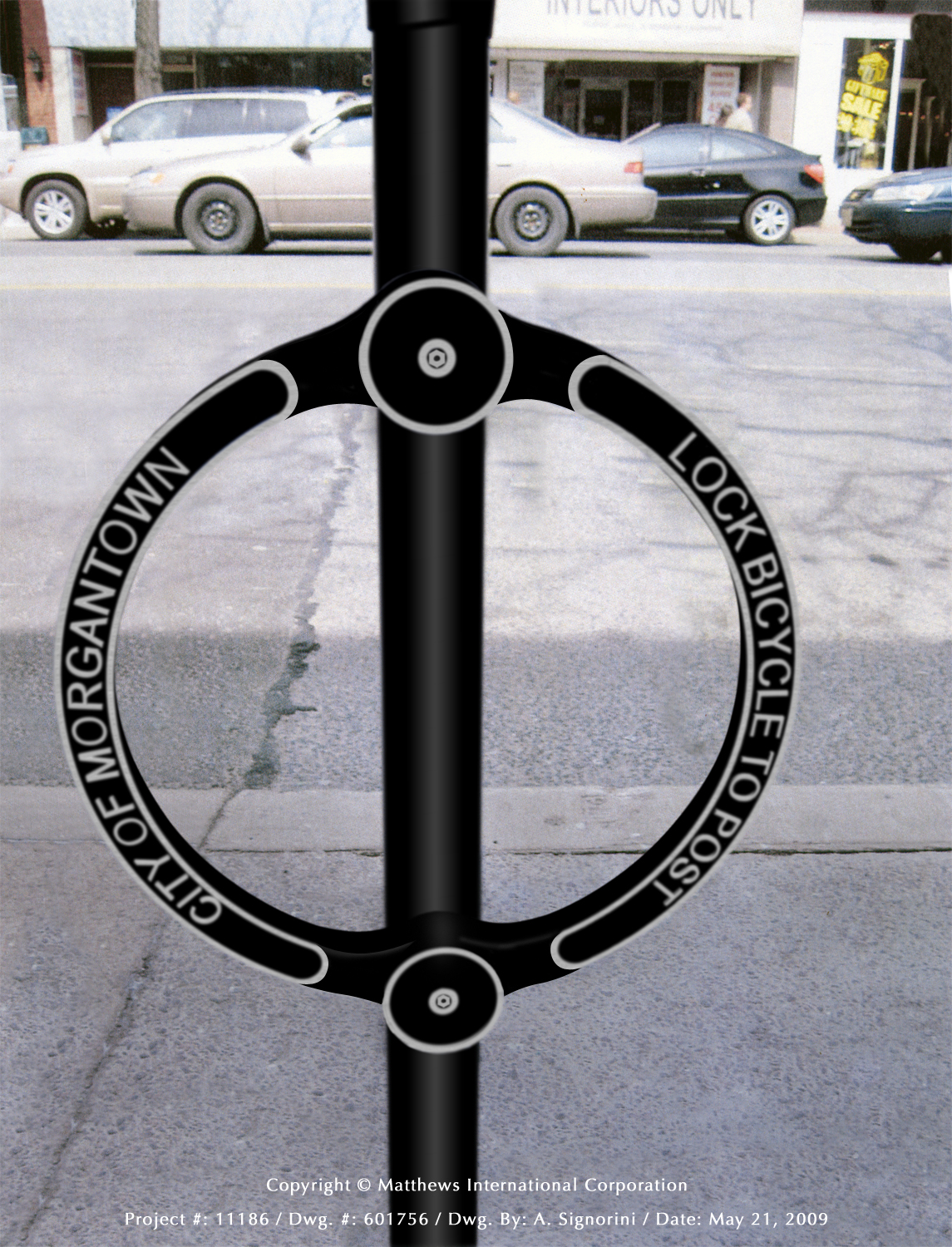
- Laid out recommended parking rack locations on High Street Streetscape map
- Created photo library on City web site http://www.morgantown.com/bike-board-documents/tm/index.htm of each planned location to reveal potential conflicts.
- Created estimate and City identified budget for the parking devices.
- Presented design and location plan to Mainstreet Morgantown Design Committee and received unanimous support.
- Reviewed design with City Public Works and Engineering. City Engineer reviewing locations and preparing final location map.
- Presented design and location plan to Mainstreet Morgantown Director and received letter of support.
- Presented parking device design and location plan to Mainstreet Morgantown merchants. Two merchants expressed concern that the parking devices will clutter High Street and that parked bicycles will interfere with pedestrian traffic.
- Received from City Engineer, drawings showing the proposed locations for the bicycle racks in downtown. The Bicycle Board originally proposed twenty-five. The City Engineer removed one due to its location. The remaining twenty-four are approved solely with respect to ADA requirements and structural requirements with respect to existing facilities within the sidewalk. No approval is being made with respect to the number of bicycle racks to be installed. These locations were based on the proposed locations submitted by the Bicycle Board and do not reflect any input from the City of Morgantown in regards to the number and placement of the racks other than the aforementioned requirements. A couple of notes include:
1. No posts can be installed within the stamped concrete portion of the sidewalks.
2. Two racks are proposed on private property. Prior to any placement, the appropriate agreements must be obtained from the property owner.
- Received letter in October 2009 from Mainstreet Morgantown Board of Directors approving Mainstreet Morgantown Design Committee recommendations that bike racks be located in offsets and setbacks that do not interfere with pedestrian traffic. This recommendation has three goals:

- Provide a safe, secure and convenient place for bicycles to be parked.

- Do not interfere with pedestrian traffic.

- Do not take up motor vehicle parking spaces.

- The Design Committee asks that the Bicycle Board present to the Design Committee locations that support these goals.
- Revised High Street locations of post-and-loop parking devices to move them from the simulated red brick to white concrete.
- Photographed each location.
- Provided revised locations to City Engineer’s office. Assistant City Engineer revised drawings to show revised locations.
- Met with Parking Authority Director and reached agreement to install bicycle parking loops on parking meter posts.
- Identified 17 parking meter posts that are in high bicycle parking demand locations, provide good security, minimize interference with sidewalk users and don’t interfere with other objects such as courtesy ticket collection boxes and tree boxes.
- Presented recommended meter posts to Parking Authority Director November 3.
- Participated in informal November 11 Parking Authority meeting at which the Parking Authority Director presented post-and-loop parking rack design, the 17 proposed parking meters to which they will be attached and the 4 locations at the Public Safety Center where they will be installed under the building overhangs. All members appeared to favor the plan. The Parking Authority will formally vote on it at their December meeting. If they approve, the next step will be for the city to purchase the racks and the parking authority to install them.
- Presented High Street parking plan to Mainstreet Morgantown Design Committee November 12. In addition to the 17 racks that will be attached to parking meters, the plan includes 3 stand-alone racks that will need to be installed in the sidewalks at locations where there is a parking demand but no parking meters. Subsequently, the Design Committee recommended to the Mainstreet Morgantown Board of Directors that they approve the plan and they did.
- On December 12, 2009, received letter of approval of the most recent plan to install racks on parking meters, around the Public Safety Building and 3 free-standing units from Mainstreet Morgantown Board of Directors.
- On December 16, 2009, conducted final review with Parking Authority Director.
- On December 21, 2009, obtained quotes from bike rack manufacturer.
- On January 4, 2010, Assistant City Manager ordered the post-and-loop bike racks.

Bike Route Map
- Google Maps released a get directions By Bicycling feature March 10 that caused the Bicycle Board to reassess the Bike Route Map that was nearing completion.

Background – Bike Route Map
- Produced a map of Morgantown streets indicating those which bicyclists use most frequently.
- Presented the Bike Route map at the WVU Intermodal Transportation Facility, Mountaineer Station on October 19.
- Developed preliminary route classification system that will consider Popularity among cyclists, Steepness of terrain, Motor vehicle speed, Motor traffic volume, Motor traffic capacity, Lane width, Visibility/Sight-line length, Road condition, Shoulder or no shoulder, etc.
- Located on a map of Morgantown and Westover, 5 arbitrary locations and then highlighted an attractive route to each location. The routes are interconnected.
- Identified 90 destinations to put on bike route map.
- Need to ride the routes, indicate hills and unpaved sections, finalize and meet with Convention and Visitors Bureau to get published.

ENGINEERING

Campus Connector
- No activity.

Background – Campus Connector
- The Campus Connector was included in the Bicycle Board’s February 7, 2007 Recommendations to the Traffic Commission (see page 2 at http://www.morgantown.com/bike-board-documents/Recommendations_070205_v2.0.pdf) . The Traffic Commission approved those recommendations.
- The Morgantown Pedestrian Safety Board also recommended the Campus Connector in the February 4, 2009 Pedestrian Safety Plan that it presented to the Traffic Commission (see project #56 on page 40 of http://www.morgantown.com/traffic-docs/Pedestrian_Safety_Board/MTown%20Ped%20Safety%20Plan%20FINAL%201_27_2009.pdf ). The Traffic Commission also approved that plan.
- Recommended to the Traffic Commission that it request of City Staff to investigate and identify property ownership within the general alignment of the Connector so that an earnest discussion with these area property owners and the City could commence.

WV 705 “improvement”
- Waiting since October for YIELD TO BIKES signs to be placed where the right turn lane onto Stewartstown Rd. terminates the shoulder.

Background – WV 705
- Widening and repaving 705 between Stewartstown and Mileground eliminated shoulders and walkways.
- In October 2009, met with MPO and WVDOT officials and recommended SHARE THE ROAD and YIELD TO BIKES signs.
- SHARE THE ROAD (with pedestrians and bicyclists) signs were erected in December 2009.
- In February, the Share the Road signs on WV 705 that formerly showed both a pedestrian and bicycle on the black on yellow diamond shaped sign were changed. The replacement sign only has a bicycle symbol.

MUB Closure of Rail Trail to Install New Sewer Line
- Participated in a March 9 meeting with WVDOT/H in which the DOH agreed with the City’s revised plan to install a bike climbing lane on Mon Blvd. between Eighth St. and Evansdale Dr. on the condition that the City and University eliminate parking on the shoulder there.

Background – Rail Trail Closure

- At the June 2009 Traffic Commission meeting, the Bicycle Board recommended and the Traffic Commission approved the following recommendations:

At least 6 months before the trail is closed:
- Install “Share the Road” and “Bike Route” signs every 250 feet on Beechurst Ave., Mon Blvd., Don Knotts Blvd. and University Ave.
- Install a bike lane going up the hill on Mon Blvd. between Eighth St. and Evansdale Drive. Keep the bike lane free of debris.

Also at the June 2009 meeting, the Bicycle Board provided the following recommendations which the Traffic Commission held in abeyance pending the Traffic Commission gathering additional information on the trail closure:
- Establish cycling detours around the trail but as close to the trail as reasonable. (Consider the businesses that depend on trail traffic. Remember Whitetail?)
- Complete the work in sections to minimize the impact on cyclists and businesses.
- Created specification for Bike Lane on the climbing side of Monongahela Blvd. between Eighth Street and Evansdale Drive.
- Met with City Manager, City Engineer and MPO Director to review the Bike Lane design and to define roles and responsibilities in getting WV DOH approval. MPO Director will take the lead.
- In August 2009, recommended to the Assistant City Engineer, specifications for a bike lane on the climbing side of Monongahela Blvd. and Share the Road signs on the descending side plus the length of Monongahela Blvd/Beechurst Ave/Don Knotts Blvd, the Assistant City Engineer. Assistant City Engineer developed drawings and a presentation package for presentation to the MPO TAC which includes WVDOT and WVDOH representatives.
- In September 2009, participated in Mon Blvd bike lane presentation to MPO TAC. The WVDOT agreed to review the Monongahela Blvd bike lane concept for conformance to prevailing standards but resists installing the bike lane or funding it.
- Greater Morgantown MPO received comments from WVDOH on January 4, 2010 and January 6, 2010 on the Monongahela Blvd bike lane. WVDOH recommends much more signage and a bike lane on the descending side. The Bicycle Board provided 2 responses to the MPO. The Bicycle Board recommends additional signage but recommends a bike lane on the descending side.
- Met with City Engineer to develop unified City response to WVDOT/H comments on the Bike Lane and Share the Road sign plan for Monongahela Blvd.
- Provided to City Engineer draft recommended response for presentation to WVDOT/H and Greater Morgantown MPO.
- Met with City Engineer, Assistant City Engineer and MPO Director to define a unified City approach and scheduled to meet with WVDOH March 9 prior to the scheduled MPO TTAC meeting.

Shared Lane Markings (Chevrons)
- Surveying 73 communities that already have Shared Lane Markings or plan to use them to make a case for approving the plan that WVDOT approved May 22, 2008 and then retracted approval October 31, 2008.

Background - Shared Lane Markings
On July 11, 2007, the Traffic Commission unanimously approved the Bicycle Board’s recommendation for the City to apply the Shared Lane Markings to specific roads in Morgantown.

On May 22, 2008 Paul Maddox, Secretary of the WV DOT, in a letter to Morgantown City Manager, Dan Boroff, authorized the City of Morgantown to apply Shared Lane Markings and to install Bicycles May Use Full Lane signs to guide bicyclists to the appropriate position on the roadway and to remind motorists that bicyclist have the same rights and are subject to the same duties as drivers of motor vehicles.

On June 13, 2008, Terry Hough requested the Bicycle Board to provide a map that she could include in the request for bids from contractors to install the Shared Lane Markings and Bicycles May Use Full Lane signs.

The Bicycle Board presented the map to the Traffic Commission at its December meeting.

In other cities such as San Francisco in which the Shared Lane Markings have been used, scientifically conducted studies showed that bicyclists are more likely to

- Drive in the direction of traffic flow,
- Drive on the right side of the road,
- Not drive on sidewalks, and
- Position themselves on the roadway to avoid colliding with opening doors of parked cars.

The studies also showed that when Shared Lane Markings are present, motorists are more aware of bicycles and give them a little more room when passing. Almost 2 years ago, Pittsburgh installed Shared Lane Markings on select streets and bicycle use has increased.

The new signs state that “Bicycles May Use Full Lane.” These signs are also in the new MUTCD. When the City sought WVDOH approval for the Shared Lane Markings, the WVDOH required a Bicycles May Use Full Lane sign to be placed along with the Shared Lane Markings. However, to minimize costs, the City negotiated to place the signs at the beginning of each run of Shared Lane Markings and in locations in which the sign would convey a clearer message than the Shared Lane Markings.

The Shared Lane Markings and Bicycles May Use Full Lane signs would be placed on Morgantown streets that bicyclists would use more if they knew they could ride on them. These streets include University Avenue, Patteson Drive, Van Voorhis Road, Collins Ferry Road, Beechurst Avenue, High Street, Spruce Street, Stewart Street, Willowdale Road, South University Avenue, Dorsey Avenue, Willey Street, Charles Avenue, Richwood Avenue, Rt. 7 in Sabraton, and Decker Boulevard.

In the process of approving the City’s plan for Shared Lane Markings, the WVDOH also agreed to install Share The Road signs on state routes leading into and around the City including Monongahela Boulevard, South University Avenue, the Mileground, and Greenbag Road.

Since the WVDOH approved our application, personnel changes led to their reconsidering their approval. An October 30, 2008 letter from Paul Maddox retracted his May 22 approval.

In a December 17, 2008 e-mail from Ray Lewis, WVDOH Staff Engineer Traffic Research and Special Projects to Bill Robinson, WVDOH Trails Coordinator, Lewis said, “From our perspective, the City presently has two alternatives open to them:

1) Apply for a permit (where State-maintained streets are involved and install SHARE THE ROAD signs, which are an approved traffic control device; or

2) File a request with the FHWA for Permission to Experiment with either or both of these new traffic control devices; the DOH would entertain a permit application for any affected State facilities, once the City has this in hand.”

Throughout 2009, the Bicycle Board worked on developing plans for conducting an experiment that the WVDOH would approve. The work involved learned what 15 other cities had done with Shared Lane Markings.

- The 2009 MUTCD was approved by FHWA on December 16, 2009. This new MUTCD includes the Shared Lane Markings (AKA Sharrows, Chevrons) and Bicycles May Use Full Lane signs that the Bicycle Board proposed in 2007.
- One reason the WVDOH rejected Morgantown’s SLM and BMUFL sign proposal was that the 2003 MUTCD did not include them.
- The 2009 MUTCD was approved by FHWA on December 16, 2009. This new MUTCD includes the Shared Lane Markings (AKA Sharrows, Chevrons) and Bicycles May Use Full Lane signs that the Bicycle Board proposed in 2007.
- The Bicycle Board asked the WVDOH to describe their procedure for adopting the new MUTCD. WVDOH replied that they have two years to adopt it and that they may not.
- The Chairman of the Morgantown Municipal Bicycle Board attended a Cumberland MD Bicycle Advisory Board meeting in which Michael Jackson, MDOT Director Bicycle and Pedestrian Access handed out section 9 of the new MUTCD, explained Shared Lane Markings and Bicycles May Use Full Lane signs and then recommended where they should consider installing these to make Cumberland a more bicycle friendly city. Apparently, Maryland adopted the 2009 MUTCD last week. Cumberland’s Bicycle Advisory Board includes the City Planner and City Engineer. Last year, Cumberland applied for the LAB Bicycle Friendly Community award and got honorable mention. Maryland is ranked 16 in the LAB Bicycle Friendly State ranking. WV ranked 42, up from 50 in 2008.

EVALUATION

Crash Study
- Learned from WVDOH that crash data after 6/30/07 is not yet available because of in process data management system upgrade.

Background – Crash Study
- The Bicycle Board requested from the WVDOH bicycle crash statistics for the Morgantown area to enable the Bicycle Board to analyze the data to identify improvements to remove crash causes.
- Received statistics from WVDOH on crashes involving bicycles in Monongalia County over the period 7/1/02 to 6/30/07. Twenty-five crashes were reported.
- Asked WVDOH to explain why data after 6/30/07 are not available.

EQUALITY
No activity.

Background – Equality
The League of American Bicyclists has adopted a 6th E: Equality, defined as equal legal status and equal treatment of cyclists in traffic law. All US states must adopt fair, equitable and uniform traffic laws that are “vehicle-neutral” to the greatest extent possible. Cyclists’ ability to access all destinations must be protected. State and local laws that discriminate against cyclists, or restrict their right to travel, or reduce their relative safety, must be repealed.
- Reviewed Morgantown Bicycle Code article 373 and identified preliminary changes.
- Reviewed unofficial preliminary draft WVDOH Bicycle/Pedestrian plan and provided comments to WVDOH

