September 1, 2010

Bicycle Board Report to Traffic Commission

HIGHLIGHTS
- Continue teaching Confident City Cycling in 1-hour segments followed by a ride every Monday night at 6 pm. Average 2-6 participants.
- Ads running in Dominion Post every Thu-Sat.
- Seven 15-second bicycle education TV spots completed and being aired regularly through out the day on Discovery, TBS, CNN, Comedy Central, CMT and Travel channel as well as irregularly on random channels.
- Since last Traffic Commission meeting, published 2 columns in Dominion Post: “Driving Near Bicycles” (July 8) and “Bicycling in Traffic” (August 5)
- Met with Greater Morgantown Commerce & Visitors Bureau to discuss publishing bike route map – need to get sponsors.
- Plan to replace Shared Lane Marking plan with Share the Road sign plan.
- A bumper sticker was developed: in purchase and production process.
- Completed photo and graphics for billboards.
- Twenty three parking rings received and being installed on High St. and Walnut St. parking meters and beside Public Safety Building
- Pursuing Bikes Belong grant to fund $10K of current $24K estimated cost of Mon Blvd. bicycle climbing lane.
- Prepared presentation for delivery to October statewide MPO conference and shared with Parkersburg and Charleston bike boards for their input.
- Continue dialog with City Engineer, MUB and WVDOT to correct in-line drain grates. (Begun Nov. 2009. Ramped up after May crash.)

Figure 1: Weekly Dominion Post ad

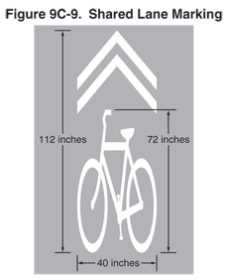
Figure 2: Shared Lane Marking

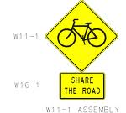
Figure 3: Share the Road sign

Figure 4: Bicycles May Use Full Lane sign


Figure 5: Bumper Sticker

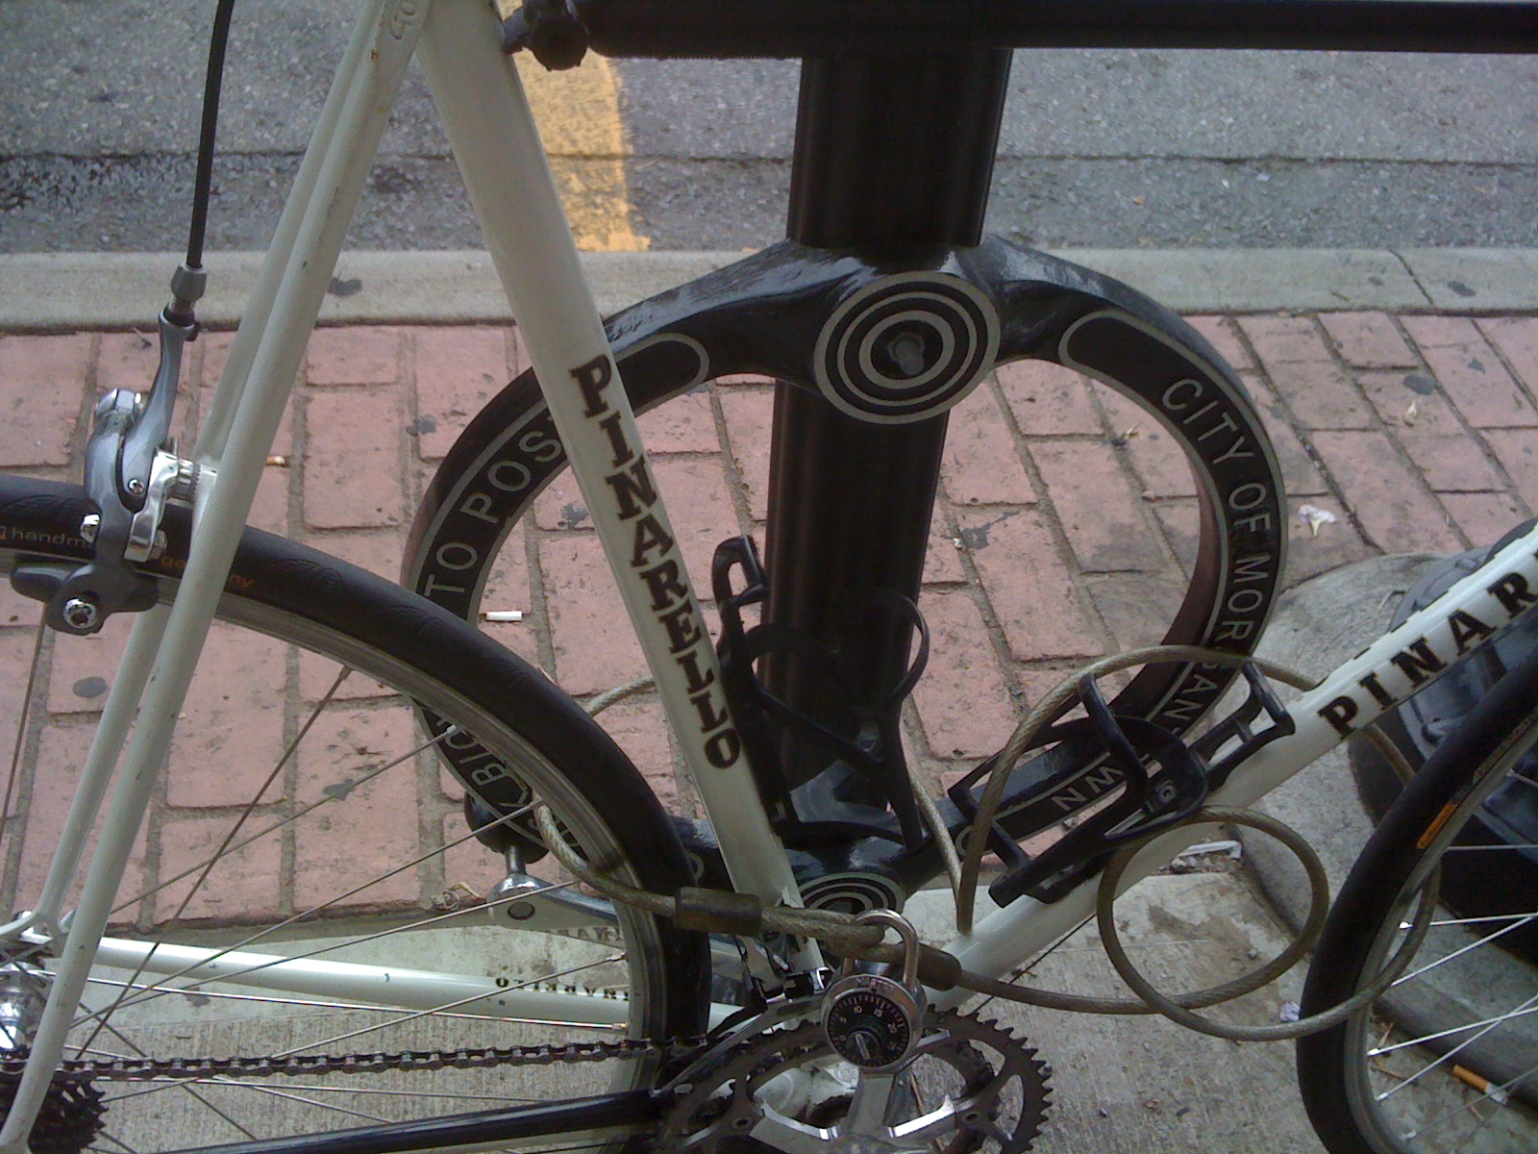
Figure 6: Parking Ring on High Street

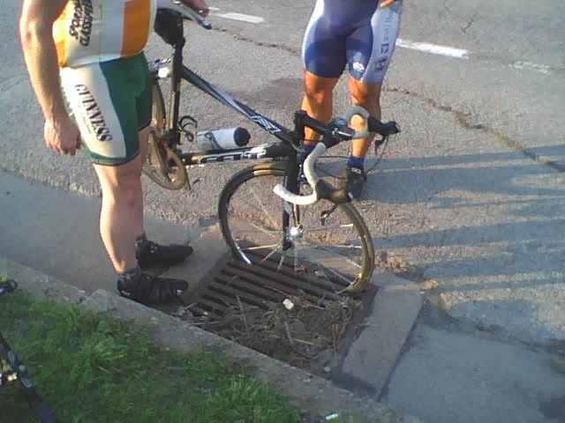
Figure 7: In-line drain grate in front of Coliseum

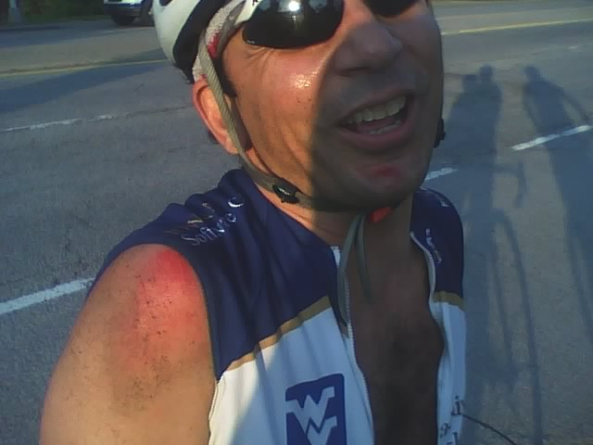
Figure 8: Lucky result of in-line grate crash

