March 28, 2012
(For April 4, 2012 Traffic Commission meeting)

Bicycle Board Report to Traffic Commission

HIGHLIGHTS

Accomplishments
- Parking Authority installed 2 bicycle lockers at 2 city garages: Public Safety Center and Wharf Street.
- Presented Greater Morgantown Bicycle Plan to City Council Committee of the Whole March 27.
- Delivered Confident City Cycling course to 12 WVU students at WVU Coliseum the weekend of March 10-11.
- Delivering Confident City Cycling course to 17 WVU students every Tuesday and Thursday March 20 – April 26.
- Arranged to have Confident City Cycling offered both WVU Summer sessions.

Plans for Next Month
- May is National Bike Month;
May 14-18 is National Bike to Work week and
May 18 is National Bike to Work Day!
- Monitor and support City Council action on Greater Morgantown Bicycle Plan.
- Attend next SPAN meeting and develop requested bicycle safety program.
- Support MPO-led activities including
  - Walk to Work Week, April 2;
  - WVU Employee Fest, April 12;
  - Bike to Work Week, May 14-18.
- Monitor status of grant application due February 29 to Bikes Belong for $10K to support Mon Blvd. bicycle climbing lane from Eighth St. to Evansdale Dr.
- Continue to support City efforts to install a bicycle-climbing lane on Mon Blvd. and to install Share the Road signs along the Mon Blvd., Beechurst, Don Knotts, South University corridor.
- Continue to coordinate with WVDOH to replace in-line drainage grates.
- Staff a bicycling information booth at WVU Employee Fest, Wednesday, April 12, 2012.
- Continue to study unicycling in Morgantown and develop recommendations.
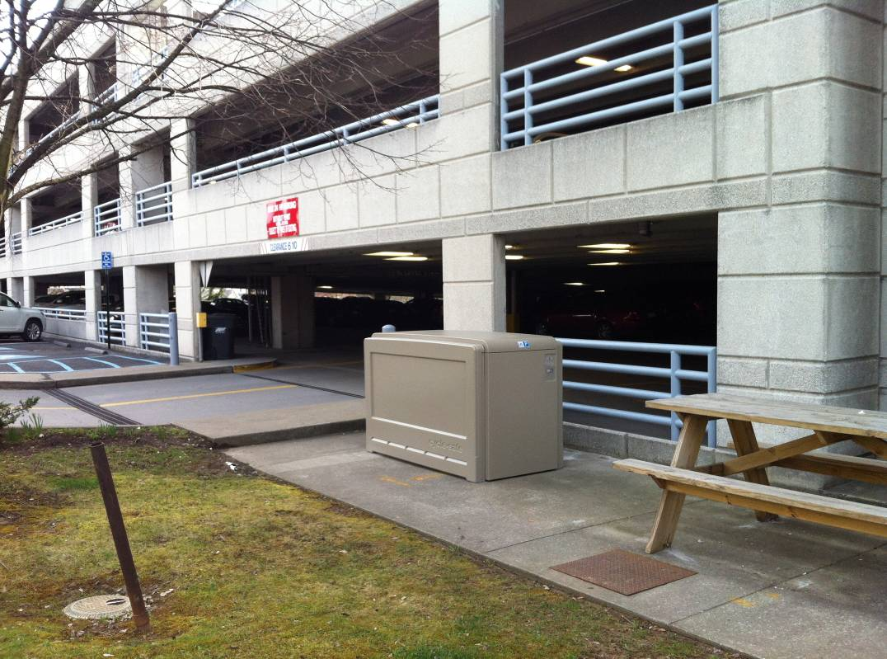
Figure 1 Bicycle locker at Public Safety Center Garage

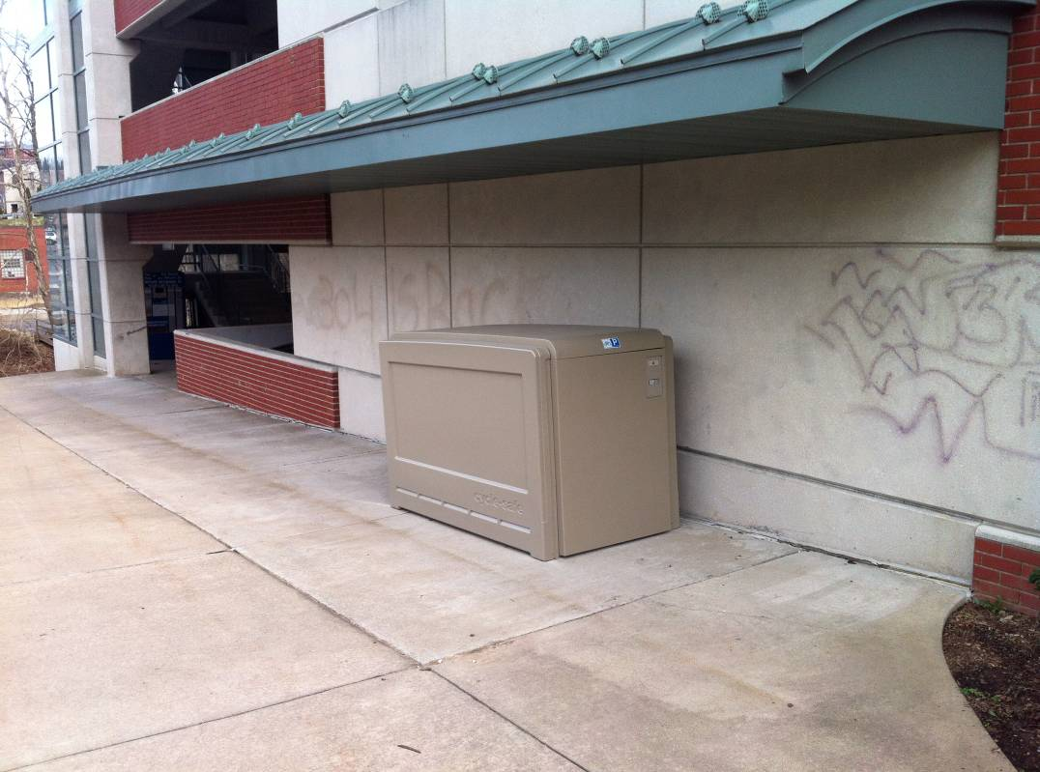
Figure 2 Bicycle locker at Wharf Street Garage

