Authoritative Striping Guidelines
Important note: Relevant text in relation to striping have double asterisks, other text is included as supporting documentation.
AASHTO: Guide for the Development of Bicycle Facilities, 1999
Chapter: Shared Use Paths
(Sight Distance, p. 42, also look at accompanying figures & graphs to establish applicability.)
** Bicyclists frequently ride side-by-side on shared use paths, and on narrow paths bicyclists have a tendency to ride near the middle of the path. For these reasons, and because of the higher potential for bicycle crashes, lateral clearances on horizontal curves should be calculated based on the sum of the stopping sight distances for bicyclists traveling in opposite directions around the curve. Where this is not possible or feasible, consideration should be given to widening the path through the curve, installing a yellow center line stripe, installing a “Curve Ahead” warning sign in accordance with the MUTCD, or some combination of these alternatives.
(Signing and Marking, p. 53)
Adequate signing and marking are essential on shared use paths, especially to alert bicyclists to potential conflicts and to convey regulatory messages to both bicyclists and motorists at highway intersections. In addition, guide signing, such as to indicate directions, destinations, distances, route numbers and names of crossing streets, should be used in the same manner as on highways. In general, uniform application of traffic control devices, as described in the MUTCD, provides minimum traffic control measures which should be applied.
** A designer should consider a 100-mm (4-inch) wide yellow center line stripe to separate opposite directions of travel. This stripe should be broken where adequate passing sight distance exists, and solid in other locations, or where passing by bicycles should be discouraged. This may be particularly beneficial in the following circumstances: (1) for heavy volumes of bicycles and/or other users, (2) on curves with restricted sight distance, and (3) on unlighted paths where nighttime riding is expected. White edge lines can also be very beneficial where bicycle traffic is expected during early evening hours.

(see recommended pavement marking materials below in MUTCD) General guidance on signing and marking is provided in the MUTCD. ** Care should be exercised in the choice of pavement marking materials .... Reduced versions [450 mm x 45 mm (18” x 18”)] of the signs in Section 9B-13 of the MUTCD may be used to warn users of sharp curves, intersections, etc.
(p. 53-54) [I am adding this as a reference because dangerous intersections on the rail-trail has been one of the subjects brought up by our members.]
Pavement markings at a crossing should accomplish two things: channel path users to cross at a clearly defined location and provide a clear message to motorists that this particular section of the road must be shared with other users. For a roadway user, a clear message must be presented in a location where it will be seen by that user. Traditional treatments have included the bicycle crossing sign (WII-I), the pedestrian crossing sign (WIIA-2), the pedestrian crosswalk lines [double 150-mm (6-inch) lines spaced not less than 1.8 m (6 feet) apart], or flashing yellow lights at the crosswalk. However, signs are frequently placed at the side of the road, out of motorists’ line of sight, and historically, flashing yellow lights have also been used at non-crosswalk applications. In recent years, new applications have been developed, including the following, which may be suitable for urban and suburban settings, but may not be suitable for rural areas:
❍ “Zebra-style" or colorized pavement crosswalks, which are far more visible than traditional designs.
❍ Raised platform crosswalks, which can be useful to define roadway space for non-motorized users and stress the need for motorists to yield to that space.
❍ Pedestrian-friendly intersection crossings, which incorporate appropriate signal heads and infrared motion detectors, pressure mats or other technologies.
❍ Midblock neck-downs or intersection curb-bulbs at the crossing to shorten the crossing distance.
The above suggestions should be considered on a case-by-case basis and should always be evaluated with regard to the safest overall method for accommodating both path users and roadway users.
(Restriction of Motor Vehicle Traffic, p. 57, note, figure 26 shows specs.)
Shared use paths may need some form of physical barrier at highway intersections to prevent unauthorized motor vehicles from using the facilities. Provisions can be made for a lockable, removable (or reclining) barrier post to permit entrance by authorized vehicles. Posts or bollards
should be set back beyond the clear zone on the crossing highway or be of a breakaway design. The post should be permanently reflectorized for nighttime visibility and painted a bright color for improved daytime visibility. **Striping an envelope around the post is recommended as shown in Figure 26. When more than one post is used, an odd number of posts at 1.5-m (5-foot) spacing is desirable. Wider spacing can allow entry to motor vehicles, while narrower spacing might prevent entry by adult tricycles, wheelchair users, and bicycles with trailers.

MUTCD: Manual on Uniform Traffic Control Devices, 2003 Edition
Section 3A.03 Materials

Support:
Pavement and curb markings are commonly placed by using paints or thermoplastics; however, other suitable marking materials, including raised pavement markers and colored pavements, are also used. Delineators, object markers, barricades, and channelizing devices are visibly placed in a vertical position similar to signs above the roadway.

Guidance:
** The materials used for markings should provide the specified color throughout their useful life.

** Consideration should be given to selecting pavement marking materials that will minimize tripping or loss of traction for pedestrians and bicyclists.

Object markers and delineators should not present a vertical or horizontal clearance obstacle for pedestrians.

Section 9C.03 Marking Patterns and Colors on Shared-Use Paths

Option:
** Where shared-use paths are of sufficient width to designate two minimum width lanes, a solid yellow line may be used to separate the two directions of travel where passing is not permitted, and a broken yellow line may be used where passing is permitted (see Figure 9C-2).

Guidance:
** Broken lines used on shared-use paths should have the usual 1-to-3 segment-to-gap ratio. A nominal 0.9 m (3 ft) segment with a 2.7 m (9 ft) gap should be used.

** If conditions make it desirable to separate two directions of travel on shared-use paths at particular locations, a solid yellow line should be used to indicate no passing and no traveling to the left of the line.

** Markings as shown in Figure 9C-2 should be used at the location of obstructions in the center of the path, including vertical elements intended to physically prevent unauthorized motor vehicles from entering the path.

Option:
A solid white line may be used on shared-use paths to separate different types of users. The R9-7 sign (see Figure 9B-2) may be used to supplement the solid white line.

Smaller size letters and symbols may be used on shared-use paths. ** Where arrows are needed on shared-use paths, half-size layouts of the arrows may be used (see Section 3B.19).
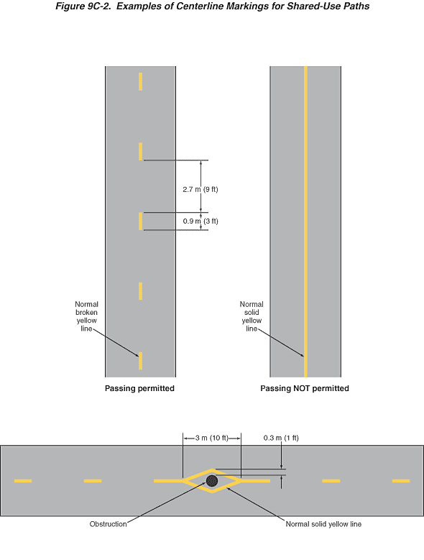
Figure 9C-2. Examples of Centerline Markings for Shared-Use Paths
This figure illustrates three examples of centerline markings for a shared-use path.
The first example shows a vertical two-lane shared-use path where passing is permitted. A centerline of a normal broken yellow line is shown marked on the pavement, separating the two lanes. The yellow line segments are shown as a dimension of 0.9 m (3 ft) long. The distance between the edges of two line segments is shown as a dimension of 2.7 m (9 ft).
The second example shows a vertical two-lane shared-use path where passing is NOT permitted. A single centerline of a normal solid yellow line is shown marked on the pavement, separating the two lanes.
The third example shows a horizontal two-lane shared-use path with a circular obstruction in the center of the path between the two lanes. At the leftmost and rightmost sides of the illustration, a normal broken yellow line is shown marked on the pavement, separating the two lanes. Closer to the obstruction, both east and west of the obstruction, the broken yellow line is shown changing to a solid yellow line. Closest to the obstruction, the obstruction is shown as being in the middle of a diamond-shaped island formed by solid yellow lines. The horizontal length of the diamond shape around the obstruction is shown as a dimension of 3 m (10 ft), and the vertical dimension from the edge of the obstruction to the outer edge of the yellow line at both of the vertically aligned points of the diamond shaped island is shown as 0.3 m (1 ft).
Back to Chapter 9C

