October 25, 2012
(For November 7, 2012 Traffic Commission meeting)

Bicycle Board Report to Traffic Commission

HIGHLIGHTS

Issues
- The Traffic Commission must appoint a Traffic Commission member to the Bicycle Board to conform to the Procedural Guidelines dictated to the Bicycle Board by the Traffic Commission.
- The Bicycle Board requests the Traffic Commission to appoint the following new members to the Bicycle Board.

Accomplishments
- Delivering WVU PE 172 Cycling Basics (Confident City Cycling).
- Delivered Confident City Cycling guest lecture to WVU Sustainable Living class Oct. 22.
- Deliver bicycle safety and maintenance guest lecture to Christian scouting program at Pierpont Church Oct. 3.
- Met with WVDOH Oct. 18 to discuss options for bicycle climbing lane on Ice’s Ferry Bridge.
- Met with City administration Oct. 17 to plan Greater Morgantown Bicycle Plan progress review with City Council at the Nov. 27 Committee of the Whole meeting.
- Identified key City stakeholders in establishing a Morgantown bikeshare system and invited their participation in an EPA sponsored seminar to learn about bikeshare systems and possible EPA funding but received no response.
- Drafted certificate of recognition for City to recognize eighth grader Matt Watson for arranging to establish a bike rack at Suncrest Middle School.
- Reviewed and unanimously concurred with Pedestrian Safety Board proposal to change Traffic Commission to Transportation Commission and to make representatives of the bike board and pedestrian safety board voting members of the commission.
- Participated in a WV Connecting Communities Legislative Committee conference call and subsequently provided revised justification for repealing WV 17C-11-5 (a) which requires bicyclists to ride as near to the right side of the roadway as practicable.
- Participated in AARP sponsored 6-hour Complete Streets workshop Oct. 23.
- Participated in Oct. 10 MPO Citizens Advisory Committee meeting.
- Defined projects and identified leaders and helpers for the projects that Bicycle Board members will attempt to accomplish directly:
  - Establish bike racks at schools
  - Define Safe Routes to Schools
  - Establish bicycle safety programs at schools
    - Subcategory: Go to Morgantown’s K-12 schools to educate them on bike skills and safety
  - Create single track trails in City
  - Complete parking inventory. Identify parking gaps.
  - Update Shared Land Marking & Share the Road sign locations.
  - Identify signs, markings, facilities on BikeMorgantown.com
  - Show WVU bike rack locations on WVU’s Google map of campus.
  - Represent Bicycle Board on WV Connecting Communities
  - Outreach to international students on bicycling
  - Write white paper to recommend bike friendly elements for Evansdale & hospital redevelopment.
  - Get all major employers rated Bicycle Friendly Businesses
  - Keep Positive Spin in operation.
  - Implement Complete Streets action in Bicycle Plan
  - Write grants, (HISP, etc.)
  - Identify locations for installation of Bike Friendly Community Signs

Plans for Next Month
- Deliver PE 172 Cycling Basics (Confident City Cycling) class at WVU.
- Continue to support City in establishing bicycle-climbing lane on Mon Blvd. between Eighth St. and Evansdale Dr.
- Support City Engineer in getting Bicycle Friendly Community signs erected.’
- Continue to pursue bicycle-climbing lane on Ice’s Ferry Bridge.
- Participate in Nov. 10 WV Connecting Communities meeting in Buckhannon.
- Do you think we should plan to attend the Nov. 27 City Council Committee of the Whole meeting when the City Manager reviews progress on the Bicycle Plan?

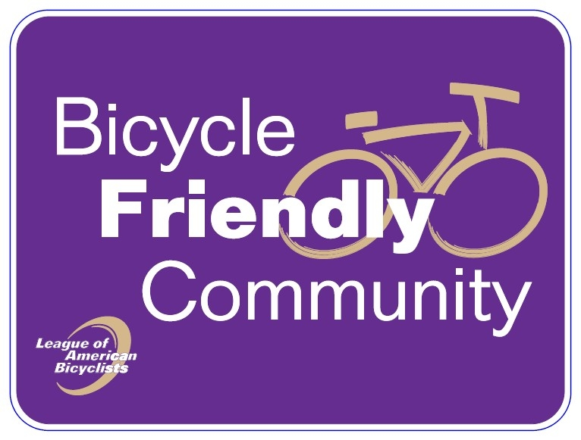
Figure 1 Bicycle Friendly Community Road Sign

