December 7, 2011

Bicycle Board Report to Traffic Commission

HIGHLIGHTS

Recommendations
- Appoint Colin Dierman to replace Jim Rye.

Accomplishments
- Graduated 3 participants from CCC TS101 class delivered Nov. 3, 11, 13 at WVU.
- Completed bicycling education video for children aged 5-10 years.
- Established 1-credit hour CCC course in WVU CPASS to be taught beginning Spring 2012.
- Distributed preliminary draft of Morgantown Bicycling Plan to key stakeholders: Terrence Moore, Jeff Mikorski, Terry Hough, Ed Preston, Chris Fletcher, Mark Wise, Tom Arnold, Bill Austin, Fouad Shoukry, Perry Keller and Wes Stafford requesting comments and changes by December 8.
- Began to write application for League of American Bicyclists Bicycle Friendly Community award to be submitted February 2012. Received Chief Preston’s completion of the Enforcement section.
- Parking Authority approved proposed bicycle lockers for 2 city garages.
- Submitted to Assistant City Manager, grant application to Bikes Belong for $10K to fund Mon Blvd. bicycle climbing lane.
- Met with Assistant City Manager to discuss joint Morgantown-Star City TEP grant application for bicycle climbing lane from Star City Bridge to WVU Coliseum. City will not submit.
- At MPO CAC recommendation, delivered to Paul Mattox, Ray LaHood, Earl Ray Tomblin, Joe Fisher, Asel Kennedy and Brent Walker, petition with 125 signatures to enable cyclists to cross Cheat Lake at Ice’s Ferry during bridge replacement
- WVDOH replaced in-line drainage grates by Coliseum with bicycle-friendly grates. Remaining in-line grates to be replaced are on Westover Bridge, Walnut St. Bridge, South University Ave. northbound between Pleasant and Walnut.

Plans for Next Month
- Present Morgantown Bicycle Plan to City Council.
- Monitor status of $130K follow-up education grant application to WVDOT.
- Monitor status of grant application to Bikes Belong for $10K to support Mon Blvd. bicycle climbing lane from Eighth St. to Evansdale Dr.
- Provide Tom Arnold bike lockers specifications to enable purchase order.
- Continue to support City efforts to implement the Traffic Commission’s approved Bicycle Board June 2009 recommendations to install a bicycle climbing lane on Mon Blvd. and to install Share the Road signs along the Mon Blvd., Beechurst, Don Knotts, South University corridor.
- Continue to coordinate with WVDOH to replace in-line drainage grates.
- Initiate activity with WVU to replace numerous in-line drainage grates on campus.
- Write Morgantown Effective Bicycling Education Program final report.
- Complete 2nd Morgantown application to the League of American Bicyclists for the Bicycle Friendly Community award.
Figure 1: Bike Locker

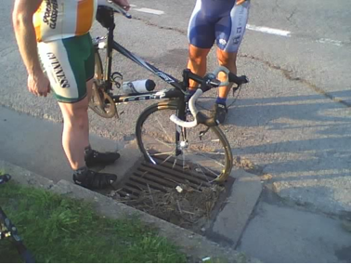
Figure 2 In-line drainage grate

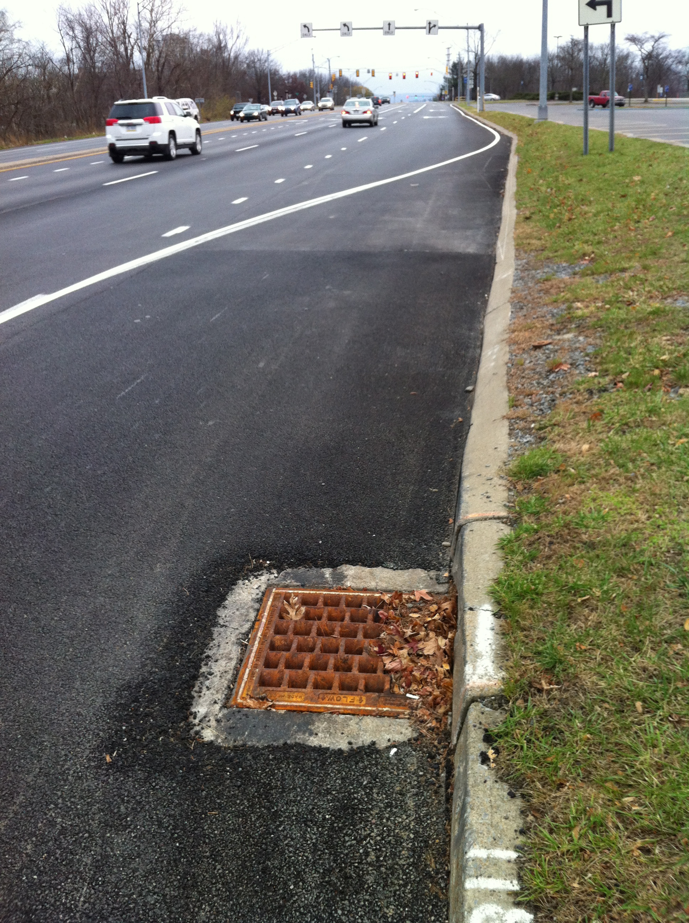
Figure 3 Bicycle-friendly drainage grate

