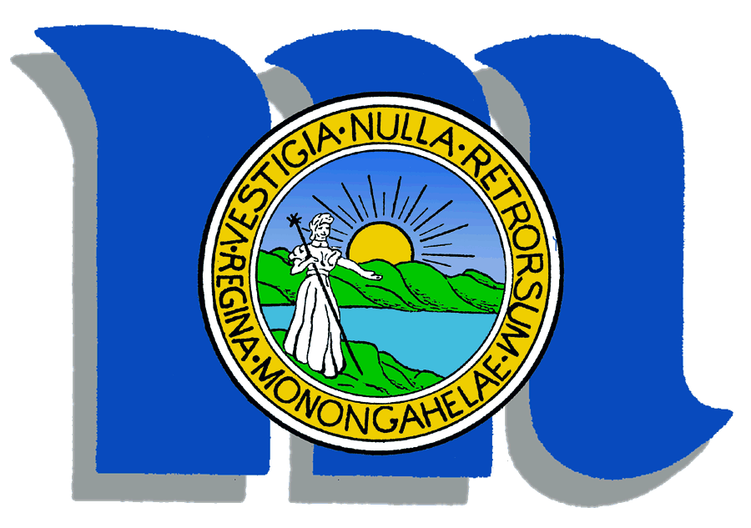

Please join
Morgantown
City Council

For a Meet and Greet with the
City Manager Candidates

Tuesday, October 26, 2010

At the
Morgantown Event Center
Lobby Foyer


6:00pm to 7:30pm

Meet and speak with the candidates to become Morgantown’s next City Manager.

