Morgantown Municipal Bicycle Board

Infrastructure Pilot Project - Bicycles on Roadway Markings

June 13, 2007

PURPOSE

In order to alert motorists to the presence of other vehicles on roadways, the Bicycle Board recommends that chevrons with a bicycle symbol be placed on roadways. It is believed that such action will:

- Improve awareness by motorists of potential presence of bicycle riders on roadway
- Increase safety for the public which travels by bicycles
- Encourage more persons to use bicycle s for transportation
- Help reduce congestion
- Assist in mitigating need for expensive parking facilities.

DESIGN AND EXPENSE

The cost of a 5’9 -6’ x 3’3” bicycle symbol is approximately $120 if purchased in lots of 5. The cost of the chevron stripes is estimated to be $30. (We have been informed that discounts between 15-30% may apply.) A copy of the full chevron design follows:

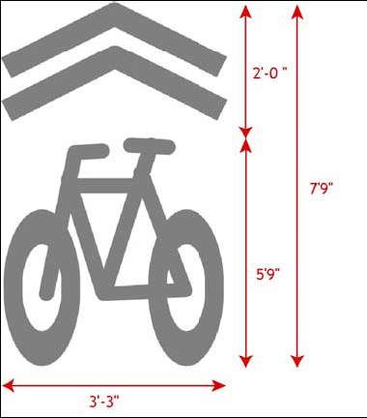

LOCATIONS

Priority locations identified for the symbol are as follows:

- 50 feet beyond the crosswalk marking area in the right acceleration lane at each signalized or primary intersection – pointing in the direction of traffic flow away from the intersection
- In the middle of the right hand lane closest to the side of the road

- In advance of hill crests where bicycles and other traffic move beyond a line of sight

- Before blind curves where bicycles and other traffic move beyond a line of sight

- At gateway of any residential connector 50 – 100’ from the entrance intersection.

- In the vicinity of school and park facilities.

INSTALLATION PRIORITIES

In order to make priority selections for installation, the Bicycle Board had identified intersections and other sites which meet the above location priority criteria – based on 1) current use by experienced bicycle riders and 2) a need to improve the safety for bicycles so that even more riders will use these roadways for transportation within the City.

The following list identifies these sites. # Chevrons/Jurisdiction

- University Ave. and Patteson Drive Intersection 4 **
- Patteson Drove and Monongahela Boulevard Intersection 3 **
- Patteson Drive/VanVoorhis Road/Elmer Prince Drive Intersection 3 **
- Collins Ferry Road/University Ave./ Baldwin Street Intersections 4 **/*
- Collins Ferry Road and Burroughs Street Intersection 3 **
- On Killarney at VanVoorhis Road 1*
- Junior Ave. and University Ave. Intersection 3**/*
- Aspen Street and Collins Ferry Road Intersection 4**/*
- Eighth Street and University Ave. Intersection 3**/*
- North Street and University Ave. (1 to east of int. beyond Warrick St.) 2**
- University Ave Blind Curve (in west bound lane before curve) 1**
- University/Stewart Street/Campus Drive Intersection 4**/*
- West on Willowdale Road and South on Stewart Street at Junction 2*
- North on Stewart Street at Van Gilder Intersection 1*
- North on College Ave. at Mai den Lane Intersection 1*
- On Beechurst Ave. and Eight Street Intersection 3**/*
- Campus Drive and Beechurst Ave. Intersection 3**/*
- West on Beechurst Ave. at Fayette Street Intersection 1**
- Beechurst and Pleasant Street Intersection 4**
- University Ave. and Dorsey Ave. Intersection 3**
- High Street and Prairie Ave. Intersection (chevron on north side of Prairie) 3*
- High Street and Willey Street Intersection 3**/*
- Ice’s Ferry Road and Charles Ave. 3**/*
- Richwood Ave. and Charles Ave. Intersection 3*
- Richwood Ave. and Darst Street Intersection (with 1 on Darst south) 3*
- Earl Core Drive (Rte. 7) and Decker Boulevard/Sabraton Ave. Intersection 4**/*
- Earl Core Drive and Decker Ave. Intersection (near Mineral Ave.) 3**/*
- Pleasant Street and Spruce Street Intersection 3**/*
- Wilson Ave. and White Ave. Intersection 3*
- Dorsey Ave and Hite Street Intersection 3**/*
- Dorsey Ave. and Ross Street Intersection 3**/*
- East Parkway and Mississippi Street Intersection 3*

Total Symbols 90
Projected Total Cost @ $150 = $13,500

Please Note:

All 32 locations listed are within the City Limits of Morgantown.

* indicates site involves only City street(s).

** indicates State Highway or County Road under DOH jurisdiction.

**/* indicates an intersection of City and DOH roadway jurisdictions.

Chevrons located on City Street jurisdiction: 33 ($4,950)

Chevrons located on DOH jurisdictions: 57 ($8,550)

