Contents
The Law 1
Problematic Sections of the Law 1
Fundamental Principle of Effective Cycling 1
Causes of crashes 2
Non MV – AKA “Falling Down” 2
Top 10 Bike-MV crashes 2
Bike-MV Crash Prevention and Avoidance 3
Lane positioning 3
Bike handling 4
Crash avoidance 5
Country Roads 5
Lane width and lane positioning 5
Straight narrow road 5
Curvy narrow road 5
Hilly narrow road 5

The Law
“Every person riding a bicycle on a roadway shall be granted all the rights and shall be subject to all the duties applicable to the driver of a vehicle by this chapter, except as to special regulations in this article and except as to those provisions of this chapter which by their nature can have no application.”
WV Code section 17C-11-2; Morgantown Code 373.02

Problematic Sections of the Law
“(a) Every person operating a bicycle upon a roadway shall ride to the right side of the roadway as practicable, exercising due care when passing a standing vehicle or one proceeding in the same direction.
(b) Persons riding bicycles upon a roadway shall not ride more than two abreast except on paths or parts of roadways set aside for the exclusive use of bicycles.
WV Code section 17C-11-5

Fundamental Principle of Effective Cycling
Cyclists fare best when they act and are treated as drivers of vehicles

Causes of crashes

Non MV – AKA “Falling Down”
- Bike – bike collision
- Cracks & holes – especially in turns, intersections, right side of lane and edge of road
- Debris: gravel, glass, mud, oil – especially in turns and intersections
- Wet: road markings, manhole covers, metal plates – especially in turns and intersections
- Railroad tracks, in-line grates
- Dogs, pedestrians
- Wind
- Parked cars

Top 10 Bike-MV crashes
- Bicyclist ran stop sign
- Motorist ran stop sign
- Bicyclist rode out at intersection
- Motorist drove out from driveway or alley
- Motorist left turn into oncoming cyclist
- Bicyclist rode out of residential driveway
- Motorist "right hooks" cyclist
- Bicyclist rode out at mid-block
- Bicyclist swerves left into same direction traffic
- Motorist overtook cyclist

Bike-MV Crash Prevention and Avoidance
- Be visible
- Be aware
- Ride straight
- Be predictable
- Be assertive
- Be courteous

Lane positioning
- Rightmost lane that serves your destination
- Straight through
- Right turn
- Left turn

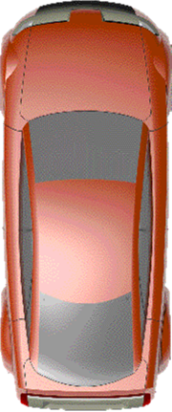
2
3
1

Bike handling
- Scan
- Signal
  - Head & eyes
  - Arm & hand
  - Body
- Negotiate
  - Eye contact
  - Body language

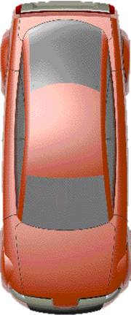

Crash avoidance
- Bottle dodge
- Quick turn
- Panic stop

Country Roads

Lane width and lane positioning
- Wide lanes: Ride straight, maximize visibility, allow room to pass
- Narrow lanes: Ride straight, be predictable, experiment, judge, scan, signal, negotiate, assertive, confident, fearless
- Uphill; Downhill

Straight narrow road
- Being overtaken
  - Single, <4
  - Large groups: single up, groups of 4
  - Waving around: don’t do it
- Overtaking: Pass on left

Curvy narrow road
- Enter, through, exit
- Right curve
- Left curve

Hilly narrow road
- Ascending
- Cresting
- Descending

