September 2, 2009

Bicycle Board Report to Traffic Commission

MEMBERSHIP
- Ralph Larue

Ralph has volunteered to be a BOPARC ex-officio member of the Bicycle Board. Ralph is BOPARC Associate Director Maintenance/Operations and Development or, as he says, he’s in Operations. He has been in the recreation business for over 30 years, has planned and built many trails, has planned and ran several bicycling events and has taken a couple classes on traffic safety.
- ???
Youth Commission Member

EDUCATION

Effective Cycling
- Morgantown Effective Bicycling Education Transportation Enhancement Program Grant:

Waiting for authorization from WVDOT to proceed.

Grant background:

On October 21, 2008 Governor Joe Manchin presented the City of Morgantown a Transportation Enhancement Program grant for the Morgantown Effective Bicycling Education Program. The state will provide $54,417 and the City will provide a $13,605 required match for a grant total of $68,022. This grant is a response to the application that the City submitted last January. The proposed work includes using print and electronic media to educate the community about cyclist and motorist rights and duties with respect to the law and each other and classes in which the League of American Bicyclists’ Traffic Skills 101 course will be delivered.

ENFORCEMENT

ENCOURAGEMENT

Downtown Bicycle Parking
- Presented parking device design and location plan to Mainstreet Morgantown merchants. Two merchants have expressed concern that the parking devices will clutter High Street and that parked bicycles will interfere with pedestrian traffic. Awaiting Mainstreet Morgantown’s counter proposal to accommodate bicycle parking downtown.
- Arranged September 11 visit to State College PA to study their bicycle parking and its effects on bicycling and local business to provide benchmarks for Morgantown.

Background
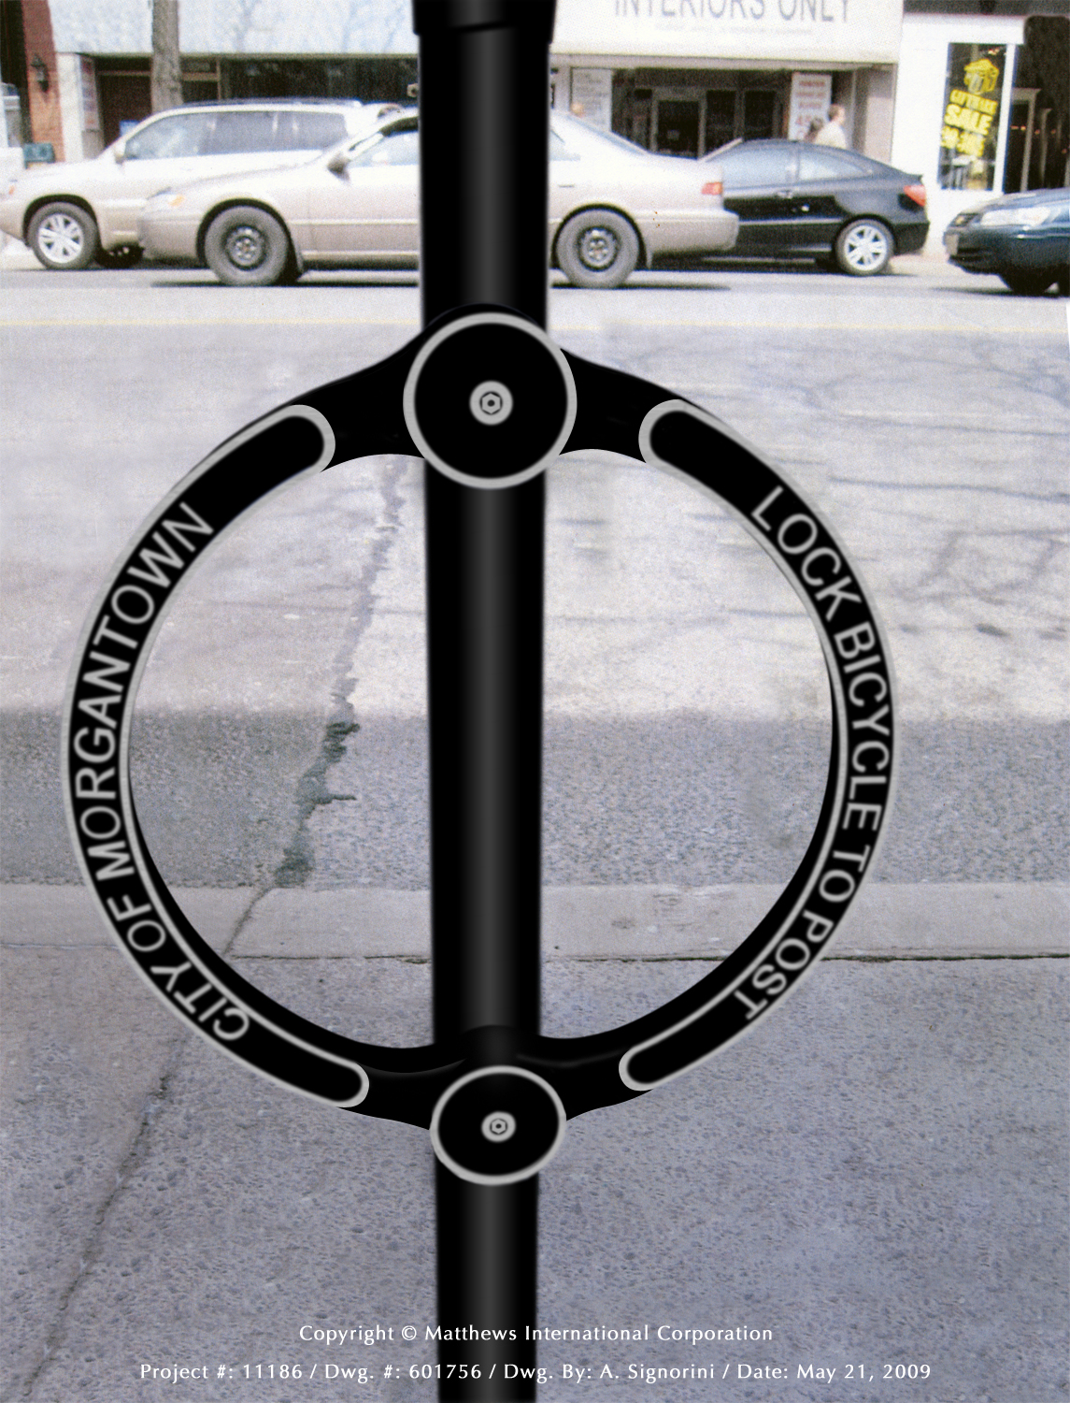
- Created estimate and City identified budget for the parking devices.
- Created photo library on City web site http://www.morgantown.com/bike-board-documents/tm/index.htm of each planned location to reveal potential conflicts.
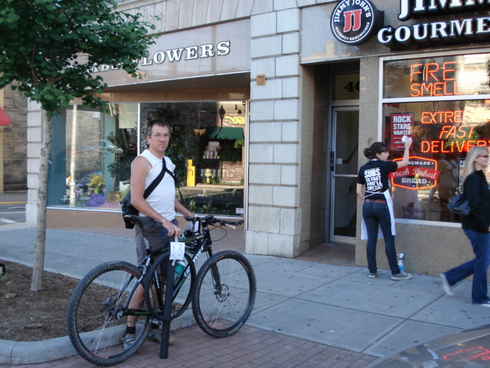
- Presented design and location plan to Mainstreet Morgantown Director and received letter of support.
- Reviewed design with City Public Works and Engineering. City Engineer reviewing locations and preparing final location map.
- Presented design and location plan to Mainstreet Morgantown Design Committee and received unanimous support.

Bike Route Map
- The Bicycle Board is in the process of classifying Morgantown streets to identify good bicycle routes. Using the new Visitor’s Bureau map, the Bicycle Board as a whole marked up the map to identify frequently used bicycle routes. The Board is using a bicycle route map produced by Athens Ohio as a benchmark for map symbol and legend.

ENGINEERING

Shared Lane Markings (Chevrons)
- The New MUTCD that was originally scheduled to be approved by FHWA this year now appears won’t be approved for 1-2 years. Shared Lane Markings are not at issue. Received correspondence from a MUTCD committee member that indicates Shared Lane Markings may receive interim approval.

SLM Background:
On July 11, 2007, the Traffic Commission unanimously approved the Bicycle Board’s recommendation for the City to apply the Shared Lane Markings to specific roads in Morgantown.

On May 22, 2008 Paul Maddox, Secretary of the WV DOT, in a letter to Morgantown City Manager, Dan Boroff, authorized the City of Morgantown to apply Shared Lane Markings and to install Bicycles May Use Full Lane signs to guide bicyclists to the appropriate position on the roadway and to remind motorists that bicyclist have the same rights and are subject to the same duties as drivers of motor vehicles.

On June 13, 2008, Terry Hough requested the Bicycle Board to provide a map that she could include in the request for bids from contractors to install the Shared Lane Markings and Bicycles May Use Full Lane signs.

The Bicycle Board presents the map to the Traffic Commission at its December meeting.

The Shared Lane Markings are in the new FHWA Manual of Uniform Traffic Control Devices (MUTCD) slated for approval at the end of this year.

In other cities such as San Francisco in which the Shared Lane Markings have been used, scientifically conducted studies showed that bicyclists are more likely to

- Drive in the direction of traffic flow,
- Drive on the right side of the road,
- Not drive on sidewalks, and
- Position themselves on the roadway to avoid colliding with opening doors of parked cars.

The studies also showed that when Shared Lane Markings are present, motorists are more aware of bicycles and give them a little more room when passing. Almost 2 years ago, Pittsburgh installed Shared Lane Markings on select streets and bicycle use has increased.

The new signs state that “Bicycles May Use Full Lane.” These signs are also in the new MUTCD. When the City sought WVDOH approval for the Shared Lane Markings, the WVDOH required a Bicycles May Use Full Lane sign to be placed along with the Shared Lane Markings. However, to minimize costs, the City negotiated to place the signs at the beginning of each run of Shared Lane Markings and in locations in which the sign would convey a clearer message than the Shared Lane Markings.

The Shared Lane Markings and Bicycles May Use Full Lane signs would be placed on Morgantown streets that bicyclists would use more if they knew they could ride on them. These streets include University Avenue, Patteson Drive, Van Voorhis Road, Collins Ferry Road, Beechurst Avenue, High Street, Spruce Street, Stewart Street, Willowdale Road, South University Avenue, Dorsey Avenue, Willey Street, Charles Avenue, Richwood Avenue, Rt. 7 in Sabraton, and Decker Boulevard.

In the process of approving the City’s plan for Shared Lane Markings, the WVDOH also agreed to install Share The Road signs on state routes leading into and around the City including Monongahela Boulevard, South University Avenue, the Mileground, and Greenbag Road.

Since the WVDOH approved our application, personnel changes have led to their reconsidering their approval. An October 30, 2008 letter from Paul Maddox retracted his May 22 approval.

In a December 17, 2008 e-mail from Ray Lewis, WVDOH Staff Engineer Traffic Research and Special Projects to Bill Robinson, WVDOH Trails Coordinator, Lewis said, “From our perspective, the City presently has two alternatives open to them:

1) Apply for a permit (where State-maintained streets are involved and install SHARE THE ROAD signs, which are an approved traffic control device; or

2) File a request with the FHWA for Permission to Experiment with either or both of these new traffic control devices; the DOH would entertain a permit application for any affected State facilities, once the City has this in hand.”

MUB Closure of Rail Trail to Install New Sewer Line

- Created design specification for Bike Lane on the climbing side of Monongahela Blvd. between Eighth Street and Evansdale Drive.
- Met with City Manager, City Engineer and MPO Director to review the Bike Lane design and to define roles and responsibilities in getting WV DOH approval. MPO Director will take the lead.
- Arranged September 11 visit to State College PA for the Bicycle Board Chairman and the MPO Director to view a climbing lane installed in April and to discuss the design and approval process with those that made it happen.

Background

At the June 2009 Traffic Commission meeting, the Bicycle Board recommended and the Traffic Commission approved the following recommendations:

At least 6 months before the trail is closed:
- Install “Share the Road” and “Bike Route” signs every 250 feet on Beechurst Ave., Mon Blvd., Don Knotts Blvd. and University Ave.
- Install a bike lane going up the hill on Mon Blvd. between Eighth St. and Evansdale Drive. Keep the bike lane free of debris.

Also at the June 2009 meeting, the Bicycle Board provided the following recommendations which the Traffic Commission held in abeyance pending the Traffic Commission gathering additional information on the trail closure:
- Establish cycling detours around the trail but as close to the trail as reasonable. (Consider the businesses that depend on trail traffic. Remember Whitetail?)
- Complete the work in sections to minimize the impact on cyclists and businesses.

EVALUATION

