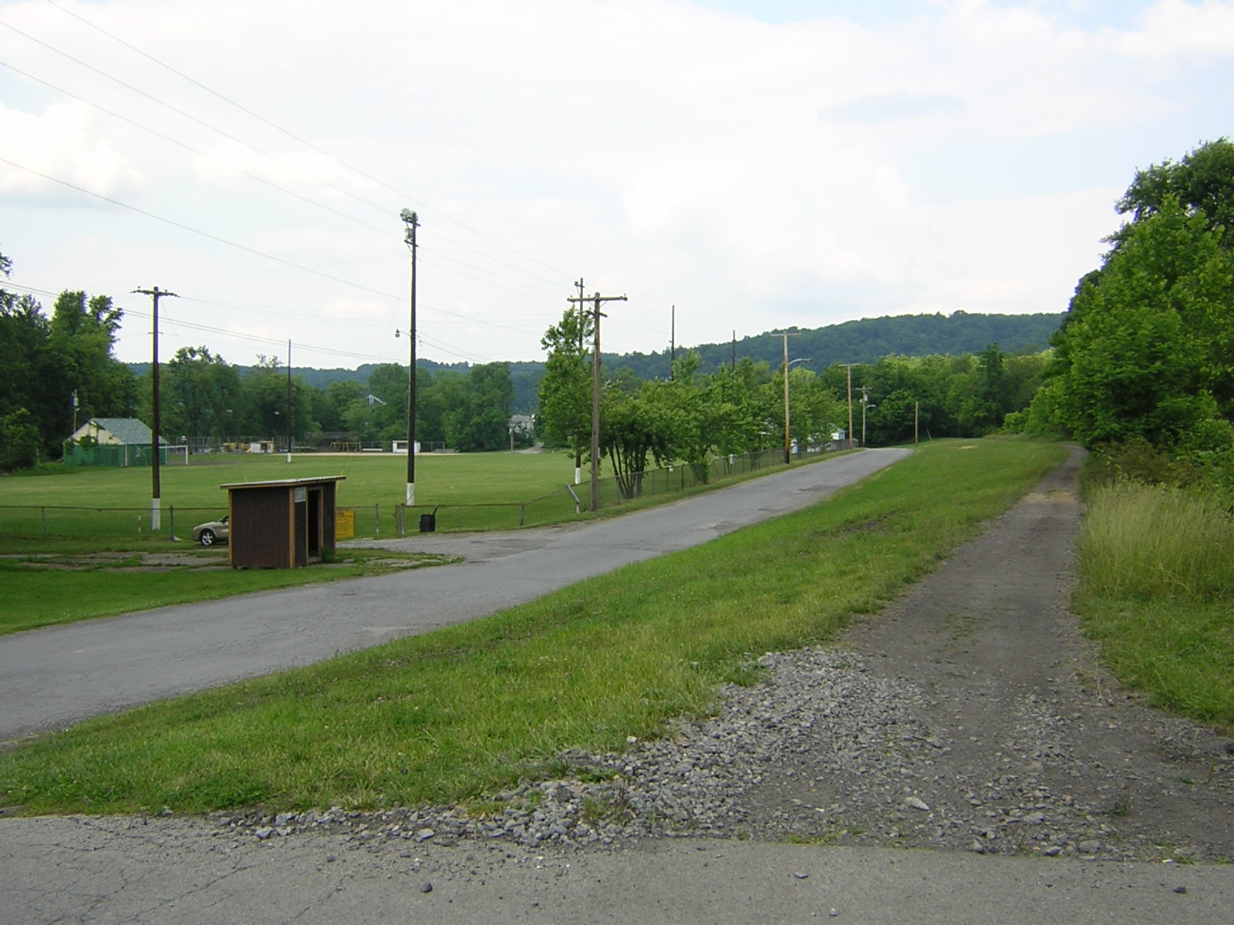 | Sheepskin Trail  You Are Invited to Attend a Tour and Open Discussion on the Sheepskin Trail  Thursday, March 7  4:30 pm – walking tour – Penn & Railroad St  5:00 – 6:00 pm – community gathering  Refreshments available  RSVP 724.437.9877
Jordan Building  26 Penn Street  Point Marion | 