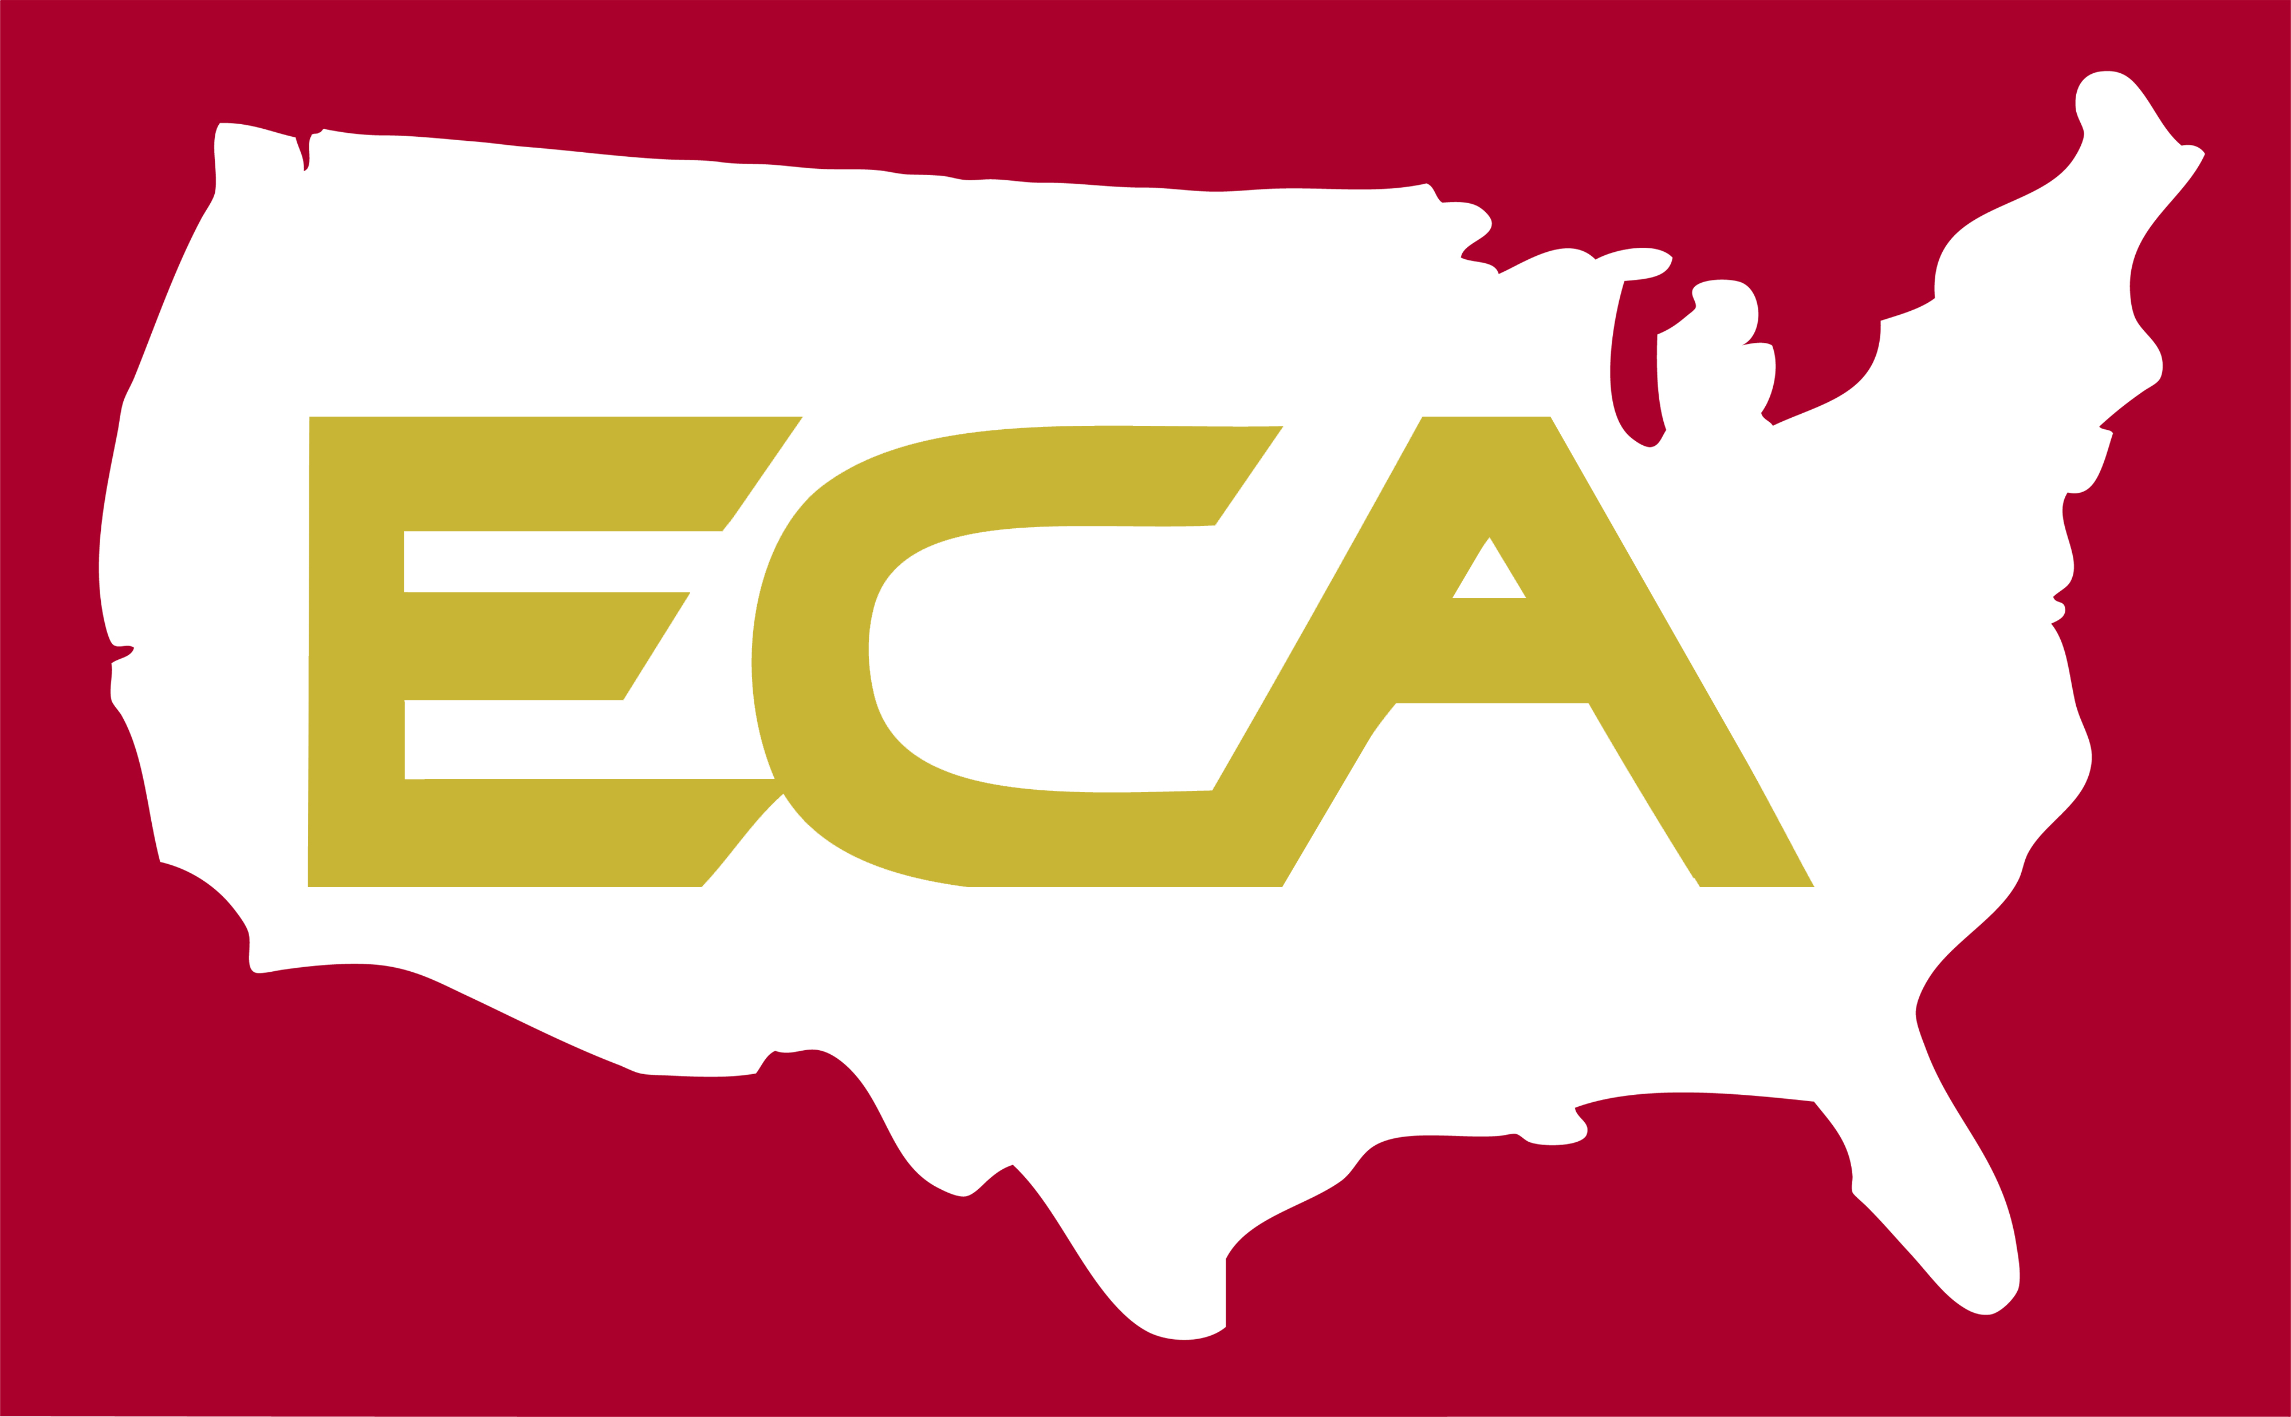

Energy Corporation of America

501 56th Street, S.E.
Charleston, W.Va. 25304
(304) 925-6100

Media Contact For Immediate Release
Jennifer Vieweg April 18, 2014
(304) 400.7304

ENERGY CORPORATION OF AMERICA ELECTS NOT TO PURSUE PRESTON COUNTY INJECTION WELL PROJECT

This week, Energy Corporation of America (ECA) determined not to pursue an injection well the company has been exploring near Masontown in Preston County.
A number of different factors led to this decision. It is a complicated and involved process, which took nearly a year to complete. Throughout this process we considered all of the factors necessary to determine if the project would be practical to pursue. These factors included well integrity, ease of site access, environmental sensitivities, and many others. In the end, our exploration simply concluded this well is not a good candidate for conversion to a Class II injection well at this time.
While we had hoped the project would come to fruition, our approach was responsible and produced the most comprehensive decision possible. We will continue to operate as we have for more than 50 years, focusing on the wellbeing of our employees, safety of the environment, and ongoing commitment to the communities where we operate.

-30-

